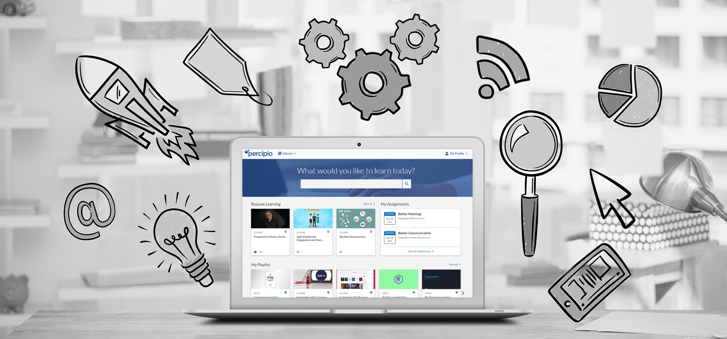
#IGOTSKILLS
What if you could tackle your next challenge, roadblock or career opportunity with just one click?  Your new ONLINE LEARNING PROGRAM delivers useful learning content aligned to your needs.  - Personal Accountability  - Accounting and Finance  - Communication Skills  - Decision Making and Problem Solving  - Business Acumen  - Microsoft Office Suite |  |  | CLICK TO LAUNCH  FEATURED ASSETS  Watch:  Justo odio dignissim qui blandit praesent luptatum zzril  Read:  Lorem ipsum dolor sit amet, conse ctetuer adipiscing elit,  Listen:  Nulla facilisi. Lorem ipsum dolorsit amet, conse ctetuer
Log on at: http://<sitename>.skillport.com>  For more information or to learn more contact  Jane Doe or email Jane.Doe@skillsoft.com. | Delete or replace with client logo

