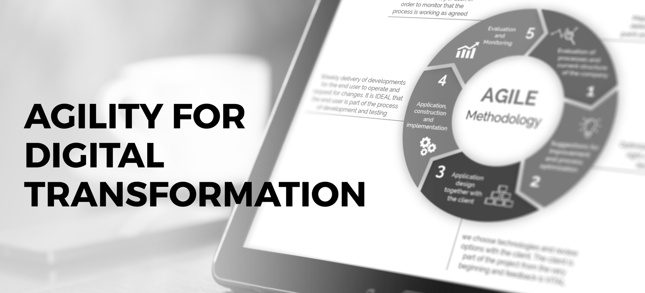
AGILE AND GROWTH MINDSETS

Are you ready to plan and execute your projects with agility?
Do you operate and model a growth mindset?
Are you adept at leading your teams through change?
At xyz company, our transition to a digital organization is bringing about exciting opportunities to utilize new technologies, systems, processes and relationships to grow and compete in our business. At the same time, in order to be successful every worker in our organization needs to have the opportunity to grow and learn new skills and competencies. To that end, we’re pleased to announce the availability of our new elearning program, Skillsoft’s Digital Transformation Collection.  We’re excited about this new program because it offers you, our leaders:  - Seven competency domains designed for the digital age, including Agility for Digital Transformation  - Engaging, high definition video-based learning content.  - Short microlearning topics available on a variety of devices.  Many content modality choices including books, videos, articles, audio books, assessments and more! |  |  |  | CLICK TO LAUNCH  FEATURED ASSETS  Watch:  Justo odio dignissim qui blandit praesent luptatum zzril  Read:  Lorem ipsum dolor sit amet, conse ctetuer adipiscing elit,  Listen:  Nulla facilisi. Lorem ipsum dolorsit amet, conse ctetuer  Practice:  Nulla facilisi. Lorem ipsum dolorsit amet, conse ctetuer
 |  |  |  | Delete or replace with client logo

It’s available now! Visit: http://<sitename>.percipio.com>

For more information or to learn more contact
Jane Doe or email Jane.Doe@skillsoft.com.

