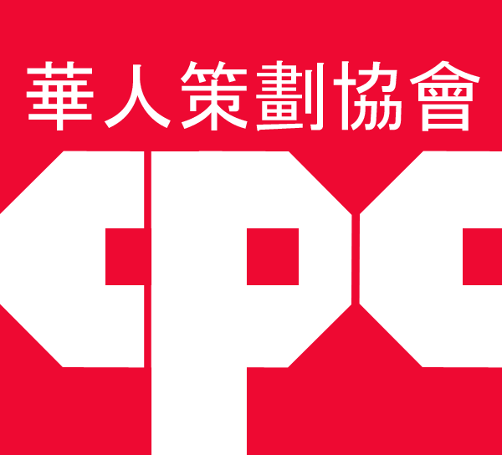
PROJECT REACH 39 Eldridge Street, 4th Floor NYC 10002 (212) 966-4227 ________________________________________________________________

With the support of Speaker Corey Johnson and the New York City Council
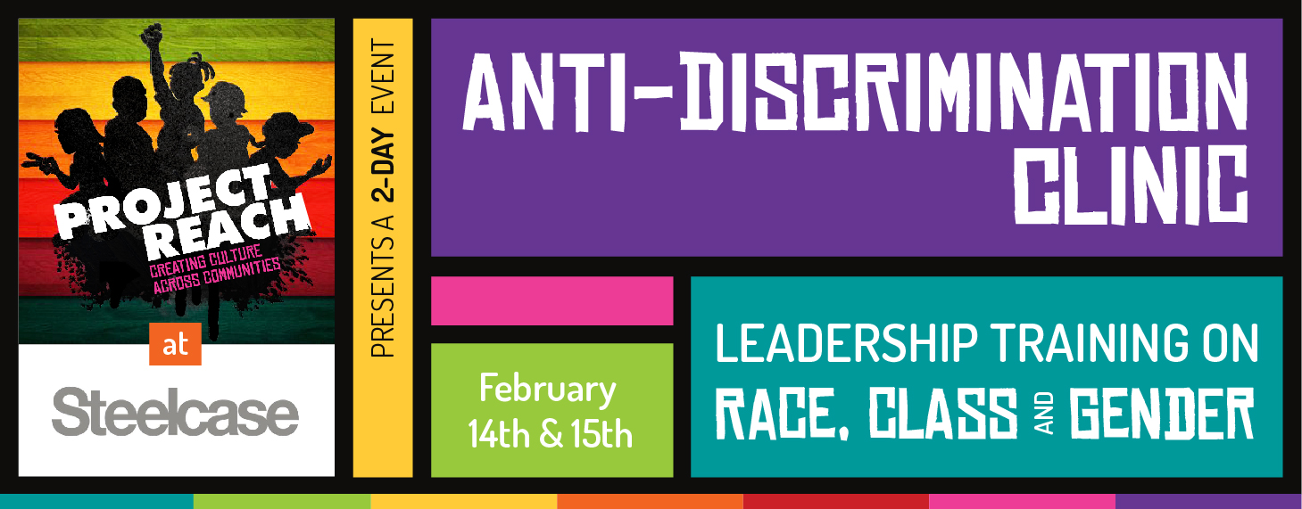
Steelcase WorkLife Center and Project Reach to host 2-day Anti-Discrimination Clinic
A 12-hour leadership training on Race, Class, and Gender

Forty-eight years ago (1971), Asian American community activists started Project Reach to provide services to Chinese immigrant youth, a direct response to the rise in Chinese youth gangs. Over 34 years ago (1985) in an action unprecedented among race-segregated youth programs, Project Reach opened its door to all young people and put in place an innovative and dynamic youth organizing training space where understanding and confronting discrimination and systemic oppression would form the foundation of its core youth organizing training curriculum.
Today, through its Social Justice Boot Camp and OUTRIGHT Consortium collaborations, Project Reach works with over 35 community-based organizations and schools in all 5 NYC boroughs and representing all 6 major racial communities. Through out-of-the-city Social Justice Boot Camp retreats in the Catskills, 5-borough youth summits, city-wide traveling, lgbt dinners, adult roundtable brunches, and cross-community exchanges (Shinnecock Reservation, Block Island School, RI, Catskills Mountain youth), Project Reach brings together young people and adults who would otherwise never meet.
Inter-group crisis intervention, awareness-building workshops, train-the-trainer series and clinics, and technical assistance to schools, community organizations, and other professional institutions have informed Project Reach’s work and development of its nationally recognized “organizing readiness” model and community empowerment curriculum. (Visit our website at www.projectreachnyc.org)
Drawing from its over 40 years of anti-discrimination and social justice training, Project Reach will offer a unique opportunity to individuals, organizations and schools to experience its most successful and impactful workshops. All people who are committed to ending discrimination and fighting for social justice are encouraged to attend.

ANTI-DISCRIMINATION Training Series

What: A 12-hour, 2-day, interactive, participant-centered, anti-discrimination training for communities and schools facing bullying/identity destruction, inter-group conflict, and community disempowerment but who are committed to ending discrimination and injustice and to institutionalizing substantive and sustainable culture change. Training will be limited to 40 attendees reflecting the geographic and racial diversity of New York City.
When: Thursday and Friday, February 14th and February 15th, 8:30am – 4:30pm.
Who: Principals, teachers, guidance counselors; Executive Directors, service providers, social workers, after-school staff; Parents and guardians of schools and community-based organizations in all 5 boroughs.
Requirements: Attendance at both all-day sessions. Registration Deadline: Mon, Feb 11, 2019
Registration Link: bit.ly/MNClinic2019
Where: Steelcase WorkLife Center, 4 Columbus Circle (corner of W. 58th St/8th Ave), NYC 10019
Trainers: Don Kao and Katherine Chambers – With over 40 years of training experience collectively, Project Reach’s training team has worked with educational, professional, community-based, and activist communities in New York City and nationally providing crisis intervention, program/organizational development, and technical assistance services.

DAY ONE

Welcome and Breakfast 8:30am – 9:30am
Session I 9:30am – 12:30pm
Diversity and Discrimination: Is there really a difference?
Have we achieved diversity? Does discrimination still exist? In this participant-centered, interactive workshop, we will use a boat, index cards, and masking tape….it's about "them" and it's about us. Come take the plunge and learn how misunderstanding "diversity" divides our multiracial, multi-gender, and seemingly disparate communities. We will look at discrimination outside ourselves and within our communities. Leave your guilt and fear at the door. This workshop is about developing practical responses to difficult situations.
Identity Crisis...or An Issue of Power and Privilege
What is Identity? Is Identity important? Using colored dots, an 8-foot Identity Chart, and self-disclosure, participants will introspectively map out what is important, safe, and empowering in their lives in order to better understand issues of power and privilege. How does our own perception of self impact the ways in which we work, address issues of cultural competence, and grow our abilities and skills in examining and challenging identity destruction and individual, community, and social disempowerment.

LUNCH 12:30pm – 1:30pm
Session II 1:30pm – 4:30pm
The Color Line: “Does skin color REALLY matter?”
“Do you treat people according to the color or shade of their skin?” In these times when increased diversity would suggest that interracial dating, trans-racial adoptions, and multiracial families are more accepted, what impact does the media’s promotion of beauty standards have on how we feel about our own and other’s race and skin color. This audience-driven workshop promises to explore how we “see” skin color and how our experiences, past and present, inform a more challenging and layered understanding of what racism and skin color have to do with dividing or building community.
The "Class" Closet: Being “Out" about Race and Class
The "class" closet - why is class background never really discussed? What is the relationship between race and class? Come join us in opening the last closet door...let's bring "class" back into the classroom. In this interactive workshop, a color line and class disclosure will provide a unique opportunity to understand ourselves and the impact of class and race on our work in People of Color, White, and multiracial communities.

DAY TWO
Breakfast and Check-in 8:30am – 9:30am

Session III 9:30am – 12:30pm
Homophobia/Heterosexism 101: For Straights ONLY…and anyone who ever thought they were!
An introspective, challenging, and engaging safe space where earliest memories, fears and apprehensions, and self-initiated disclosure will form the medium from which we will explore the root causes of homophobia and heterosexism and the all-to-often failure to recognize their interconnection to sexism and misogyny.
TRANSformative 101: Sex and Gender…the underpinnings of Sexism, Misogyny and Transphobia?
What is the difference between sex and gender? How do decisions about gender identity and gender expression promote liberation and freedom of choice but also perpetuate rigid gender conformity – particularly when one’s sex and gender do not match. How can what we learn from transgender and intersex communities, inform more effective and substantive strategies to ending sexism and misogyny.

LUNCH 12:30pm – 1:30pm

Session IV 1:30pm – 4:30pm
Model Minority or Manipulated Minority?
— The History of Racism in the U.S.: an Asian American Perspective
Through a quote, slide show, and 10-foot multiracial history time line, we will examine the origins of the “model minority" myth; explore the 170-year history of racism against Asians in the U.S.; see how racist media depictions of Black people (though political cartoons) were used to discredit and justify the exclusion of Asians from the U.S.; and better understand the ways Asians have been used to undermine other People of Color communities and movements for social change. In addition, the use of the multiracial history time line will reveal the interconnections of Native American, African American, Latina/o, Asian/Pacific Islander and Women’s herstories/histories to more clearly substantiate the "changing face of racism" over the past 500 years in the United States and world-wide.

Registration Deadline: Mon, Feb 11, 2019
To register, go to: bit.ly/MNClinic2019

For more information:
dkao@cpc-nyc.org or kchambers@cpc-nyc.org
Don - (917) 749-6116 or Katherine – (315) 664-8059

