Barnabas McHenry Hudson River Valley Awards
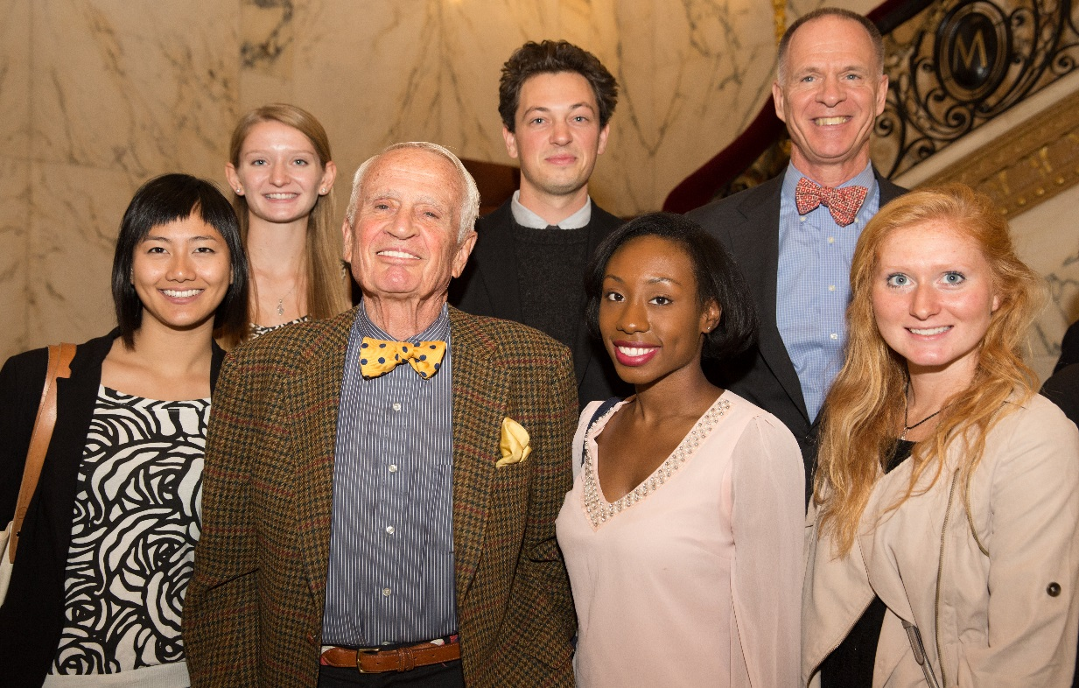
“Conservation is something we’ve got to do now. Because if we don’t do it now, we won’t ever get the chance to do it again.”
—Barney McHenry
The Barnabas McHenry Hudson River Valley Awards were created in 2007 to honor Barnabas McHenry’s extensive accomplishments and to foster future leaders in the Hudson River Valley. The Awards provide financial support to the pairing of young leaders with nonprofit organizations to conduct exemplary projects that make significant contributions to the Hudson River Valley. Each year, four grants are awarded in four distinctive disciplines: environmental conservation, historic preservation, tourism and the arts.
OSI has raised endowment pledges and commitments of $600,000 to date. Additional donations will allow OSI to further support the cultivation of the next generation of regional visionaries and their projects in the Hudson River Valley. Four awards of up to $5,000 per year are made annually. Any non-profit working in the Hudson Valley in the fields of environmental conservation, historic preservation, tourism, and/or the arts is eligible to nominate a candidate and project. An advisory committee selects the award winners.
Barney McHenry
For the past forty years, Barney McHenry has worked to protect the Hudson River Valley—its landscapes, heritage and culture. As counsel to DeWitt and Lila Acheson Wallace, founders of Reader’s Digest, he was the principal architect of the Wallace Funds, which have contributed to the arts, education, humanities, and the environment throughout the Hudson River Valley. He demonstrates his commitment to the region as a Member of the Palisades Interstate Park Commission, Chair of the Hudson River Valley Greenway Communities Council, Co-Chair of the Hudson River Valley Natural Heritage Area, President of Boscobel, and Trustee of both Friends of the Hudson Valley and the Open Space Institute.
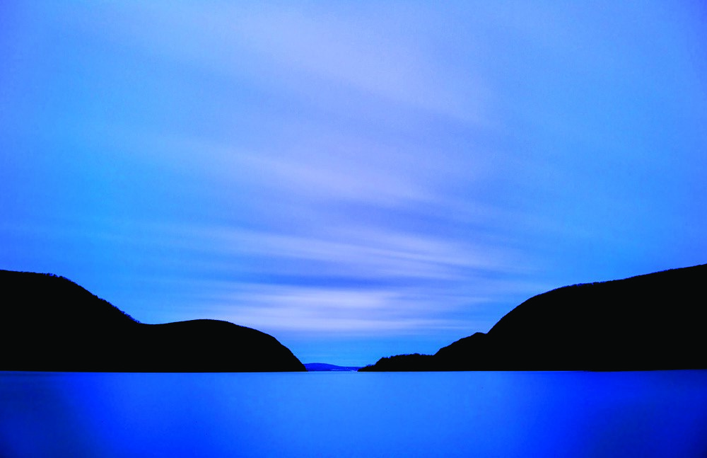
Michael Neal O’Donnell
McHenry Fellows

2007
Michael Diez, Historic Preservation, Boscobel
Completed a widely circulated research paper entitled “Loyalists in the Hudson Valley.”

Jenny Reisner, Arts, Historic Hudson Valley
Catalogued the William and Ruth Diebold Collection of Hudson River Prints.

Matt Weiner, Environmental Conservation, Mohonk Preserve
Upgraded the Preserve’s land easement monitoring system to comply with the national standards and practices of the land conservation field.

2008
Jessica Friedlander, Arts, The Hudson River Valley Institute and Walkway over the Hudson
Produced visual and written works that illustrate the history of the Poughkeepsie-Highland Railroad Bridge.

David Jakim, Environmental Conservation, Hudsonia Ltd.
Developed a database of ecologically significant habitats that landowners and municipal agencies can use to protect important biodiversity resources.

Alyson Mazzone, Historic Preservation, The Olana Partnership
Developed an historical exhibition about Fredric Church’s paintings of the Hudson River.
2009
Jesse Catalano, Environmental Conservation,
The Bedford Garden Club
Created the Sustainable Bedford website and developed the “Summit in a Box” guide that enables communities to hold their own environmental summits.

Melissa Kay Oles Gavilanes, Arts, The Thomas Cole National Historic Site
Developed afterschool programs and family education materials related to Thomas Cole.

Matthew Shook,
Historic Preservation, The Friends of the Palisades Parks Conservancy
Curriculum and teacher training and field guide for Sterling Forest’s Lakeville-Ironworks Trail.

2010
Aaron Ahlstrom, Arts, Historic Hudson Valley
Has “taken art to the landscape” by developing activities, lesson plans and teaching tools to assist educators as well as attract and encourage a younger age group to visit Montgomery Place.

Matthew Colon, Historic Preservation, Washington’s Headquarters
Digitized the slide collection of Washington’s Headquarters Archives to preserve and enhance the availability of the collection for public use (Jan 2011 completion).

Kate Ito, Environmental Conservation, Hudson River Watershed Alliance
Researched how a National Park designation can support the Hudson Valley’s economic, environmental, social and natural institutions.

Chelsea Sorrento, Tourism, Mohonk Preserve
Investigated the economic value of protected open space in the region and developing a marketing plan to showcase the advantages of protected open space for local communities (June 2011 completion).
2011
Alexandra Church, Historic Restoration, Newburgh Armory Unity Center
Completed a preliminary master plan for the 12-acre Newburgh Armory for the purpose of developing and implementing programs.

Cornelia Harris, Environmental Conservation, Cary Institute
Through a series of after-school workshops, led a summer program that trained students from Poughkeepsie Schools to become stewards of the Hudson River.

Sara Kendall, Arts, free103point9 Radio
Produced special exhibitions, led media training, and developed a news blog and local calendar for the community-run media project in Greene and Columbia counties.

Derrick Mead, Tourism, Glynwood
Mapped orchards, composed profiles of various orchard locations that produce apples and cider for the “Hudson Valley Cider Route” project.
2012
Meredith Clavin-Marquet, Arts, Orange County Citizens Foundation
Cataloged and digitized more than 400 original photos and letters from painter and sculptor Kurt Seligmann to mark the presence of Surrealism in Orange County.

Erin Hoagland, Tourism, Winnakee Land Trust
Developed an arboretum at the Winnakee Nature Preserve in Hyde Park. Erin’s project educates visitors about tree identification and environmental issues facing Hudson Valley forests.

Sarah Parks, Environmental Conservation, The Rensselaer Plateau Alliance
Generated GIS maps which are core to the Rensselaer Plateau Regional Conservation Plan. Sarah developed a Community Values Mapping effort that will provide additional data for the Conservation Plan.

Marissa Unger, Historic Preservation, Olana
Organized a symposium to explore the concept of viewsheds in a national context. The symposium, the third in a series, continued the conversation about how art and architecture have established the Hudson Valley’s signature character.

2013
Derrick Mead, Tourism, Glynwood
Mapped orchards, composed profiles of various orchard locations that produce apples and cider for the “Hudson Valley Cider Route” project.

Megan McClellan, Tourism, Woodstock Land Conservancy
Engaged community members, businesses and government in the creation of the Catskill Mountain Rail Trail. A key component was establishing a “Friends of the Catskill Mountain Rail Trail” Committee.

Christina Ritter, Historic Preservation, Hudson River Valley Institute
Created the “Dutchess County Social Studies Toolkit for Educators” for the Hudson River Valley Institute and Teaching the Hudson Valley.

Keith Shane, Environmental Conservation, NY-NJ Trail Conference
Keith monitored and removed invasive plants to control invasives in the PIPC and Taconic State Park regions in continued cooperation with the Lower Hudson Partnership for Regional Invasive Species Management.

2014
Sawyer Cresap, Historic Preservation, Preservation League of NYS
Published a grassroots guide to public participation in the Public Service Commission review process, with an emphasis on the role that historic and cultural resources and designation serve in the process.

Ben Himmelfarb, Historic Preservation, Shaker Heritage Society
Developed a Heritage Tourism plan as part of Partners for Albany Stories (PASt).

Samantha Singleton, Arts, Thomas Cole National Historic Site
Conducted inventory, organized, planned, and developed a recently donated collection of all known Thomas Cole letters, journals, drawings, paintings, exhibition records, articles, books and other documents for use by Thomas Cole staff and Fellows.
Katherine Sopko, Environmental Conservaion, Rondout Valley Growers’ Association
Produced a comprehensive profile of farming in the Rondout Valley and its contributions to the environmental, social, economic and historical fabric of the Hudson Valley.

2015
Julia Czarnecki and Marissa Porter, Environmental Conservation, Marist College
Organized a series of public seminars on leadership in sustainability in an attempt to bridge the disconnect between the public and climate change.

Michael Meehan, Environmental Conservation, Glynwood
Created a toolkit for the purpose of facilitating the baseline property assessment of agricultural properties by Partners in the Hudson Valley Farmlink Network.

Tashae K. Smith, Historic Preservation, Manhattanville College
Researched and presented to local and academic communities the history of enslaved and indentured African-American labor in the physical construction of the city of Newburgh, New York, with a particular focus on the period from the Revolutionary War to 1840.

Sheena Zhang, Urban Planning, Newburgh Community Land Bank
Researched opportunities for a Food Hub in historic downtown Newburgh that incorporates market aggregation of farm products in the region, value added processing and food incubator opportunities.

2016
Otto Ohle, Arts, Pratsville Art Project Inc.
Developed a series of multimedia digital workshops for rural youth that explored the experiences of young people growing up among the forests and mountain valleys of the Northern Catskills.

Nicole Pidala, Environmental Conservation, Hudson Highlands Land Trust
Updated the town’s Open Space Index and Open Areas Inventory within its Comprehensive Plan to guide long-term protection of the town’s ground and surface water, biodiversity, community character and recreation.

Maija Niemisto, Environmental Conservation, Hudson River Sloop Clearwater
Researched the distribution of fish and plankton in the Hudson River estuary via sonar.

Allison Montroy, Environmental Conservation, The Beacon Institute
Created an educational exhibit about the Hudson River that integrated digital art and real-time data from the River and Estuary Observatory Network.
2017
Miranda Fey Whitus, Historic Preservation,
Bard College
Created a genealogy and comprehensive history of the families connected to the historic Montgomery Place and Hudson Valley Through Collection Materials.
Michael Burke, Healthy Communities, Rondout Valley Growers Association
Created a model of community outreach that engages the next generation in addressing food insecurity through RVGA’S Farm to Food Pantry Program.
Anya Ptacek, Healthy Communities, Hudson Valley Seed
Designed and built four new educational gardens at elementary schools in Newburgh and Kingston where she taught healthy eating programs.
Molly Scott, Historic Preservation, Teaching the Hudson Valley
Created a comprehensive guide of Hudson Valley heritage sites associated with notable women or events related to women’s history to be used by K-12 Schools in the region.
Samantha Robinson, Environmental Conservation, Groundwork Hudson Valley
Lead the Green Team program as a youth leader and mentor during their weekly shift at the Yonkers’ Farmer’s Market and developed a one- hour curriculum surrounding urban agriculture and healthy communities.

2018
Christiano Liriano, Environmental Conservation,
Friends of Van Cortland Park
Worked with Friends of Van Cortland Park to contribute to a larger goal of ecological enhancement of six acres of Flood Plain Forest bordering Tibbett’s Brook, located within Van Cortland Park in the North West Bronx.

Robert Celestin, Environmental Conservation,
New York – New Jersey Trail Conference
Helped to preserve the region’s biodiversity by enabling more efficient, invasive species management by building a comprehensive database that integrates regional invasive plant data from several environmental agencies with geographic information mapping software.

Zachary Henderson, Environmental Conservation, Palisades Park Conservancy
Worked with Palisades Park Conservancy in an effort to make accessible PIPC’s William A. Welch archival collections. As the PIPC General Manager from 1914-1940, he also oversaw the construction of the Bear Mountain Inn, Henry Hudson Drive and Harriman’s lake.
Amanda Samuels, Historic Preservation, University at Albany
Worked with the University at Albany to create educational packages through collaboration with the Stockbridge-Munsee, the University at Albany and the Tribal Historic Preservation Officer to develop educational material to be used in university courses in archaeology and historic preservation.
2019
Grace Alli, Historic Preservation, Hudson Valley Initiative and Columbia University’s Graduate School of Architecture, Planning, and Preservation
Developed a toolbox that will communicate the policies and processes for turning city-owned vacant lots in Newburgh into temporary or permanent neighborhood amenities.

Ethan Scott Barnett, Historic Preservation, A.J. Williams-Myers African Roots Library
Helped establish Kingston, NY as one of the important African Heritage sites in the nation through research and interpretation of a local African burial ground. The Kingston burial ground will be a case study for establishing a community space where shared memory is honored and illustrated through the tensions of politics, history, and race.

Erin R. Clark, Tourism, Hudson Valley Pattern for Progress
Analyzed the tourism habits of college students and Millennials (19-38 years old) with a survey and analysis of MetroNorth outbound weekend ridership from NYC to the Hudson Valley.

(2019 Cont)
Lindsey Drew, Environmental Conservation, Woodstock Land Conservancy (WLC)
Helped assess and address impacts in the Sawkill Creek watershed, which includes the towns of Woodstock, Hurley, Kingston, and Ulster. The Sawkill waters contribute to the municipal water supply for seven Hudson River communities and more than 100,000 people.

Hannah Tremblay, Environmental Conservation, National Young Farmers Coalition (NYFC)
Researched issues farmers are facing in the Hudson Valley including land access policies designed to address the challenges of high land prices, intergenerational transition, and competition from non-farming buyers.

