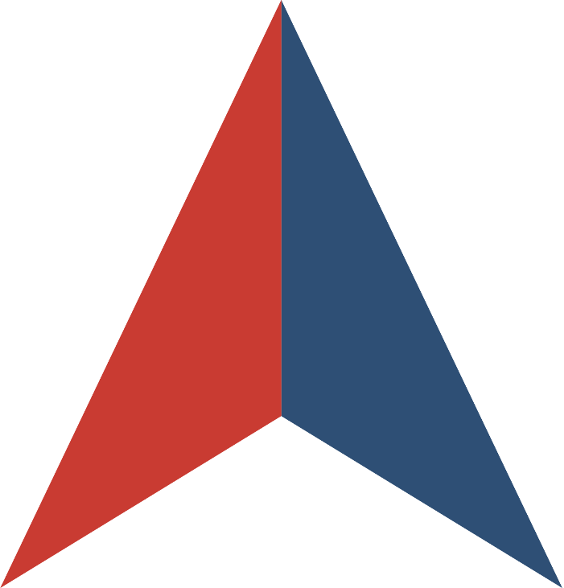

INVITATION FOR BID
for
WIC Infant Formula Rebate

Issued by
the STATE OF KANSAS

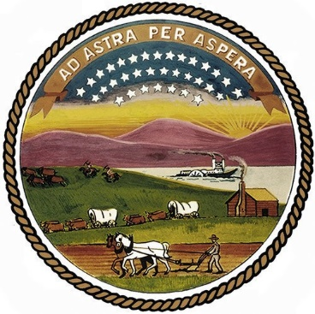
In collaboration with
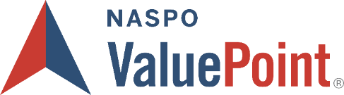

SOLICITATION NUMBER: EVT0009507
IFB WEBSITE: Kansas Public Procurement System
IFB OVERVIEW

- INTRODUCTION
This Invitation for Bids (IFB) is being issued by the State of Kansas (“Lead State”) in collaboration with the NASPO ValuePoint cooperative purchasing program. The purpose of this IFB is to establish one or more Master Agreements for WIC Infant Formula Rebate which will provide a rebate for iron-fortified infant milk-based and soy-based formulas in all physical forms (liquid concentrate, powder, and ready-to-feed) in their contract brand infant formula product line through the State Special Supplemental Nutrition Program for Women, Infants, and Children (WIC) retail distribution system.

The WIC Program is a federally funded nutrition education and supplemental food program, which was established in 1972 under federal Public Law 92-433. The Program was added as Section 17 of the Child Nutrition Act of 1966 and subsequently amended by the Healthy, Hunger Free Kids Act of 2010. Federal regulations implementing these laws are codified in 7 Code of Federal Regulations part 246.

The state of Kansas, in coordination with NASPO Value Point, is releasing this solicitation on behalf of Alaska, American Samoa, Arizona, Commonwealth of the Northern Mariana Islands (CNMI), Delaware, District of Columbia, Guam, Hawaii, Idaho, Inter Tribal Council of Arizona (ITCA), Inter-Tribal Council of Nevada (ITCN), Kansas, Maryland, Montana, Navajo Nation, Nevada, Oregon, Osage Nation, Pueblo of Isleta, Utah, U.S. Virgin Islands, Washington, West Virginia and Wyoming, hereafter referred to as the Participating Entities. Per federal regulations, no state or eligible organization can be added after this solicitation is released. This requirement shall remain in effect through the life of resulting contract.

About NASPO ValuePoint
NASPO ValuePoint is a division of the National Association of State Procurement Officials (NASPO), a non-profit association dedicated to advancing public procurement through leadership, excellence, and integrity. In accordance with NASPO ValuePoint’s Lead State Model™, the Lead State is issuing this IFB, evaluating responses, and establishing Master Agreements with the support and assistance of a Multistate Sourcing Team™ composed of individuals from other member states, representing a broad range of perspectives that ensure the IFB incorporates best practices recognized by public entities across the country.

Participation in NASPO ValuePoint Master Agreements is convenient and cost-effective for eligible entities—including state departments, institutions, agencies, and political subdivisions, federally recognized tribes, and other eligible public and nonprofit entities in the 50 states, the District of Columbia, and U.S. territories—and suppliers, with no membership or registration required. In 2021, contractors reported a combined $19.94 billion in sales through NASPO ValuePoint Master Agreements awarded through cooperative solicitations like this IFB, including a combined $879.58 million in sales through the current WIC Infant Formula Rebate portfolio.

More information about NASPO, NASPO ValuePoint, and the NASPO ValuePoint Lead State Model can be found at www.naspo.org and www.naspovaluepoint.org and in Attachment E, Participation Information.

- GENERAL INFORMATION AND INSTRUCTIONS
  - IFB Contact. The following individual is the sole contact for this IFB:
Bonnie Edwards
Deputy Director
State of Kansas
Bonnie.edwards@ks.gov
(785)-296-3125

  - IFB Website. The following website is the sole official source for IFB information and updates. The solicitation may be found by searching the solicitation number within the eProcurement portal. Any potential Offeror is also required to register their company at the link below:

    - Kansas eProcurement Portal
    - Kansas Offeror Registration

  - IFB Documents. This IFB consists of this IFB Overview, the following attachments, and any information or materials posted by the Lead State to the IFB Website, as amended:

    - Attachment A, IFB Terms and Conditions
    - Attachment B, Scope of Work
    - Attachment C, IFB Evaluation Plan
    - Attachment D, Sample Master Agreement
    - Attachment E, Participation Information
    - Attachment F, Protest Information
    - Attachment G, Offeror Information, Acknowledgements, and Certifications
    - Attachment H, Offeror Response Worksheet
    - Attachment I, Bid Proposal
    - Attachment J, Signed Amendments (any amendments issued by the Lead State must be reviewed, signed, and submitted with submission.
    - Attachment K, Claim of Business Confidentiality
    - Attachment L, Certification of Procurement
    - Attachment M, Tax Clearance Certificate
    - Attachment N, Certification Regarding Immigration Reform
    - Attachment O, Policy Regarding Sexual Harassment
    - Attachment P, Certification of Antiboycott of Israel
    - Attachment Q, Kansas WIC Event Details
    - Attachment R, Kansas Contractual Provisions – DA 146a
    - Exhibit 1, State WIC Data (Individual State folders with agency information, rebate invoice, and state information sheet) Exhibit 1 Link
    - Exhibit 2 – Milk Based and Soy Based Infants (average number of infants using infant formula by physical form)
    - Exhibit 3 – Total Infants Participating
    - Exhibit 4 – Milk and Soy Based Units (6 month history used for Bid Proposal)
    - Exhibit 5 – WIC FNS Resources Website (including access to ALL WIC Policy Memorandum referenced) - FNS Resource Link

  - Important Dates.
    - IFB Open Date: Wednesday, June 12, 2024
    - IFB Q&A Deadline: Wednesday, July 3, 2024 3:00 PM CST
    - IFB Close Date: Wednesday, July 24, 2024 2:00 PM CST
    - IFB Bid Opening: Bids will be publicly opened and read aloud on the day the bids are due (possible webinar or video call (recorded) at 2:30 PM CST.
    - IFB Award Date: As soon as possible upon review of the bids, such date no later than August 30, 2024.
No pre-proposal conference is scheduled for this Bid Event.
Questions requesting clarification of the Bid Event must be submitted via email (in MS Word format) to the Procurement Officer (Event Contact – Bonnie Edwards) indicated above prior to 3:00 PM CST on Wednesday, July 3, 2024. Each question or clarification should reference the appropriate Bid Event section.
Dates and deadlines are subject to change. Offerors should continue checking the IFB Website for the most up-to-date information.
  - How to Ask Questions.
    - Read and review this IFB, including all attachments, exhibits, and amendments.
    - For questions about the content of this IFB, send your questions via email to the IFB Contact listed above by the deadline stated. Questions must reference the specific section of the IFB to which the question relates.
    - For assistance with technical issues associated with the IFB Website, contact the IFB Contact, Bonnie Edwards.
    - Answers to questions will be available in the form of an amendment on the Procurement and Contracts' website, http://admin.ks.gov/offices/procurement-contracts. Offeror MUST sign and submit any amendments issued by the Lead State with its submission.
    - It shall be the responsibility of all participating Offerors to acquire any and all amendments and additional information as it is made available from the web site cited above. Offerors not initially invited to participate in this Bid Event must notify the Procurement Officer (Event Contact) of their intent to bid at least 24 hours prior to the event's closing date/time. Offerors are required to check the website periodically for any additional information or instructions.

  - How to Respond.
    - Read and review this IFB, including all attachments, exhibits, and amendments.
    - Prepare a proposal that:
      - Follows the requested format;
      - Includes the Solicitation Number on all materials making up the proposal;
      - Addresses each question and request for a response in this IFB, including all questions in Attachment H, Offeror Response Worksheet;
      - Clearly demonstrates your ability to meet the Scope of Work described in Attachment B; and
      - Includes all required submissions identified in Section IV below.
    - Receive Official Invite: if you are interested in bidding on this you MUST BE OFFICIALLY INVITED to the event. Contact the person named above, Bonnie Edwards, at least 24 HOURS BEFORE the official finish date and time to request the official invitation.
    - Submit your proposal by the IFB Close Date via email to procurement@ks.gov.
      - Cost Sheets submitted by Offeror should be separate from the rest of the submission packet.
    - It is the responsibility of the Offeror to ensure the bid date and time is met and the EVT number and company name is included in the subject line of the email. Offerors are encouraged to submit bids to the above email address no later than 1:45PM on the bid closing date. This allows time for staff to receive the bid and log it into our system prior to the bid closing at 2:00PM CST.
    - Bids are not considered received until they are date and time stamped in the Office of Procurement and Contracts. The Office of Procurement and Contracts will not be responsible for late deliveries.
    - Invitation for Bids (IFB) submissions will be publicly read as needed via telecom on the specified Bid Event Closing date beginning at 2:30pm CST.
Join on your computer or mobile app
Click here to join the meeting
Meeting ID: 251 517 806 960
Passcode: n7Dv2M

Or call in (audio only)
+1 785-414-8630,,780766580# United States, Topeka
Find a local number
Phone conference ID: 780 766 580#

    - Tab sheet requests for Invitation for Bids (IFB) can be requested by emailing tabsheets@ks.gov. Please include the EVT number on your request. Tab sheets will be emailed within five (5) business days of the request.
    - For questions regarding confirmation that your bid has been received by the Office of Procurement and Contracts, please call 785-296-2376.

- SCOPE OF WORK
A detailed description of the Deliverables being sought through this IFB is attached as Attachment B, Scope of Work.

The scope of this IFB and its resulting Master Agreement(s) is intended to benefit all NASPO WIC Alliance members and their state departments, institutions, agencies, and political subdivisions and other eligible public and nonprofit entities. Offerors should not interpret the Scope of Work to be associated with or limited to any specific purchase, implementation, project, need, or program within the Lead State or any other state or eligible entity. Proposals should be generally applicable to all potential Participating Entities and Purchasing Entities, except where specificity is requested.

The initial term of the Master Agreement(s) resulting from this IFB is anticipated to be 5 years. No renewals.

- OFFEROR RESPONSE
  - Required Submissions. The following must be submitted with your proposal:
    - Any response required to be submitted directly through the IFB Website;
    - Attachment G, Offeror Information, Acknowledgements, and Certifications – Completed and signed.
    - Attachment H, Offeror Response Worksheet - Completed
    - Attachment I, Bid Proposal, submitted as a separate document and separate file, if submitting electronically
    - Attachment J, Any amendments should be signed
    - Attachment K, Claim of Business Confidentiality – Completed and signed if applicable - Redacted copy of proposal clearly marked as such, if claiming confidential, proprietary, or protected information.
    - Attachment L Certification of Procurement (Kansas) – Completed and signed.
    - Attachment M Tax Clearance Certificate (Kansas) - Follow instructions to obtain doc.
    - Attachment N Certification Regarding Immigration Reform (Kansas) – Completed and signed.
    - Attachment O Policy Regarding Sexual Harassment (Kansas) – Completed and signed.
    - Attachment P Certification of Antiboycott of Israel (Kansas) – Completed and signed.
    - Attachment Q Kansas WIC Event Details Document – Completed and submitted

  - Other Documents. The following are informational only and do not need to be submitted with your proposal:
    - This IFB Overview
    - Attachment A, IFB Terms and Conditions
    - Attachment B, Scope of Work
    - Attachment C, IFB Evaluation Plan
    - Attachment D, Sample Master Agreement
    - Attachment E, Participation Information
    - Attachment F, Protest Information
    - Attachment R, Kansas Contractual Provisions – DA 146a
      - The State of Kansas, as the lead State, is required to post this document as part of the solicitation. This form is provided for transparency purposes and is not required to be reviewed, negotiated, or have questions asked as part of the bid submission. Should an Offeror be awarded and receive a Master Agreement, this document would be negotiated at the Participating Addendum (PA) level for ONLY the State of Kansas.
    - Exhibit 1, State WIC Data
      - The exhibit is listed as a link that contains several files for all State WIC Data. Exhibit 1 Link
    - Exhibit 2 – Milk Based and Soy Based Infants (average number of infants using infant formula by physical form
    - Exhibit 3 – Total Infants Participating
    - Exhibit 4 – Milk and Soy Based Units (6 month history used for Bid Proposal)

- EVALUATION AND AWARD PROCESS
  - Proposals will be sealed until the IFB Close Date. After opening, proposals will be evaluated in stages as set forth in this section and further detailed in Attachment C, IFB Evaluation Plan.

    - Stage 1: Initial Responsiveness Evaluation. Proposals will be reviewed for completeness and initial responsiveness. Proposals omitting required documents or responses may be rejected in accordance with Attachment A, IFB Terms and Conditions.
    - Stage 2: Mandatory Minimum Requirements Evaluation. Complete and responsive proposals will be reviewed for compliance with mandatory minimum requirements. Proposals failing to meet or exceed all Mandatory Minimum Requirements identified in Attachment C, IFB Evaluation Plan may be rejected in accordance with Attachment A, IFB Terms and Conditions.
    - Stage 3: Cost Evaluation. For each category (Soy and Milk Based) a single contract will be awarded for all line items to the Contractor with the responsive and responsible Offeror with the lowest total monthly net price for infant formula (subject to 7 C.F.R. § 246.2 and 7 C.F.R. § 246.16a (c) (4-7) (i-iv) for a standardized number of units of infant formula.

  - A Offeror has the option of bidding on (a) milk-based, Iron-Fortified Infant Formula; (b) soy-based, Iron-Fortified Infant Formula; or (c) both milk-based and soy-based, Iron-Fortified Infant Formulas. The milk-based, Iron-Fortified Infant Formula being bid must meet the requirements under 7 Code of Federal Regulations part 246.10(e)(1)(iii) and (e)(2)(iii) and be suitable for routine issuance to the majority of generally healthy, full-term infants. The soy-based, Iron-Fortified Infant Formula being bid must meet the requirements under 7 Code of Federal Regulations part 246.10(e)(1)(iii) and (e)(2)(iii).
  - After cost evaluations are completed, the Lead State will determine which Offeror provides the lowest total monthly net price to the WIC Alliance Members.
  - Prior to announcement of awards and execution of Master Agreements, the Lead State will present an award recommendation to NASPO ValuePoint for approval of the proposed awards.
  - Following approval of NASPO ValuePoint, the Lead State will notify the awarded Offeror.

