PORTFOLIO SNAPSHOT

OVERVIEW:
The RFxPremier Industrial Kitchen Supplies portfolio provides public agencies with access to commercial kitchen equipment, smallwares, infrastructure, and related support services through competitively solicited Master Agreement(s). Designed for K–12 schools, higher education, healthcare facilities, corrections, and government dining operations, this portfolio delivers compliant, cost-effective solutions to support safe and efficient foodservice environments.

KEY BENEFITS:

- This portfolio delivers competitively solicited, not-to-exceed pricing that helps public agencies reduce costs while eliminating the administrative burden of conducting their own procurement process.
- Provides a comprehensive, one-stop solution for commercial kitchen equipment, smallwares, infrastructure, and related services, including installation, maintenance, and training, ensuring institutions can efficiently manage their food service operations under a single cooperative contract.
- Qualified suppliers capable of nationwide delivery and proven public-sector experience, this portfolio ensures compliance, reliability, and streamlined purchasing for agencies across all 50 states.

Initial Term: February 19, 2026, through February 19, 2028

SOLICITATION INFORMATION:
- Type: Request for Proposals (RFP)
- RFP #: RFxP2503JZ
- Date Released: December 16, 2025
- Date Closed: January 16, 2026
- Number of Amendments Posted: 0
- Days Publicly Posted: 31

AWARD CATEGORY:
- Commercial Kitchen Equipment and Appliances
- Smallwares and Kitchen Accessories
- Supporting Infrastructure and Furnishings

PRICING:
Master Agreement pricing reflects uniform costs for both rental and direct purchases. See below for sample pricing description in both categories.

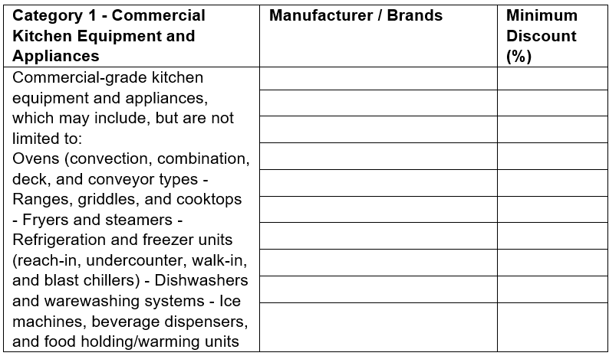

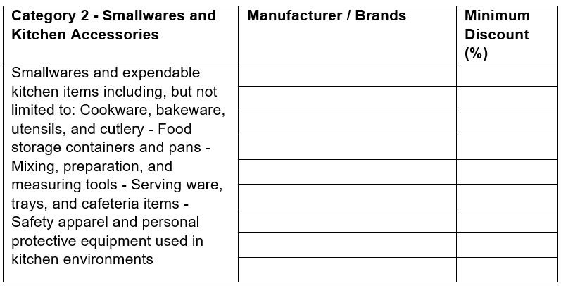

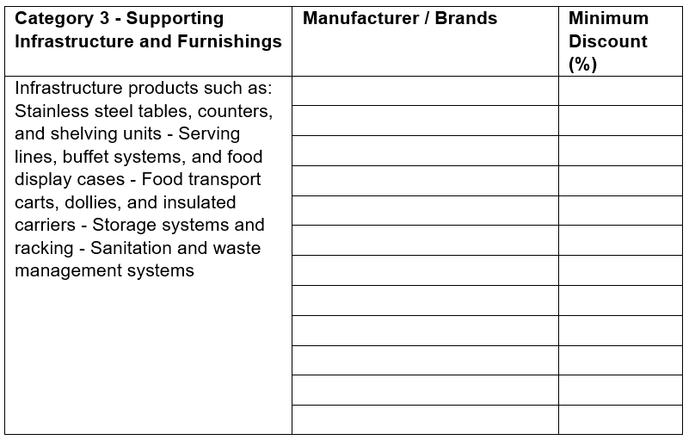

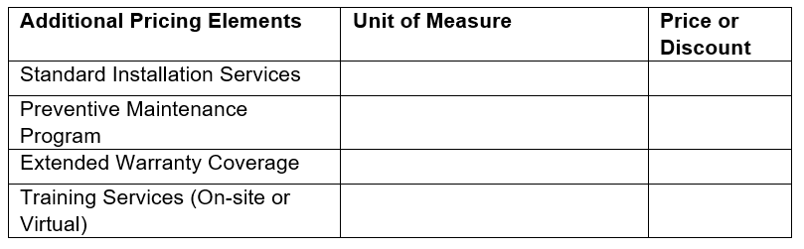

EVALUATION AND SCORING:
Stage 1: Mandatory Minimum Requirements Evaluation. Complete and responsive proposals were reviewed for compliance with the following Mandatory Minimum Requirements:

Criteria | Evaluation | Result
Offeror has been in continuous business operation providing industrial kitchen supplies, commercial kitchen equipment, or related services for a minimum of five (5) years. | Pass/fail
Offeror shall provide a minimum of three (3) references from governmental or public sector agencies (e.g., state, local, education, or nonprofit entities) for which the Offeror has provided equivalent products or services within the past five (5) years. | Pass/fail
Offeror affirms that they can provide sales and ship to all 50 United States, and all shipping shall be F.O.B. Destination (including Alaska and Hawaii), freight pre-paid. | Pass/fail
Offeror affirms to accept and fulfill orders from all eligible Purchasing Entities. | Pass/fail
Stage 1 Result:

Proposals failing to meet or exceed all Mandatory Minimum Requirements were subject rejection.

Stage 2: Technical Criteria Evaluation. Proposals meeting or exceeding the Mandatory Minimum Requirements were evaluated against the following Technical Criteria. The Evaluation Team evaluated and scored all Responsive Proposals submitted by Responsible Offerors in accordance with the Technical Criteria.

Criteria | Technical Points Possible | Offeror’s Technical Points Earned
Contractor Experience | 150
Order Processing and Distribution | 150
Products, Services and Solutions | 200
Customer Service and Support | 125
Delivery, Unloading, and Installation | 75
Preventive Maintenance Programs | 25
Training and Education | 25
Implementation and Promotion of the RFxPremier Master Agreement | 50
Stage 2 Total: | 800

Stage 3: Cost Evaluation. Cost Proposals for proposals not rejected following evaluation of Technical Criteria were evaluated. The cost proposals were ranked based on the highest minimum discount offered across the categories offered. The proposals with the highest minimum discount were awarded all 200 points, and then the others were normalized and ranked.

Cost | Cost Points Possible | Offeror’s Technical Points Earned
Cost Evaluation: | 200
Stage 3 Total: | 200

AWARD:
In alignment with the solicitation, two awards have been made for Industrial Kitchen Supplies. RFxPremier awarded contracts to Culinary Depot and The Wasserstrom Company.

