Attachment 05
PARTICIPATION INFORMATION

The NASPO ValuePoint Process
The NASPO ValuePoint Lead State Model™ is a collaborative procurement process representing the input and interests of public entities across the nation.
THE LEAD STATE MODEL™
 | Members & Stakeholders Identify Shared Cooperative Contracting Needs
 | NASPO ValuePoint Engages Lead State & Multistate Sourcing Team
 | Members & Stakeholders Provide Input on RFP Specifications & Objectives
  RFP | Lead State Issues RFP in Compliance with Lead State Laws
 | Lead State & Multistate Sourcing Team Evaluate Supplier Proposals
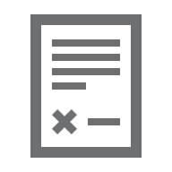 | Lead State Negotiates & Executes Master Agreements
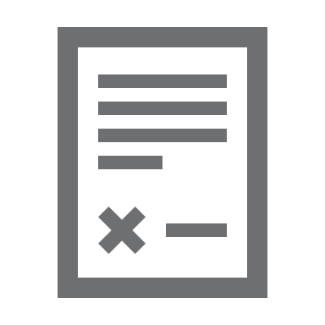 | Participating States & Entities Execute Participating Addenda
 | Purchasing Entities Buy Directly from NASPO ValuePoint Contractors

NASPO ValuePoint does not charge fees to Participating Entities or Purchasing Entities—including state departments, institutions, agencies, and political subdivisions, federally recognized tribes, and other eligible public and nonprofit entities in the 50 states, the District of Columbia, and U.S. territories—to use NASPO ValuePoint Master Agreements. Suppliers pay only a nominal administrative fee based on their total sales. By leveraging the collective volume of potential purchases nationwide, NASPO ValuePoint is able to offer customers the best value in cooperative contracting while giving suppliers the opportunity to reach multiple markets through a single solicitation.
Historical Usage
The following table identifies total sales reported by Electronic Monitoring contractors through NASPO ValuePoint Master Agreements over the past five (5) calendar years:
Year | Reported Historical Sales Volume
2021 | $30.24M
2022 | $30.56M
2023 | $27.38M
2024 | $29.09M
2025 (3 quarters reported) | $20.88M
No minimum or maximum level of sales volume is guaranteed or implied.
Interested States
The states below have requested to be named in this RFP as potential participants in the resulting Master Agreement(s). This list neither guarantees execution of a Participating Addendum by an Interested State nor precludes execution of a Participating Addendum by any state or entity not identified as an Interested State.
Interested States | Reported Estimated Annual Volume | Sample Participating Addendum Terms and Conditions
Oregon | $500,000 | Attached
Utah | $330,000 | Attached
Connecticut | $4,500,000 | Attached
Hawaii | $228,000 | Attached
Alaska | not available | Attached
Washington | $ 800,000 | Attached
Nevada | Not available | Attached
Maine | Not available | Attached
New Mexico | Not available | Attached

TOTAL ESTIMATED ANNUAL VOLUME FROM INTERESTED STATES: $6,358,000
The Reported Estimated Annual Volume above aggregates usage estimates, self-reported by the Interested States, which may be based on any factor considered relevant by each Interested State, including historical usage and anticipated future usage. No minimum or maximum level of sales volume is guaranteed or implied.
Some Interested States have also provided state-specific terms and conditions, included in this attachment, that may apply to a Participating Addendum executed with an Offeror awarded a Master Agreement through this RFP. These terms and conditions are being provided for informational purposes only and will not be incorporated into the Master Agreement or addressed or negotiated by the Lead State. Participation and the terms and conditions applicable to each Participating Entity will be determined by the Participating Entity following negotiation of a Participating Addendum with a Contractor.

