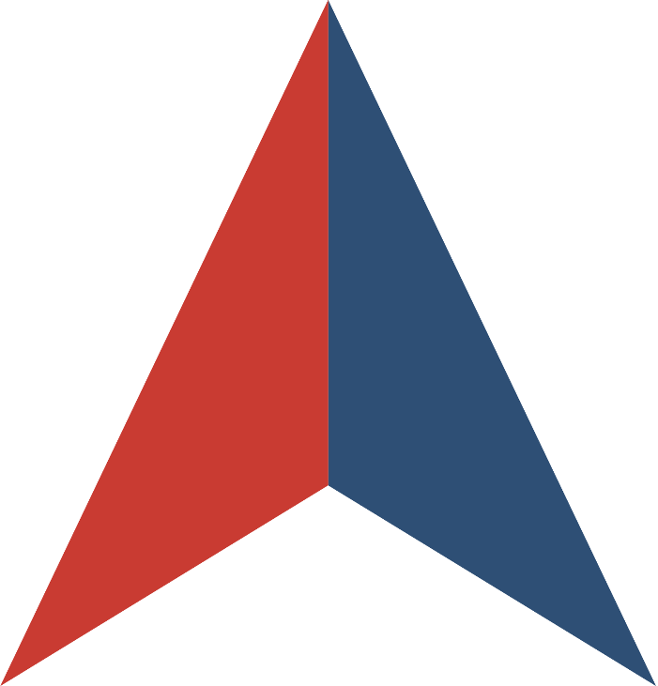

REQUEST FOR PROPOSALS
for
ELECTRONIC MONITORING

Issued by
the STATE OF NEVADA



In collaboration with


SOLICITATION NUMBER 99SWC-S3474
RFP WEBSITE: https://nevadaepro.com/bso/
RFP OVERVIEW

- INTRODUCTION
This Request for Proposals (RFP) is being issued by the State of Nevada (“Lead State”) in collaboration with the NASPO ValuePoint cooperative purchasing program. The purpose of this RFP is to establish one or more Master Agreements for Electronic Monitoring.
The RFP includes but is not limited to, Global Positioning System (GPS) Monitoring, Radio Frequency Monitoring (RFM), and Alcohol Monitoring (AM). Installation, maintenance, and support of the equipment is also included as part of the Scope of Work. The intent is to establish multiple contracts with reliable, secure, and cost-effective Contractors that promote compliance with Participating Entity supervision conditions and promotes the successful management of monitored individuals.

About NASPO ValuePoint
NASPO ValuePoint is a division of the National Association of State Procurement Officials (NASPO), a non-profit association dedicated to advancing public procurement through leadership, excellence, and integrity. In accordance with NASPO ValuePoint’s Lead State Model™, the Lead State is issuing this RFP, evaluating responses, and establishing Master Agreements with the support and assistance of a Multistate Sourcing Team™ composed of individuals from other member states, representing a broad range of perspectives that ensure the RFP incorporates best practices recognized by public entities across the country.
Participation in NASPO ValuePoint Master Agreements is convenient and cost-effective for eligible entities—including state departments, institutions, agencies, and political subdivisions, federally recognized tribes, and other eligible public and nonprofit entities in the 50 states, the District of Columbia, and U.S. territories—and suppliers, with no membership or registration required. In 2024, contractors reported a combined $21 billion in sales through NASPO ValuePoint Master Agreements awarded through cooperative solicitations like this RFP, including a combined $29 million in sales through the current Electronic Monitoring portfolio.
More information about NASPO, NASPO ValuePoint, and the NASPO ValuePoint Lead State Model can be found at www.naspo.org and www.naspovaluepoint.org and in Attachment 05, Participation Information.
- GENERAL INFORMATION AND INSTRUCTIONS
  - RFP Contact. The following individual is the single point of contact for this RFP:
Joel Smedes
Purchasing Officer II
State of Nevada
775-531-3312
j.smedes@admin.nv.gov
Offerors and their representatives shall only contact the single point of contract or use the electronic procurement system regarding this solicitation until after a notice of award (NOA) has been issued. Failure to observe this restriction may result in disqualification of a response per NAC 333.155(3).
  - RFP Website. The following website is the sole official source for RFP information and updates:
https://nevadaepro.com/bso/
Pursuant to NRS 333.313, Offeror must be registered at www.nevadaepro.com to respond to the solicitation. Offeror information must match Nevada business license and sam.gov entity registration. Offeror information in www.nevadaepro.com will be used for contract formation. Email address(es) associated with general mailing address or default bid mailing address (if different from general mailing address) in www.nevadaepro.com will be used for formal notifications. If a vendor has a different contact name and email for negotiations, that should be indicated on the title page(s) of their response.
  - RFP Documents. This RFP consists of this RFP Overview, the following attachments, and any information or materials posted by the Lead State to the RFP Website, as amended:
    - Attachment 01, RFP Terms and Conditions
    - Attachment 02, Scope of Work
    - Attachment 03, RFP Evaluation Plan
    - Attachment 04, Sample Master Agreement
    - Attachment 05, Participation Information
    - Attachment 06, Protest Information
    - Attachment 07, Offeror Information, Acknowledgements, and Certifications
    - Attachment 08, Offeror Response Worksheet
    - Attachment 09, Cost Proposal Instructions
    - Attachments for Cost Proposal, 09.1, 09.2, 09.3, 09.4 (Cost Proposals per Category)
    - Attachment 10, Proposed Modifications to Sample Master Agreement
    - Attachment 11, Claim of Business Confidentiality
  - Important Dates.
    - RFP Open Date: [date/time or “See RFP Open Date on RFP Website”]
    - RFP Q&A Deadline: [date/time or “See RFP Q&A Close Date on RFP Website”]
    - RFP Close Date: [date/time or “See RFP Close Date on RFP Website”]
Dates and deadlines are subject to change. Offerors should continue checking the RFP Website for the most up-to-date information.
  - How to Ask Questions.
    - Read and review this RFP, including all attachments, exhibits, and amendments.
    - All questions regarding this solicitation shall be submitted using the bid Q&A feature at nevadaepro.com. Questions must reference the specific section of the RFP to which the question relates.

  - How to Respond.
    - Read and review this RFP, including all attachments, exhibits, and amendments.
    - Prepare a proposal that:
      - Follows the requested format;
      - Includes the Solicitation Number on all materials making up the proposal;
      - Addresses each question and request for a response in this RFP, including all questions in Attachment 08 Offeror Response Worksheet;
      - Clearly demonstrates your ability to meet the Scope of Work described in Attachment 02; and
      - Includes all required submissions identified in Section IV.
    - Submit your proposal by the RFP Close Date via www.nevadaepro.com.
- SCOPE OF WORK
A detailed description of the Deliverables being sought through this RFP is attached as Attachment 02, Scope of Work.
The scope of this RFP and its resulting Master Agreement(s) is intended to benefit all state departments, institutions, agencies, and political subdivisions and other eligible public and nonprofit entities in the 50 states, the District of Columbia, and U.S. territories. Therefore, Offerors should not interpret the Scope of Work to be associated with or limited to any specific purchase, implementation, project, need, or program within the Lead State or any other state or eligible entity. Proposals should be generally applicable to all potential Participating Entities and Purchasing Entities, except where specificity is requested.
The initial term of the Master Agreement(s) resulting from this RFP is anticipated to be two years, with the option to exercise renewals totaling up to an additional four years following the initial term, upon mutual agreement by the Lead State and Contractor.

- OFFEROR RESPONSE
  - Required Submissions. The following must be submitted with your proposal:
    - Any response required to be submitted directly through the RFP Website www.nevadaepro.com;
    - Completed and signed Attachment 07 Offeror Information, Acknowledgements, and Certifications
    - Completed Attachment 08, Offeror Response Worksheet
    - Completed Attachment 09.1, 09.2, 09.3, 09.4, Cost Proposal, by Category, submitted as a separate document and separate file
    - Completed Attachment 10, Proposed Modifications to Sample Master Agreement
    - Redlined copy of Attachment 04 Sample Master Agreement, if proposing modifications
    - Completed and signed Attachment 11, Claim of Business Confidentiality
    - Redacted copy of proposal clearly marked as such, if claiming confidential, proprietary, or protected information
  - Other Documents. The following are informational only and do not need to be submitted with your proposal:
    - This RFP Overview
    - Attachment 01, RFP Terms and Conditions
    - Attachment 02, Scope of Work
    - Attachment 03, RFP Evaluation Plan
    - Attachment 04, Sample Master Agreement
    - Attachment 05, Participation Information
    - Attachment 06, Protest Information
    - Attachment 09, Cost Proposal Instructions

- EVALUATION AND AWARD PROCESS
  - Proposals will be sealed until the RFP Close Date. After opening, proposals will be evaluated in stages as set forth in this section and further detailed in Attachment 03, RFP Evaluation Plan.
    - Stage 1: Initial Responsiveness Evaluation. Proposals will be reviewed for completeness and initial responsiveness. Proposals omitting required documents or responses may be rejected in accordance with Attachment 01, RFP Terms and Conditions.
    - Stage 2: Mandatory Minimum Requirements Evaluation. Complete and responsive proposals will be reviewed for compliance with mandatory minimum requirements. Proposals failing to meet or exceed all Mandatory Minimum Requirements identified in Attachment 03, RFP Evaluation Plan may be rejected in accordance with Attachment 01, RFP Terms and Conditions.
    - Stage 3: Technical Criteria Evaluation. Proposals meeting or exceeding the Mandatory Minimum Requirements will be evaluated against the Technical Criteria set forth in Attachment 03, RFP Evaluation Plan. Offerors earning a minimum of 420 (60% of 700) points will move on to Stage 4: Cost Evaluation. The proposal of any Offeror not earning the minimum of 420 points will be rejected.
    - Stage 4: Cost Evaluation. Cost Proposals for proposals not rejected following evaluation of Technical Criteria will be evaluated by the Multistate Sourcing Team. Cost Proposals may also be subject to an independent review for reasonableness and best value by the Lead State. Costs determined not to be reasonable or best-value by the Lead State may result in all or part of Offeror’s proposal being rejected, notwithstanding the results of the Cost Proposal evaluation.

  - After evaluations are completed, the Lead State and Multistate Sourcing Team will determine which proposals are most advantageous to the Lead State and potential Participating Entities and Purchasing Entities. Methods used to make this determination may include, but are not limited to, one or more of the following:
- Identification of a natural break in total scores
- Identification of a minimum scoring threshold above which Proposers are deemed to be adequately qualified
- Consideration of the optimal number of Contractors required to successfully supply Deliverables to Participating Entities and Purchasing Entities
  - Prior to announcement of awards and execution of Master Agreements, the Lead State will present an award recommendation to NASPO ValuePoint for approval of the proposed awards.
  - Following approval of NASPO ValuePoint the Lead State will post a public notice of an Intent to Award and begin negotiations with successful Offeror(s).

