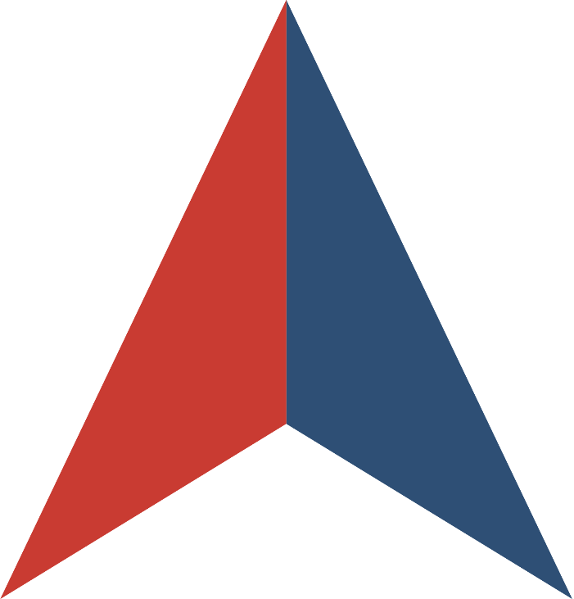

REQUEST FOR PROPOSALS
for
ELECTRIC VEHICLE CHARGING STATION EQUIPMENT AND SERVICES

Issued by
the STATE OF MARYLAND

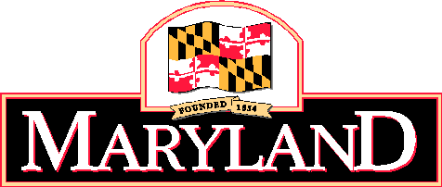

In collaboration with


SOLICITATION NUMBER # BPM037964
RFP WEBSITE: https://emma.maryland.gov
RFP OVERVIEW

- INTRODUCTION
This Request for Proposals (RFP) is being issued by the State of Maryland (“Lead State”) in collaboration with the NASPO ValuePoint cooperative purchasing program. The purpose of this RFP is to establish one or more Master Agreements for Electric Vehicle Charging Station Equipment and Services.

The solicitation is intended provide comprehensive EV Charging Station Solutions and Support for Participating Entities within the following Award Categories:

  - Category 1: Level 2 – EV Chargers (Hardware/Software/Support Services); and

  - Category 2: Level 3 – DC Fast Chargers (Hardware/Software/Support Services).
The scope for these two Award Categories includes all hardware (inclusive of original equipment purchases and replacement parts), software, and support services (i.e., training, repair, professional services, consulting services, project development, etc.) to develop, install, maintain, and repair the applicable Level 2 or 3 charging station.
Where an Offeror submits a proposal to both Award Categories, Offeror’s Technical proposals will be evaluated as a whole, based on the Category(ies) they are seeking an award in. Offeror should therefore submit a single combined Technical proposal, regardless of the number of Categories seeking an award in. An Offeror may submit a Cost for one or both categories. The Cost proposals will be evaluated only against the category submitted.
About NASPO ValuePoint
NASPO ValuePoint is a division of the National Association of State Procurement Officials (NASPO), a non-profit association dedicated to advancing public procurement through leadership, excellence, and integrity. In accordance with NASPO ValuePoint’s Lead State Model™, the Lead State is issuing this RFP, evaluating responses, and establishing Master Agreements with the support and assistance of a Multistate Sourcing Team™ composed of individuals from other member states, representing a broad range of perspectives that ensure the RFP incorporates best practices recognized by public entities across the country.
Participation in NASPO ValuePoint Master Agreements is convenient and cost-effective for eligible entities—including state departments, institutions, agencies, and political subdivisions, federally recognized tribes, and other eligible public and nonprofit entities in the 50 states, the District of Columbia, and U.S. territories—and suppliers, with no membership or registration required. In 2021, contractors reported a combined $16.94 billion in sales through NASPO ValuePoint Master Agreements awarded through cooperative solicitations like this RFP. This RFP constitutes the first iteration of a NASPO ValuePoint established portfolio for Electric Vehicle Charging Station Equipment and Services.
More information about NASPO, NASPO ValuePoint, and the NASPO ValuePoint Lead State Model can be found at www.naspo.org and www.naspovaluepoint.org and in Attachment E, Participation Information.
- GENERAL INFORMATION AND INSTRUCTIONS
  - RFP Contact. The following individual is the sole contact for this RFP:
Matthew Smith
Procurement Officer
State of Maryland
Matthew.smith2@maryland.gov / (410) 767-3039

  - RFP Website. The following website is the sole official source for RFP information and updates:
https://emma.maryland.gov

    - eMaryland Marketplace Advantage (eMMA)
    - eMMA is the electronic commerce system for the State of Maryland. The Solicitation Conference summary and attendance sheet, Offeror’s questions and the Procurement Officer’s responses, addenda, and other solicitation-related information will be made available via eMMA.
    - In order to receive a contract award, a vendor must be registered on eMMA. Registration is free. Go to emma.maryland.gov, click on “New Vendor? Register Now” to begin the process, and then follow the prompts.
    - If the RFP is revised before the due date for Proposals, the State of Maryland shall post any addenda to the RFP on eMMA and shall endeavor to provide such addenda to all prospective Offerors that were sent this RFP or are otherwise known by the Procurement Officer to have obtained this RFP. It remains the responsibility of all prospective Offerors to check eMMA for any addenda issued prior to the submission of Proposals.
    - Proposals shall only be accepted via the State’s internet based electronic procurement system, eMMA. Offerors may not mail or hand-deliver Proposals.
    - Assistance with eMMA can be found at emma.helpdesk@maryland.gov.

  - RFP Documents. This RFP consists of this RFP Overview, the following attachments, and any information or materials posted by the Lead State to the RFP Website, as amended:
    - Attachment A, RFP Terms and Conditions
    - Attachment B, Scope of Work
    - Attachment C, RFP Evaluation Plan
    - Attachment D, Sample Master Agreement
    - Attachment E, Participation Information
    - Attachment F, Protest Information
    - Attachment G, Offeror Information, Acknowledgements, and Certifications
    - Attachment H, Offeror Response Worksheet
    - Attachment I, Cost Proposal
    - Attachment J, Proposed Modifications to Sample Master Agreement
    - Attachment K, Claim of Business Confidentiality
    - Attachment L, Bid / Proposal Affidavit
    - Attachment M, Conflict of Interest Affidavit and Disclosure
    - Attachment N, Mercury Affidavit
    - Attachment O, Contract Affidavit
  - Important Dates.
    - RFP Open Date: July 14, 2023
    - RFP Q&A Deadline: August 7, 2023
    - RFP Close Date: August 23, 2023 2:00 PM Eastern Time.
IMPORTANT: There will be a pre-bid conference held via Google Meet. The information is provided below:
Pre-Bid Conference: July 31, 2023 2pm Eastern Time
EV Charging Station Pre Bid Conference
Monday, July 31 · 2:00 – 3:00pm Local
Google Meet joining info
Video call link: https://meet.google.com/yuk-odyq-des
Or dial: ‪(US) +1 402-839-8289‬ PIN: ‪515 104 311‬#
Dates and deadlines are subject to change. Offerors should continue checking the RFP Website for the most up-to-date information.
  - How to Ask Questions.
    - Read and review this RFP, including all attachments, exhibits, and amendments.
    - For questions about the content of this RFP, send your questions via the “Discussion + Q&A” tab through eMMA. Questions must reference the specific section of the RFP to which the question relates.
    - For assistance with technical issues associated with the RFP Website, contact eMMA support desk at emma.helpdesk@maryland.gov and/or state e-procurement administrator contact information.
  - How to Respond.
    - Read and review this RFP, including all attachments, exhibits, and amendments.
    - Prepare a proposal that:
      - Follows the requested format;
      - Includes the Solicitation Number on all materials making up the proposal;
      - Addresses each question and request for a response in this RFP, including all questions in Attachment H, Offeror Response Worksheet, Attachment I Cost Proposal, and provided affidavits (Attachment L, M, and N);
      - Clearly demonstrates your ability to meet the Scope of Work described in Section III (below) and Attachment B; and
      - Includes all required submissions identified in Section IV (below).
    - Submit your proposal by the RFP Close Date via eMMA portal.

- SCOPE OF WORK
A detailed description of the Deliverables being sought through this RFP is attached as Attachment B, Scope of Work.
The scope of this RFP and its resulting Master Agreement(s) is intended to benefit all state departments, institutions, agencies, and political subdivisions and other eligible public and nonprofit entities in the 50 states, the District of Columbia, and U.S. territories. Therefore, Offerors should not interpret the Scope of Work to be associated with or limited to any specific purchase, implementation, project, need, or program within the Lead State or any other state or eligible entity. Proposals should be generally applicable to all potential Participating Entities and Purchasing Entities, except where specificity is requested.
The initial term of the Master Agreement(s) resulting from this RFP is anticipated to be three (3) years with two, 1-year renewal options. Renewal options must be executed upon mutual agreement by the Lead State and Contractor. Master Agreement term including renewal options not to exceed five years.

- OFFEROR RESPONSE
  - Required Submissions. The following must be submitted with your proposal:
    - Any response required to be submitted directly through the RFP Website;
    - Redacted copy of proposal clearly marked as such, if claiming confidential, proprietary, or protected information
    - Attachment D, Redlined copy of Sample Master Agreement, if proposing modifications.
    - Attachment G, Offeror Information, Acknowledgements, and Certifications, completed and signed.
    - Attachment H, Offeror Response Worksheet, Completed
    - Attachment I, Cost Proposal, submitted as a separate document and separate file, Completed.
    - Attachment J, Proposed Modifications to Sample Master Agreement, Completed.
    - Attachment K, Claim of Business Confidentiality, completed and signed.
    - Attachment L, Bid/Proposal Affidavit, completed and signed
    - Attachment M, Conflict of Interest Affidavit and Disclosure, completed and signed.
    - Attachment N, Mercury Affidavit, completed and signed
    - Attachment O, Contract Affidavit, completed and signed

  - Other Documents. The following are informational only and do not need to be submitted with your proposal:
    - This RFP Overview
    - Attachment A, RFP Terms and Conditions
    - Attachment B, Scope of Work
    - Attachment C, RFP Evaluation Plan
    - Attachment D, Sample Master Agreement, if NO redlines submitted
    - Attachment E, Participation Information
    - Attachment F, Protest Information
V. EVALUATION AND AWARD PROCESS
  - Proposals will be sealed until the RFP Close Date. After opening, proposals will be evaluated in stages as set forth in this section and further detailed in Attachment C, RFP Evaluation Plan.
    - Stage 1: Initial Responsiveness Evaluation. Proposals will be reviewed for completeness and initial responsiveness. Proposals omitting required documents or responses may be rejected in accordance with Attachment A, RFP Terms and Conditions.

    - Stage 2: Mandatory Minimum Requirements Evaluation. Complete and responsive proposals will be reviewed for compliance with mandatory minimum requirements. Proposals failing to meet or exceed all Mandatory Minimum Requirements identified in Attachment C, RFP Evaluation Plan may be rejected in accordance with Attachment A, RFP Terms and Conditions.
    - Stage 3: Technical Criteria Evaluation. Proposals meeting or exceeding the Mandatory Minimum Requirements will be evaluated against the Technical Criteria set forth in Attachment C, RFP Evaluation Plan. Offerors earning a minimum of 70% of available Technical Points will move on to Stage 4: Cost Evaluation.

    - Stage 4: Cost Evaluation. Cost Proposals not rejected following evaluation of Technical Criteria will be evaluated. Costs will be scored as detailed further within Attachment C – RFP Evaluation Plan. Cost Proposals may also be subject to an independent review for reasonableness and best value by the Lead State. Costs determined not to be reasonable or best-value by the Lead State may result in all or part of Offeror’s proposal being rejected, notwithstanding the results of the Cost Proposal evaluation.

    - Evaluation Summary: After the calculation of Cost Proposals, the technical and cost points will be combined to determine Offerors Total Points earned:
Stage | Total Points Possible | Offeror’s Total Points Earned
Technical Criteria Evaluation (Stage 3) | 700
Cost Evaluation (Stage 4) | 300
Total | 1000

    - Best and Final Offer (BAFO). The Lead State reserves the right to conduct discussions with the Offerors who submit proposals determined to be reasonably susceptible of being selected for award, followed by an opportunity to make best and final offers pursuant to COMAR 21.05.0303 but proposals may be accepted without discussions. When in the best interest of the State, the procurement officer may permit qualified offerors to revise their initial proposals by submitting best and final offers. The procurement officer shall establish a common date and time for the submission of best and final offers. The procurement officer may require more than one series of submissions of best and final offers and discussions if the agency head or designee makes a written determination that it is in the State's best interest to conduct additional discussions or change the procurement agency's requirements and require another submission of best and final offers.
    - The Lead State has the authority per COMAR 21.06.03.10 to make a multiple award per the criteria and threshold above. The intent is to provide Master Agreements that will be able to provide goods and services to the Members of NASPO which is best fulfilled via a multiple award.
  - After evaluations are completed, the Lead State and Multistate Sourcing Team will determine which proposals are most advantageous to the Lead State and potential Participating Entities and Purchasing Entities. Final evaluations, including evaluation of the recommendation of the evaluation committee, if any, shall be performed by the Lead State procurement officer. Prior to announcement of awards and execution of Master Agreements, the Lead State in coordination with its Chief Procurement Officer shall make a final recommendation for award to the Maryland Board of Public Works.

  - Following approval of the Maryland Board of Public Works, the Lead State will present the final award to NASPO ValuePoint. After a contract is entered into the procurement agency shall publish notice of its award in eMaryland Marketplace not more than 30 days after the execution and approval of the contract.

