RFxPremier Lead Entity Solicitation
Proof of Publication

The content and images below serve as proof of publication for the Data Communications cooperative portfolio. This solicitation was issued under Request for Proposal #SPB-RFP-2025-0563LS by the State of Montana, acting as the Lead Entity in collaboration with RFxPremier. Collectively, they document that the solicitation was publicly advertised across multiple platforms in support of broad notice, transparency, and competitive opportunity.

The Data Communications solicitation number SPB-RFP-2025-0563LS was publicly posted 9/26/2025 on the Montana Acquisition & Contracting System (eMACS) found at: https://bids.sciquest.com/apps/Router/PublicEvent?CustomerOrg=StateOfMontana

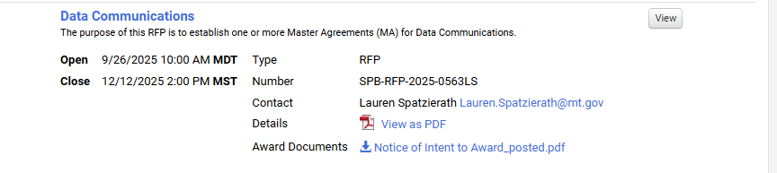

In addition, the following notice was posted in the All Members NASPO Community 9/26/2025:
(content within screenshot below)
Hello:

The RFxPremier Request for Proposal (RFP) for Data Communications was released by the State of Montana on September 26, 2025. The RFP number is SPB-RFP-2025-0563LS. All vendor proposals must be submitted by 2:00 PM, MST on November 7, 2025.

The purpose of this Request for Proposal (RFP) is to establish Master Agreements with qualified offerors, to provide Data Communications solutions for Purchasing Entities. The objective of this RFP is to obtain best value, and in some cases achieve more favorable pricing, than is obtainable by a governmental entity because of the collective volume of potential purchases by numerous state and local government entities.

The Master Agreement(s) resulting from this procurement may be used by governmental entities (including departments, agencies, institutions), institutions of higher education, political subdivisions (i.e., colleges, school districts, counties, cities, etc.), the District of Columbia, territories of the United States, and other eligible entities.

It is now appropriate to post any required legal notices in your entity and to distribute the URL and solicitation information below to prospective suppliers that you may be aware of who would be interested in responding to this RFP. We encourage you to post this solicitation to reserve your entity's ability to participate at some point in the future, even if you don't immediately have plans to participate.

The RFP is available on Montana's procurement system website using the following link: https://bids.sciquest.com/apps/Router/PublicEvent?CustomerOrg=StateOfMontana or the RFxPremier website at: https://www.rfxpremier.org/current-solicitations/

We express our sincere appreciation to Lauren Spatzierath and others in the State of Montana for leading this project!

If you have any questions please contact Matt Limoges, Cooperative Procurement Strategy Official at mlimoges@rfxpremier.org.

Thank you!

