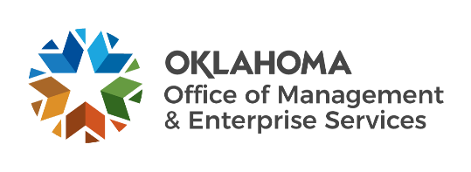 |  | Statewide Contract  Addendum

This addendum is added to and is to be considered part of the subject contract.

Statewide Contract #: | SW0300M (NASPO)
PeopleSoft Contract ID: | Avive #7549 , Zoll #7306 Stryker #7558, Phillips #7307
Contract Title: | AUTO EXT DEFIBRILATOR AED
Contract Issuance Date: | VARY
Contract Supplier: | Listed Below
Addendum #
  1
Addendum Date: | 1/12/2026
OMES Point of Contact:
Contracting Officer: | Jeannie Troxel
Phone Number: | 405-521-6082
E-mail address: | Jeannie.troxel@omes.ok.gov
Amendment Information:
This addendum # 1 is issued to inform you that the contract has been renewed for all
suppliers for the contract period 03/01/2026-02/28/2027 for SW0300M AUTO EXT
DEFIBRILATOR (AED)

(List all suppliers)
Avive Solutions Inc.
Zoll Medical
Stryker Sales Corp.
Phillips North America

