Response to:
Washington State Department of Enterprise Services No. 00318
Cooperative Purchasing Master Agreement for Public Safety Communication Products, Services and Solutions
Zetron Response to Exhibit B3 Experience, Qualifications, Certifications and Services

February 8, 2021



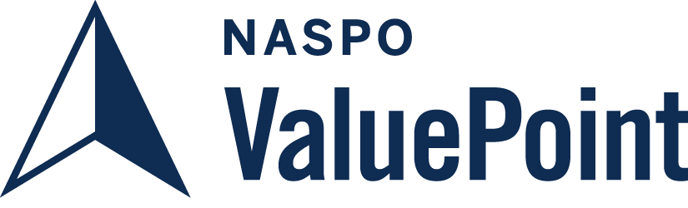

PROPRIETARY & CONFIDENTIAL
The data contained in this document is considered proprietary and confidential and is not to be disclosed to any unauthorized agencies without the written permission of Zetron, Inc. No duplication of the whole or any part is permissible except for the purpose of evaluating this document.

Table of Contents
1. Trainings and Certifications 1
2. Company Experience 2
3. Partner Utilization 2
4. Ordering Process 4
5. Escalation Process 5
6. Standard Support 5
7. Services – Consultation 7
8. Services - Project Management 7
9. Services – Implementation 13
10. Services – Installation 14
11. Services – Configuration/Design 15
12. Services – Radio Programming 15
13. Services – Product Recycling/ Buy Back 15
14. Services – Training 15
15. Services – Maintenance/Repair 18
15.1. MAX Solutions Product Service Plan 18
15.2. ACOM Maintenance Service Plan 23
16. Services – SingleKey Encryption 28
17. Services – MultiKey Encryption 28
18. Services - Other 28
18.1. Onsite Consultation Services 28
18.2. Onsite Implementation Services 28
18.3. Onsite Configuration Services 28
18.4. Onsite Training Services 29
18.5. Onsite Support Services 29

Trainings and Certifications
List any factory trainings and certifications your company’s staff has attended/acquired to support the proposed infrastructure network, and all related subsystem equipment.
For Zetron manufactured products, Zetron tech support staff participates in product training provided by Zetron engineering for each new release.
For 3rd party products the following Trainings and Certifications are documented:
Informational Technology Department:
- CCNA: Cisco Certified Network Associate
- CISSP: Certified Information Systems Security Professional
- MSCE: Server Infrastructure
- MCSA: Microsoft Certified Solutions Associate
- Comptia: Security +
- Comptia: A+
- EvCC: Cisco Core Networking Essentials
- EvCC: Cisco Networking Integrations
- EvCC: Cisco Advanced Routing and Switching
- MTA: Networking Fundamentals
- MTA: Security Fundamentals
- MTA: Windows OS System Fundamentals
IP Networking Training:
- The training was organized in partnership with Everett Community College (ECC) and Cascadia Community College (CCC).
- Dates: Sept. 2017 – July 2018 (Course Syllabus is attached in the Supplemental Information folder)
- Employees: 55 Zetron employees from various business units took part the IP Networking Trainings
- Module 1: Core Networking Essentials (6 weeks)
- Module 2: Network Integrations Course: (9 weeks)
- Module 3: Advanced Routing and Switching (8 weeks)

Company Experience
For 40 years, Zetron has been a trusted provider of mission critical communications systems since 1980. It is ALL we do. With a comprehensive portfolio of technology solutions, including integrated next generation call taking, dispatch, CAD, mapping, fire station alerting, logging/reporting systems and more, Zetron is relied on by communications centers in public safety, transportation, utilities, healthcare, and other markets on all seven continents of the world. Zetron’s relentless pursuit of quality, durability and interoperability has made it one of the most enduring and consistently trusted brands in mission critical communications for 40 years. Our solutions are backed by world class technical support, training, project management and professional services, as well as a global network of highly capable partners and system integrators dedicated to exceeding the unique needs of Zetron customers.

Partner Utilization
Does your company utilize partners for providing products and services? If so, describe:
- process to qualify partners and sales personnel to represent the product, including any certifications
- how partners are contractually bound to the Master Agreement terms and conditions,
- how partner sales will be accurately tracked and reported, and
- remedy plan if the partner or sales personnel are not in compliance.
Zetron maintains alliances with a worldwide network of Authorized Channel Partners (Dealers) who market and support its products and custom systems. This gives Zetron a significant presence in over 60 countries. Zetron and its partners have installed and deployed thousands of systems worldwide. The scope and success of these projects demonstrate the performance, and reliability of Zetron’s products and the capabilities of our reseller partners throughout the world.
To support our partners in multiple regions, Zetron Territory Managers help our Channel Partners identify opportunities and gain product knowledge. Additionally, Zetron provides the opportunity for Factory Training so that Channel Partners can become proficient in installing, maintaining and operating our various system products.
Quality craftsmanship and responsiveness to issues are critical elements that any authorized Channel Partner must display in order to be considered for Zetron qualification. Zetron has selected fully qualified Channel Partners to participate in this contract that have been evaluated and selected by Zetron from among many channel partners based on their stability, work ethic, technical capabilities and public safety experience. Service locations of these channel partners are located throughout the United States to provide rapid response in the rare case of an equipment failure. Zetron stands behind our Channel Partners by providing them up-to-date technical training; quality control of our products based on our ISO 9001 certification, and 24-hour technical and engineering support. Zetron has confidence that customers will be well served by these Channel Partners.
Please see the attached Supplemental listing of these Channel Partners organized by State. Please note that this is a small portion of the approximate 500 Zetron Channel Partners nationwide.
In order to become a Zetron Authorized Channel Partner, the company must first provide sufficient evidence of their expert knowledge and abilities in public safety communication equipment. Zetron Authorized Channel Partners go through factory training on Zetron products to ensure that all Zetron Authorized Channel Partners have the ability to provide customers with exceptional products and services. The expectations and responsibilities of all our subcontractors/dealers/resellers are captured in a Subcontracting/Channel Partner Agreement which describes in detail NASPO expectations.
All Zetron Channel Partners have the knowledge and expertise to assist customers with order development and tracking. Zetron works closely with each channel partner to achieve an accurate and complete quote and order. The Order Entry Team will assist Channel Partner with order development, placement and tracking. Zetron has processes in place that ensure NASPO contract compliance with any order that is placed with us. All NASPO orders are tracked by a Price List system, end user information is required for all NASPO sales, and Zetron has a dedicated point of contact in house who approves each order before it may be shipped and submits quarterly reporting on NASPO sales.
All of Zetron’s Subcontractors/dealers are held to high professional standards. These standards are defined in their Subcontractor Agreement and Channel Partner Agreement. If Zetron finds a subcontractor/dealer to be unsatisfactory we will terminate that company’s involvement in the project and reassign the work to a qualified Zetron trained company.
Further, Zetron may by written notice, require Subcontractor to stop Services and/or Deliverables at any time, or may terminate the same, if the applicable Contract is terminated for any reason or Zetron is otherwise required to stop work or Customer requires Subcontractor to stop work, and Subcontractor’s sole remedy shall be the compensation becoming due hereunder with respect to the Services and Deliverables satisfactorily completed or delivered to the date of stoppage or termination.
With respect to adding new Channel Partners, if we find a market that does not have a channel partner, we will recruit the best in the marketplace, train and certify to ensure they comply with the NASPO terms and conditions. Our Territory Managers are constantly improving the Reseller Channel to ensure support in every state and region. After a Channel Partner is chosen, and agrees to perform the duties an agreement is put in place which will lay out all the duties and responsibilities with respect to the NASPO Contract and any state specific contractual obligations.

Ordering Process
Please describe your company’s ordering process. Include sub-contractors, authorized resellers/dealers/manufacturer representative’s role in the ordering process.
Zetron's order process is designed to simplify the purchasing experience for our customers and partners. The order process is broken down into the following areas:
Initiation
- The end-user customer requires a purchase of either a Zetron component, software, or service.
- The end-user customer will communicate with their authorized Zetron partner to determine exact requirements.
Zetron's authorized partner will contact Zetron Sales for consultation or submit their order directly into Zetron's Order Entry.
Discovery
- Depending on the end-user's request, Zetron's corresponding Territory Manager (Sales) will log the request into Zetron's CRM system.
A Zetron Sales Engineer would engage both the Territory Manager and the Partner to determine the exact requirements and scope of work.
Quotation
- A Zetron Sales Engineer will generate a quote for both the end-user customer and Zetron's authorized partner who supports the end-user customer.
Quotations may be delivered via the authorized Zetron partner or through the Territory Manager.

Purchase Order
- Purchase Order is received, typically from Zetron's authorized partner.
- Purchase orders are processed via Zetron's Order Entry team, which reports into the Finance department.
- Purchase orders may be delivered from the authorized partner or via the Territory Manager
- Order Entry team members process the order, check the order by sending back to the Sales Engineering team, then send to Zetron's Operations department.
For service-related orders, Support teams are directly notified in order to begin their fulfillment processes.
Fulfillment and Shipping
- Zetron Operations receives orders and provides Order Entry with expected ship date.
- Order Entry may relay ship date back to Zetron's authorized partner.
Parts and components are procured (if applicable), tested, and shipped to the address provided by the Zetron authorized partner.
Invoicing
- Zetron's Finance department is responsible for invoicing the purchasing agency (typically Zetron's authorized partner).
Zetron's authorized partner is responsible for invoicing the end-user customer.
Zetron has a dedicated NASPO Contract page located on our corporate Channel Partner Web Portal as well as a general contract/Sales landing page located here:
https://www.zetron.com/state-contracts/
Sales Order Email: zetron.orders@zetron.com
Sales Inquiries: https://www.zetron.com/sales-support/

Escalation Process
Please describe your company’s escalation process for technical and billing issues.
We have two dedicated contract accounts receivable personnel, one of which will be assigned to handle billing/payment issues or questions and the other of which will be available on a back-up basis. Special requests can be made at the time the order is placed and we will do everything we can to accommodate the invoicing requests on a case by case basis. Billing issues can be escalated to management/senior staff as needed and coordinated by the Territory Manager.
The Customer and/or Customer’s designated service provider, as applicable, will provide a centralized point-of-contact and an escalation path for Zetron’s Technical Support team to obtain approval in a timely manner for any additional onsite support required by Zetron employees.
Zetron will provide a centralized point-of-contact and escalation path for the Customer if needed.

Standard Support
Please describe your company’s standard customer/technical support services during regular business hours and time zone support will be provided. (For example: Monday through Friday 8:00 am – 5:00 pm ET).
Provide a copy of your company’s service level agreement (SLA) to include tiered support and response times for each tier and after hours support.
Zetron provides our Customers with technical support for MAX Solutions and Specialty Products through our US-based Support Engineering department. The department is headed by the Customer Service Manager, who reports directly to the Vice President of Customer Fulfillment.
BUSINESS HOURS TECHNICAL SUPPORT
Zetron’s Customer Service Department is open from 6am to 5pm Pacific, each weekday.
This support covers critical and non-critical needs, and is included as part of warranty and Product Service Plan coverages.
During Business Hours, requests for technical support are initiated by emailing Zetron at customercare@zetron.com, submitting a Tech Support request form or opening a chat on www.zetron.com, or by calling Zetron’s toll-free number at 1-877-284-4616, option 3.
All requests for support are routed to Zetron’s Customer Care desk. Live operators respond to the incoming requests during business hours to confirm the needed customer information and a basic description of the problem. From this information, a call ticket is generated within Zetron’s business system and forwarded to an available Technical Support Engineer (TSE). If there are no TSE’s currently available, the call ticket is placed into queue, and the Customer is called back by the next available TSE.
The Technical Support team responds to the tickets based on specific Product Service Plan status and SLA callback requirements, severity of the issue, and by receipt order of the request, as applicable. Technical Support staff document all customer interactions within Zetron’s business system.
EMERGENCY AFTER-HOURS TECHNICAL SUPPORT
After-hours support is available from 5pm to 6am weekdays, and all-day during weekends and holidays, for emergency situations only. Situations determined to be non-critical by Zetron staff will be deferred to the next business day.
After-hours support is not covered under standard warranty, but is available by purchase of a Product Service Plan for MAX Solutions, or at minimum hourly quantities for designated Specialty Products.
During after-hours periods, Zetron responds to emergency support requests through the use of our 24/7/365 on-call personnel.
Assistance for after-hours is provided via phone only by calling Zetron’s toll-free number at 1-877-284-4616. Chat, web forms, and Email are not monitored after business hours.
Callers will be guided via voice prompts to leave a voicemail message based on the Customer’s specific Zetron solution (MAX Solutions, Series 2000, etc.) After the voicemail message is recorded, Zetron’s After-Hours personnel are automatically notified and will return the call within 30 minutes.
If After-Hours personnel do not retrieve the voicemail within 30 minutes, the message is automatically forwarded to Customer Service Management for escalation.
Zetron does not utilize one standard SLA document. We provide a tiered approach to support Service Level issues based on the Product Service Plan the customer has in place with us. Please see more information regarding support in Section 15 Services -Maintenance/Repair.

Services – Consultation
Describe in detail what is included in your company’s consultation services in the space provided – for all Services below
The objective of Consultation Services are for Zetron and the customer to jointly agree on the optimal solution to meet the customer’s needs at an early stage of the project. Consultation Services will include:
- Identification of stakeholders
- Needs discovery and assessment
- Review of the existing design
- Deployment requirements
- Deployment strategies
- Best practices
- Risk identification

Services - Project Management
Systems are assigned to Zetron's Project Office which reports directly to the Vice President of Customer Fulfillment. Zetron project-management teams oversee all phases of system projects. For each project, they collect and apply detailed requirement documents, field surveys, user-interaction information, and task analyses. They also manage and coordinate each of the three critical project management elements—scope, schedule and budget—to achieve a healthy balances of all three.
Project management includes planning, detailing, monitoring, controlling, and reporting. It also requires that project managers take preventive or corrective action whenever necessary to achieve the project objectives and to ensure customer satisfaction.
With its expertise in system connectivity, Zetron has successfully engineered and managed projects that are as diverse in their scope and geographic location as they are in their functional and application requirements. The successful completion of large system projects for customers throughout the world demonstrates Zetron’s ability to engineer and manage large-scale integration efforts in the highly complex global marketplace.
Our project management system includes processes that encompass all steps from:
- Field Surveys, User / Task Analysis, and Requirements Definition
- Task Definition
- Staffing / Resource Allocation, Including Subcontracted Services
- Equipment Specification / Material selection
- Manufacturing / Assembly / System Staging
- Site Preparation / Compliance with Regulatory / Environmental Requirements
- Factory Acceptance Testing (FAT)
- Shipment / Site Equipment Staging
- Equipment installation / System Integration
- On-site Acceptance Testing (SAT)
- Cut Over / System Commissioning / Beneficial Use
- Operator / Maintenance Training
Maintenance Service Plans (Extended Warranty through to Gold Level)
Project Team
The mission of the Project Team is to ensure that all development activities are completed in a timely, professional, and fiscally sound manner, thus ensuring the successful acceptance and commissioning of the system. The following are examples of the personnel and their background that are normally assigned to a project of this magnitude. Note that Zetron reserves the right to substitute other personnel with similar background depending upon current project load and availability.
VP of Customer Fulfillment
Zetron recognizes the importance of the service aspect of any system project the size and complexity of the project. To that end we have created an executive level office whose focus is creating and maintaining the resources within Zetron to meet our contractual obligations and is charged with supplying the services required for our system projects reporting directly to the President of the company.

Project Management Office Organization Chart
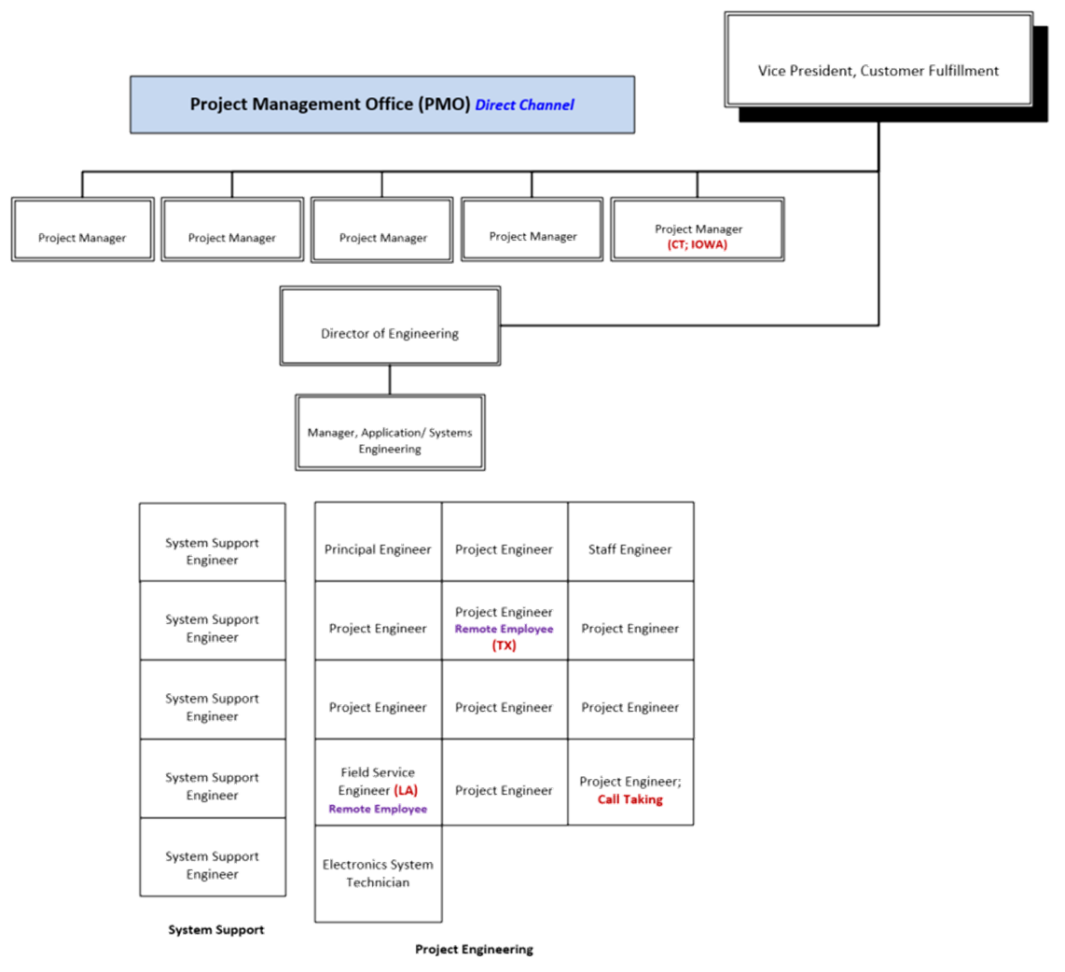

Services – Implementation
Implementation services are managed by the assigned Project Engineer and typically include the following steps:
Solution specification review
Technical discovery
Operational discovery
Operational optimization
Initial solution design
Preliminary design review
Final solution design
Solution build
Assure customer site is in a state of readiness for installation and commissioning
Solution test and acceptance
The Factory-based Project Engineer will function as the single point of contact for technical matters related to system design and functionality, including system configuration, technical consultation, and deployment strategies. The same individual may function as both Project Manager and Project Engineer for a given project.

Services – Installation
Installation typically consists of the physical installation of equipment in racks / furniture, cabling to the demarcation points and loading of the software on the installed hardware.
Once received and inventoried for completeness, the Channel Partner will perform “equipment staging”. This process allows the Channel Partner to set up the equipment in an environment of their choosing, allowing the equipment to work for a period of time (“burn-in”). Once the Channel Partner is comfortable that the system is performing as required the equipment can be disassembled and shipped to the customer location. (Note: in some cases there is enough room at the customer location to allow this “staging” to occur on-site). Installation will be based on the “Installation Plan” developed by the Project Management team and approved by the customer. This plan can vary from customer to customer based on considerations such as the amount of room available on the desktop and in the equipment room, the time of day and expected traffic, degree of involvement of third parties such as Telco and CAD companies, etc.

Services – Configuration/Design
Configuration typically consists of customizing the software parameters of the solution according to the specific technical and operational needs defined in the solution design. This may be done by Zetron or Channel Partner and may be done at the Factory, staging site and / or final deployment site.
After the initial configuration, configuration optimization and validation can be provided.
Remote Configuration Services are available to assist the customer in configuring their system prior to site cutover and monitoring the site post-cut. They are also available for feature or new code implementation. These services are administered by a Zetron technical support engineer (TSE) before the system ships from the factory and/or via telephone and/or via virtual private network (VPN) access into the installed system.
A single point of contact will be assigned to assist the channel partners and end users in the process of initial system configuration, cutover, and system software upgrades when applicable.

Services – Radio Programming
Radio Programming is NOT OFFERED by Zetron as part of this proposal.

Services – Product Recycling/ Buy Back
Product Buy Back can be offered occasionally in form of a promotional package, typically when replacing an existing legacy system with a next generation system from Zetron.
Conditions, availability and applicability will be determined by Zetron Product Management and communicated to Channel Partners and customers.

Services – Training
Operator and Maintenance Training
Operator and Maintenance Training team is charged with working with their counterparts on the customer’s staff to design and conduct Factory overviews and/or on-site training classes that best suits the customer’s schedule and requirements. Zetron also offers “train the trainer” programs where our personnel train the customer’s staff in the knowledge and techniques for training their own employees on how to operate and maintain the system. Zetron has a wide array of capabilities in customer training, so that we can design almost any program to suit the customer’s needs.
Zetron Training Overview
Our audience drives our purpose. Whether we’re teaching technicians how to install, configure, and maintain our systems, or showing dispatchers, operators, or call-takers how to use our consoles and software tools, our goal is to ensure that trainees get the information they need to do their jobs.
In support of these goals, Zetron offers a diverse program of training courses that may be offered via our reseller network and taught by Zetron personnel (Resellers also provide training) and through our direct sales on large systems projects. The classes are focused on meeting the distinct needs of technical and administration personnel and operators.
Technical Maintenance Training
Maintenance training focuses on the technical function, configuration, and maintenance of the major system components. This training is intended for electronic technicians and/or engineers and system administrators.
The session begins with a comprehensive system overview to introduce system elements and establish a common language. The balance of the session is practical demonstrations and hands-on exercises learning task-based function, configuration, and maintenance procedures.
Trainees must have a basic understanding of radio and/or telephone communication systems and computers, extensive knowledge of the customer’s existing communication system, and component-level troubleshooting.
The Maintenance Training course will require three days. Zetron recommends class sizes no larger than 8 technicians.

Operation Train-the-Trainer
This course covers basic system operation and communication tasks using each system’s operation software. The class is a combination of one standard operation training session and a variable-length instructor-facilitated workshop to ensure trainer-level understanding. The course can also include an additional administration/supervisor module for attendees requiring that information. After completing the Operation Train-the-Trainer course, attendees will have sufficient knowledge to be able to explain the system features and functions to other users.
Class Environment
Technical Maintenance classes for standard system products are regularly held at Zetron’s dedicated training facilities headquartered in Redmond, WA. Technical training class sizes are intentionally kept small to ensure a high degree of student/instructor interaction.
Of course the ideal training platform is the customer’s operational system. For that reason training for larger projects is often held at the customer facilities and scheduled after system installation prior to operational cut-over. This allows the demonstration of system functionality on the actual equipment including specific features unique to the customer application.
In both factory and on-site courses trainees receive plenty of hands-on experience with both the hardware and software supplemented by classroom sessions where formal lecture materials are presented. Each class includes quizzes and end-of-class tests with a certificate of completion provided. Zetron supplies copies of all training materials used in the classes including files of slides, instructor notes, and worksheets/exercises used in class as well as PDFs of standard product manuals.
Customization
We recognize that each customer has widely diverse training needs. For that reason the quantity and content for all of our course offerings can be customized to meet specific needs and business challenges.
Web-based Training
With the advent of COVID-19 and health related restrictions, Zetron has acknowledged the importance of remote on-line training and is now offering training classes without the need for customers to travel to the factory or for Zetron trainers to travel to the customer premises.
In order to provide hands-on experience, customers can receive remote training on the Zetron system installed at their premises with no limit on the number of attendees per session (typically before cut over to production) or log into positions at the Zetron training room in the factory as the training vehicle for up to 6 attendees per session (typically when the customer premises system is not available).
Remote operator training sessions are included as part of the Product Service Plan subscription and additional sessions can be purchased separately as needed.

Services – Maintenance/Repair

MAX Solutions Product Service Plan
With each system sold, Zetron provides exceptional warranty support. It starts with Base Service Plan coverage that includes 1 year of hardware coverage and 1 year of software coverage. The Base Service Plan protects against defects in materials, workmanship and software. It also provides training and, access to other users of MAX products. Optional Add-On Services are available to tailor the Base Service Plan to meet your specific installation, configuration, and training needs.
To extend the Base Service Plan to cover additional years, an Extended Service Plan is available to purchase in one or more yearly increments. The Extended Service Plan is sold for the MAX product that you are purchasing and the cost is based on the number of seats (individual console positions) and length of the extension (incremental years) being purchased. The Extended Service Plan is also available as a 4 year package, which provides an additional discount if purchased at the time of the product purchase.
Zetron also offers PSP coverage beyond 5 years. This coverage starting after year 5 is only applicable for software. If hardware coverage is requested after 5 years, a separate hardware lifecycle replacement will need to be done at your expense. Hardware refresh estimates are determined by a Zetron Sales Engineer.
The Base Service Plan comes standard with every MAX system sold and is defined in the table below:
Service Type | Included Services | Service Details | Included Coverage
Hardware Services | Hardware Warranty | Hardware warranty protects against material defects in materials and workmanship and consists of the following services: | 1 year
 | Hardware Defects Repair | Provides hardware repair including parts and labor for no charge with a 10 day turnaround. Return Shipping will be paid by Zetron and match incoming shipment class of service. | 1 year
 | Advance Replacement of any Hardware Component | Immediate shipment of replacement hardware based on remote diagnosis. | 1 year (only available for the first year)
Software Services | Software Warranty | Software warranty protects against material defects in Zetron software that is delivered as part of the MAX product solutions and consists of the following services: | 1 year
 | Software Maintenance/ Service Packs | Provides at no additional charge license for patches or bug fixes (service packs) for the feature group releases or firmware version(s), typically 2 per year. | 1 year
 | Software Upgrades | Provides at no additional charge license for software updates for feature group releases or firmware version(s), typically 1 per year. | 1 year
Technical Phone Support | Business Hours Technical Phone Support | Provides standard phone support for hardware and software issues. Standard Business Hours are Monday – Friday, 6:00 am to 5:00 pm, Pacific Standard Time. | 1 year
After Hours Technical Phone Support | After Hours Technical Support | After hours phone support for emergencies and planned upgrades. | 1 year
Operator Web Training | Operator Web Training | Web based operator training course  (2 sessions, 4 hours each) | 1 Day (2 - 4 hour sessions)
Zetron MAX User Group Access | Zetron MAX Solutions User Group Access | Inclusion into MAX Solutions User Group, email, webinars, and product roadmap updates. | 1 year

The Extended Service Plan simply extends the length of warranty coverage offered by the Base Plan in yearly increments. The plan can be purchased by product and by position per year. If 5 years of coverage is required, a 4 year Extended Service Plan is required (1 year Base Service Plan + 4 years Extended Service Plan = 5 years of coverage). If this is purchased in a 4 year block, discounts apply.
Note: Extended Service Plan does not include Advanced Hardware Replacement. This is only available for the initial one year warranty. Otherwise, Customer must maintain critical spare components for immediate replacement.
After five (5) years only MAX software can be covered by the Extended Service Plan. For systems older than five (5) years needing hardware coverage, a system hardware refresh will be required. Please contact Zetron for hardware refresh pricing and availability.
Zetron continuously evaluates system hardware components in order to improve solution reliability, efficiency, and longevity. To ensure quality and uninterrupted service, as well as avoid large system refreshes when possible, particular emphasis is placed on components in years six to ten of PSP coverage and/or those that will soon no longer be supported, as they are most vulnerable to failure.
PSP coverage is a critical owner benefit and responsibility. Technology updates are essential for implementing security patches, next generation features, new radio and 3rd party system compatibility, and maintaining overall system performance and optimization.
Increased risks of using hardware 5+ years old: downtime due to failures, unexpected costs for repairs and purchases, cybersecurity vulnerabilities, incompatibility with other critical systems.
Add-On Services:
Add-On Services can be added to the Base Service Plan or the Extended Service Plan at any time. These services are identified in the table below:

Service Type | Description | Included Coverage | Purchased
Remote Configuration Services | Remote Technical Configuration Support for installations, upgrades, feature add-ons or advanced troubleshooting | A predetermined block or Technical Support time | Time not to exceed 32 hours for new system set-up.  Individual quotes will be done for custom jobs, new feature adds or system upgrades
On-Site Services | On-Site Technical Support or Operator Training | As needed | Flat fee per day
Operator Web Training | Remote Web based Operator Training | 2 -4 Hour Sessions | Flat fee (2 sessions for 4 hours)

Definition of the Services:
Advance Hardware Replacement:
Once our factory is notified and confirms a defective part, an advance replacement can be immediately shipped from Zetron. An RMA will be issued for the defective part.
Advance Hardware Replacement for 1 year from activation date comes with each new system purchased from Zetron (first year only).
Note: Advance Hardware Replacement is not meant to take the place of spares. For a list of recommended spares for your system consult with your dealer.
After Hours Technical Support:
Standard business hour technical support for each service type can be extended to emergency after-hours technical telephone support for critical issues. Calls to Zetron outside of standard business hours on any regular business day, at any time on weekends, or during Zetron recognized holidays are covered as after-hours emergency calls. These calls are received and routed by our system to Zetron’s technical support engineering team. A member of this team will return your call within 30 minutes. A critical issue is defined as the loss of any operation in a redundant system, or for non-redundant systems, as little as a 10-percent loss of lines or positions.
After hours phone support can also be used, if scheduled in advance, to assist with off hours planned upgrades. After hours support is part of the Base Service Plan and can be extended up to 5 years total with the purchase of the Extended Service Plan.
Hardware Services:
The hardware services protect against material defects in materials and workmanship for hardware that is delivered by Zetron as part of the MAX product solution. Hardware services are provided for one (1) year during Base Plan period based on PSP Activation and can extended up to five (5) years total coverage with the purchase of the Extended Services Plan.
For the duration of the coverage period, Zetron will provide parts and factory labor free of charge to resolve any material defects in material or workmanship as described in Zetron’s standard System Terms and Conditions.
Once our factory receives your defective product for repair, it’s our goal to have the equipment repaired and on its way back to you as fast as possible. Our standard turnaround time is to deliver a return no more than ten working days. However, Zetron’s average turnaround time is currently 6 working days based on the last ten years of service data.
Zetron requires a hardware refresh at your expense after 5 years if you want additional PSP coverage for hardware. Contact your Zetron Sales Engineer for information.
On-Site Services:
Zetron has a dedicated On-Site Technical Support team. These are always custom quotes to account for system variances and travel time. With this purchase Zetron can provide:
Technical Support:
A Zetron factory-qualified technician will provide on-site technical support for the following activities: troubleshoot issues Zetron is unable to resolve via telephone support, provide onsite assessment of installed equipment and recommend if any items should be replaced, and/or software upgrade support.
Training:
A Zetron factory-qualified trainer can provide onsite training services for operation training and operation train-the trainer.

Operator WEB Training:
Operator training classes are included in the Base Plan via a webinar rather than a factory classroom setting. This training uses the same training module and materials as the factory training and is taught by a live instructor leading the webinar. Web training is available for up to 2 sessions or 4 hours for the life of the plan and additional training can be purchased.
Remote Configuration Services:
Configuration services are available to assist the customer in configuring their system prior to site cutover and monitoring the site post-cut. They are also available for feature or new code implementation. These services are administered by a Zetron technical support engineer (TSE) via telephone and/or via virtual private network (VPN) access into the installed system.
Standard System Configuration is sold in a block for your convenience. If there is a need for more than what is offered in the Base Plan Remote Configuration Service coverage, additional coverage days can be added to the plan. Additional one (1) day increments of technical configuration support can also be purchased at a ﬂat fee rate.
Software Services:
The software warranty protects against material defects in Zetron software that is delivered as part of the MAX product. It provides a license for Software Maintenance & Service Packs and Software Upgrades during the one (1) year Base Service Plan period based on PSP Activation date and if purchased as part of an extended plan.
Software Maintenance & Service Packs:
Under the Software Services, the customer is entitled to receive at no additional charge a license for any patches or bug fixes contained in a service pack for Zetron feature group or firmware version(s) where they have active licenses. Zetron sends a notification to all registered MAX PSP customers, indicating that a new service pack is available and ensures that the necessary media to install the service pack is made available to the customer. Zetron typically provides a minimum of two service packs per year.
Software Upgrades:
The customer is also entitled to receive any license for software upgrades for feature group releases of the application or firmware version(s) where they have active licenses. Upgrades typically include minor enhancements, as well as access to certain major new features that do not require special licensing. Upgrades also incorporate any previously released bug fixes/patches. Major features, which require special licensing, are offered to plan holders at a discount. Zetron typically provides a minimum of one software upgrade per year with major features.
Technical Phone Support (Business Hours):
Zetron’s technical support team is supremely qualified to provide telephone support to technicians and system administrators who are installing, configuring or maintaining Zetron Software. Zetron’s software technical support engineers are available during standard business hours.
Standard Business Hours are Monday-Friday 6:00 am to 5:00 pm Pacific Standard Time.
Calls during standard business hours to Zetron at 1-425-820-6363 or 1-877-284-4616 are answered by Zetron personnel who validate PSP Software Service license and establish a call ticket number. Qualified personnel then collect detailed issue information from the caller, and enter the call into the call queue. Head of the queue and priority call back privileges are given to callers with a MAX PSP license.
During the initial one year warranty period, Technical Phone Support is available to all qualified owners of Zetron Solutions. If it is determined that a software upgrade is required, a PSP must be purchased to continue support.
Zetron also offers emergency after-hours technical telephone support. If you need after hours support, see After Hours Technical Phone Support to learn more about this extended coverage.
Zetron MAX Solutions User Group:
Once a customer activates their MAX PSP, they are added to the Zetron MAX Solutions User Group. This gives the customer direct access to User Group meetings hosted by Zetron’s Product Management Team. These meetings will allow the customer to be kept up to date on software service packs, upgrades, and product roadmaps. The meetings will provide direct access to the product management team where product feedback can be collected. The customer also receives benefit through networking with other PSAPs and access to a broader knowledge base.
MAX PSP Activation:
MAX PSP is active either when the product is shipped or when the customer registers the product. To register a MAX system and its individual console positions, a customer/end user must go online to www.zetron.com/max-product-service-plan
The activation date will be the later of the date of shipment of the product from Zetron’s facility or up to ninety (90) days from the shipment date, based on the date of customer activation and registration which cannot exceed 90 days from the shipment date. The activation start date on products which have not been registered by the end user is the date the product shipped from Zetron’s facility. Expired PSPs require a reinstatement fee for reactivation.
Expired PSPs require a reinstatement fee for reactivation.

ACOM Maintenance Service Plan
Essential Services for Mission-Critical Systems
Keeping your mission-critical system functioning at all times requires more than simply buying the right equipment. You need services in place that will provide quick and efficient resolution to any problems that might arise. Zetron’s Service Plans do just that with a family of service plans sized to meet the different needs of our customers. Don’t put your mission-critical communication system into action without one of Zetron’s service plan options.
All Zetron products are shipped with a basic Limited Warranty. The basic warranty protects against defects in materials and workmanship and provides business-hour telephone support during the first year warranty period.
Three additional service plan options are available for coverage up to five years and are tailored to meet your organization’s unique service needs. Zetron offers a variety of the Maintenance Service Plans to accommodate all potential customer needs based on each product line. A brief overview of the services plans are described below.
Extended Limited Warranty
- System coverage includes Zetron products and Zetron accessories.
- Ensures a standard repair turnaround time.
- Covers repairs of defects in materials and workmanship
- Includes software maintenance.
- Includes business-hour telephone support.
Silver Service Plan
- System coverage includes Zetron products and Zetron accessories.
- Includes emergency after-hours technical telephone support.
- Covers repairs of defects in materials and workmanship.
- Ensures a five-day repair turnaround time.
- Includes business-hour telephone support with guaranteed rapid call back.
- Includes a 65-percent discount on refurbished equipment.
- Includes software maintenance
Gold Service Plan
- System coverage includes Zetron products, Zetron accessories, and ancillary third-party equipment.
- Includes a 75-percent discount on refurbished equipment.
- Includes software maintenance
- Covers repairs of defects in materials and workmanship.
- Includes factory onsite services.
- Includes business-hour telephone support with guaranteed rapid call back.
- Includes software installation and upgrade support.
- Includes emergency after-hours technical telephone support.
- Ensures a two-day repair turnaround time.
Service Highlights
Repair of Defects in materials and Workmanship
Zetron is dedicated to keeping your system up and running. To that end, we will resolve any defects in the materials or workmanship of a Zetron product or accessory by providing parts and factory labor free of charge for the duration of your service plan.
In order to get your system up and running as quickly as possible, Zetron may replace or repair a defective part. A repairs-tracking process gives you access to up-to-date information on the status of your repair.
Third-Party Repairs
Custom solutions often include a combination of Zetron products and accessories and third-party equipment, such as PCs. Zetron will cover the items specified for three years after original purchase.
If your third-party equipment requires repair or replacement, Zetron will ensure that the repaired or replacement unit remains compatible with your existing system. This is particularly important if the device is replaced rather than repaired. Zetron will reconfigure repaired or replaced units against last-known configuration before returning the unit to the field
Repair Turnaround Time
Once our factory receives your defective product for repair, it’s our goal to have the equipment repaired and on its way back to you within a standard turnaround time of ten working days.
If you need a faster turnaround time, consider our Silver Plan, which accelerates the turn- around time to five working days, or our Gold Plan, which accelerates the turnaround time to two working days (shipping time not included).
Technical Telephone Support During Business Hours
Zetron’s technical support team is supremely qualified to provide telephone support to technicians and system administrators who are installing, configuring or maintaining Zetron equipment or software applications.
Zetron’s factory technical support engineers are available during standard business hours.
Emergency After-Hours Technical Telephone Support
Zetron offers emergency after-hours technical telephone support. Calls to Zetron outside of standard business hours on any regular business day, at any time on weekends, or during Zetron-recognized holidays are covered as after-hours emergency calls. These calls are received and routed by our system to Zetron’s technical support engineering team. A member of this team will return your call within 30 minutes.
Software Upgrades
Software upgrades will be available at no charge for the application software or firmware version(s) that were sold as part of the original Zetron system. Upgrades typically include minor enhancements as well as access to certain major new features that do not require special licensing. Upgrades also incorporate any previously released bug fixes/patches. A limited amount of Zetron on-site assistance is included for upgrades that require it. Some options may require a separate assessment and/or the additional purchase of hardware, firmware, or licensing.

Software Maintenance
Software defects are covered for the duration of your service plan. Zetron diligently creates patches for defects as they are discovered. Our customers are entitled to receive every applicable software maintenance patch for the application or firmware version(s) covered. To ensure dependable performance, all Zetron software maintenance patches are subject to full internal software-release and design- verification processes as well as standard configuration management practices.
We understand that custom systems require extra attention, so for software applications in certain systems, Zetron requires customization assessment as well as installation support to ensure a successful transition.
Factory Onsite Services – (Gold Plan Only)
Each year of your service plan, Zetron will provide up to three days of onsite services. You can apply these hours to technical support, training, equipment installation and programming optimization, or hardware preventive maintenance services. If you need additional hours, you can purchase them at the applicable rates. This approach ensures that you have onsite technical support services when you need them.
Software Installation and Upgrade Support
Custom systems require extra attention when you apply software maintenance patches to them, or you install a full upgrade. Zetron offers factory-installation support to ensure that those processes run smoothly. A Zetron factory-qualified technician will provide onsite software installation and configuration support for certain software maintenance or upgrade releases.
Local Onsite Response
Mission-critical systems sometimes require immediate support. It is for these systems that Zetron has developed the Local Onsite Response service. After a problem is diagnosed, Zetron will dispatch local, factory-trained, qualified technicians to repair or replace equipment. This occurs within customer-defined response times. Although this service only applies where available, Zetron is constantly expanding the areas it covers.
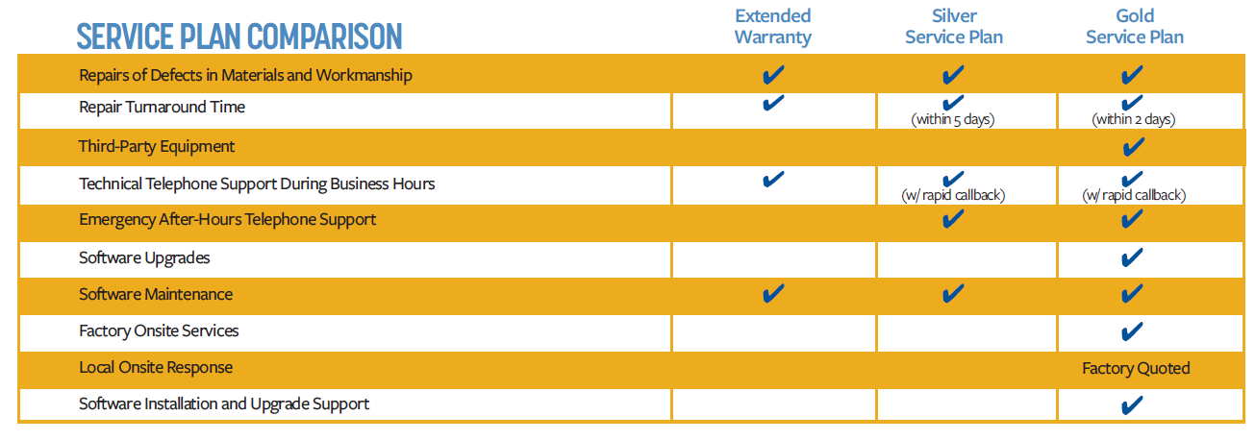

Services – SingleKey Encryption
NOT OFFERED by Zetron as part of this proposal.

Services – MultiKey Encryption
NOT OFFERED by Zetron as part of this proposal.

Services - Other

Onsite Consultation Services
Refer to Section 7. Services – Consultation.
These services can be offered onsite at the daily rate listed in the Bid Price document.

Onsite Implementation Services
Refer to Section 9. Services – Implementation.
These services can be offered onsite at the daily rate listed in the Bid Price document.

Onsite Configuration Services
Refer to Section 11. Services – Configuration/Design.
These services can be offered onsite at the daily rate listed in the Bid Price document.

Onsite Training Services
Operator training services can be offered onsite at the daily rate listed in the Bid Price document.
The Operator training course covers basic system operation and communication. Utilizing a variety of theory, demonstration and hands-on techniques, participants in the course learn to use the features and functions related to this system. After completing this course, operators should have the skills necessary to operate the Zetron equipment.
This course is generally two hours in length for each group of operators and can be held at different times of the day to cover different shifts. Classes are kept small to allow each attendee hands-on access for a complete learning experience.
The content assumes experience operating radio communication consoles and knowledge of standard industry dispatching practices. Zetron only instructs on the operation of Zetron equipment.
On-site classes are taught at the customer location(s). This training requires access to a configured, functional system and accompanying consoles. Zetron instructors bring a laptop PC and projector. The customer provides a power source, writing surface (flipchart or whiteboard), and a large monitor wall display, projector screen or blank light-colored wall.

Onsite Support Services
Technical support services can be offered onsite at the daily rate listed in the Bid Price document.
Onsite support services may include:
- Configuration optimization and validation
- Cut-over support
- Advanced troubleshooting and issue resolution

