NASPO DOCUMENT #A09

e-Meter Read Information and Instructions
Meter reads can be submitted through Toshiba’s E-Meters Online (Online Web E-Meter Submission) system using the Internet. Through E-Meter, you can submit your current meter reads for all equipment on a spreadsheet that can be exported on the site and then MASS upload the reads for all devices. Or you can directly enter each meter read per device on the web page.
When are meters due?
The eMeter Online website opens on the 26th of the prior month. Please submit your current meter reads from this date through the 8th of the current month.
If the dates are missed above, you can go to the ‘Submitted Meter Read’ tab and edit the estimated meter read that processes around the 9th of each month. Meter Reads can be changed from the 9th through the 14th. Billing occurs on the 15th therefore, the website is closed. The site does not open again until the 26th of the month.
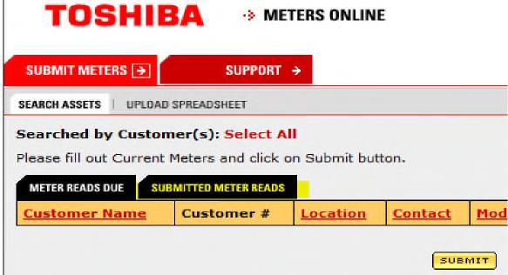
To enter a meter read, please follow the steps listed below. eMeters On line Submission Instructions
- Log onto FYI
- Go to: Programs and click on Meters Online
- Search by ‘ALL’ or Customer Name.
- Enter the meter read by device.
- Or export the upload spreadsheet, enter the meter reads, then save the document.
- The on the website click on the upload spreadsheet, retrieve your data and hit submit. All reads should automatically update. If any fallout, a message will be displayed.
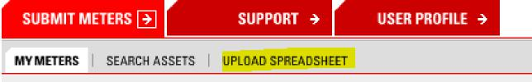
Should you have any questions on submitting your meters on line please either email tabs.fsm@tabs.toshiba.com or call (800) 866-4361, select option 1.

