NASPO ValuePoint / Washington State Department of Enterprise Services

No. 00318 Public Safety Communications Products, Services and Solutions

10. Category: Furniture, Dispatch Console

Welcome!

Welcome NASPO ValuePoint Contract User! We are excited about the opportunity to serve you.
Russ Bassett is an industry leading designer and manufacturer of the highest quality console furniture for PSAPs, ECCs and other mission critical operations centers. We look forward to discussing your project and to helping you determine if Russ Bassett Corporation is the right fit.

This introduction letter is a supplement to website posted comprehensive product line MSRP ‘list price’ catalogs. These are list price books and there is a discount of the list price applied to all materials. Service pricing is outlined in the solicitation response forms.

The 00318 discount is 40% off of the published list price off, applied to all Russ Bassett products.

Please contact us to coordinate a site visit. We will walk you through the design development process, educate you on the full range of options at your disposal, learn about your needs, survey and measure your facility and then follow up with a detailed design and cost proposal including all associated materials, freight services and installation services.

Russ Bassett has an in-house full-service Design Team and as part of the proposal process will assist with:
- Space and floor plan confirmation and/or provision of additional/alternative layout options
- Dialing in of adjacencies (work groupings, access to shared services and facilities, sight line evaluation)
- Dialing in of the console design and functionality
- Creation of formal equipment lists, location maps and wiring diagrams by position type
- Discussion and dialing in of options such as Status Indicator Lights, console signage and other accessories
- Assist team in defining and confirming console grounding methodology to meet Motorola R56 requirements
- Source electrical and communications cabling integration design and coordination
- Console finishes selection
- Final, detailed shop drawings including plan, elevation, perspective and detail views
- Photo-realistic 3D color renderings of the final console and peripheral component design prior to sign off
- Floor coring drawings and templates for use by PSAP’s facilities and/or construction teams
We look forward to assisting NASPO ValuePoint Contract Users with the design of their console furniture needs.

Our proposals will be thorough, accurate and helpful to the PSAP in making their decision. Below are screen shots reflecting the design and proposal documents we generate:

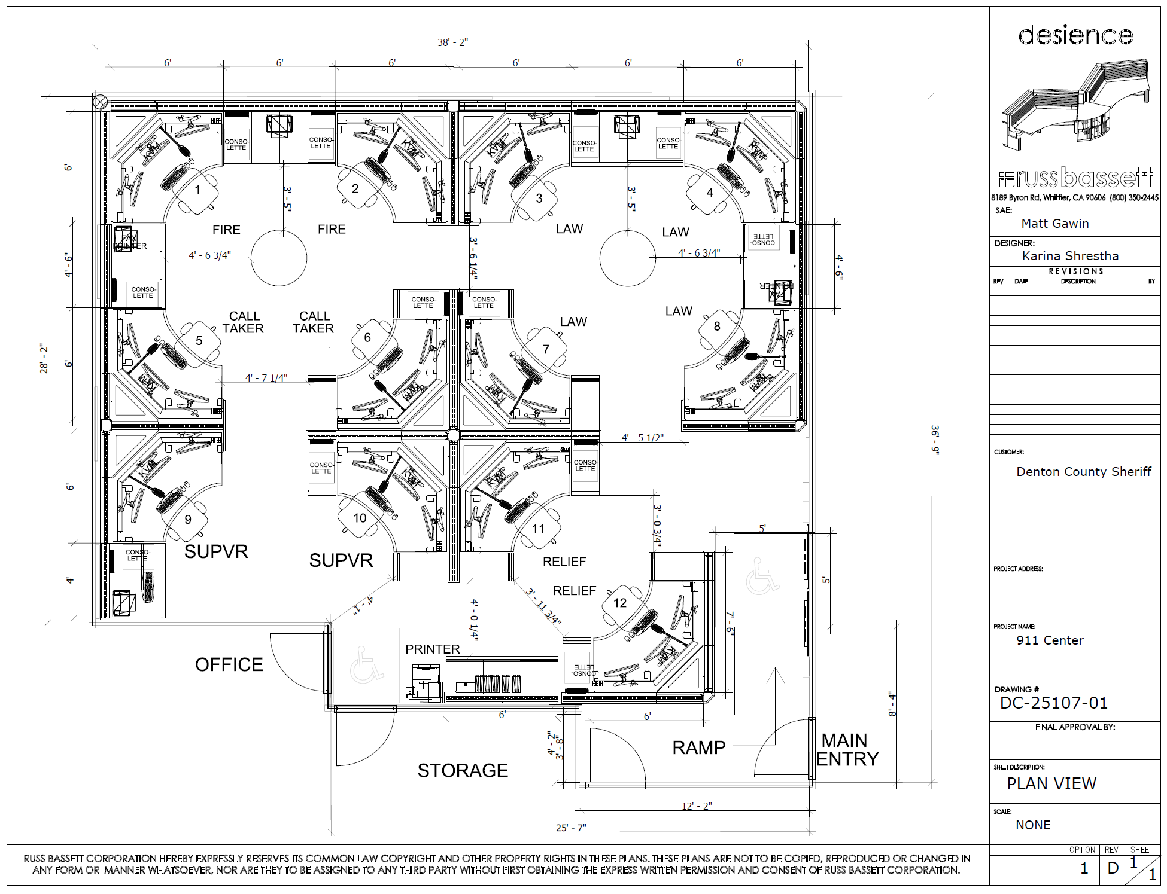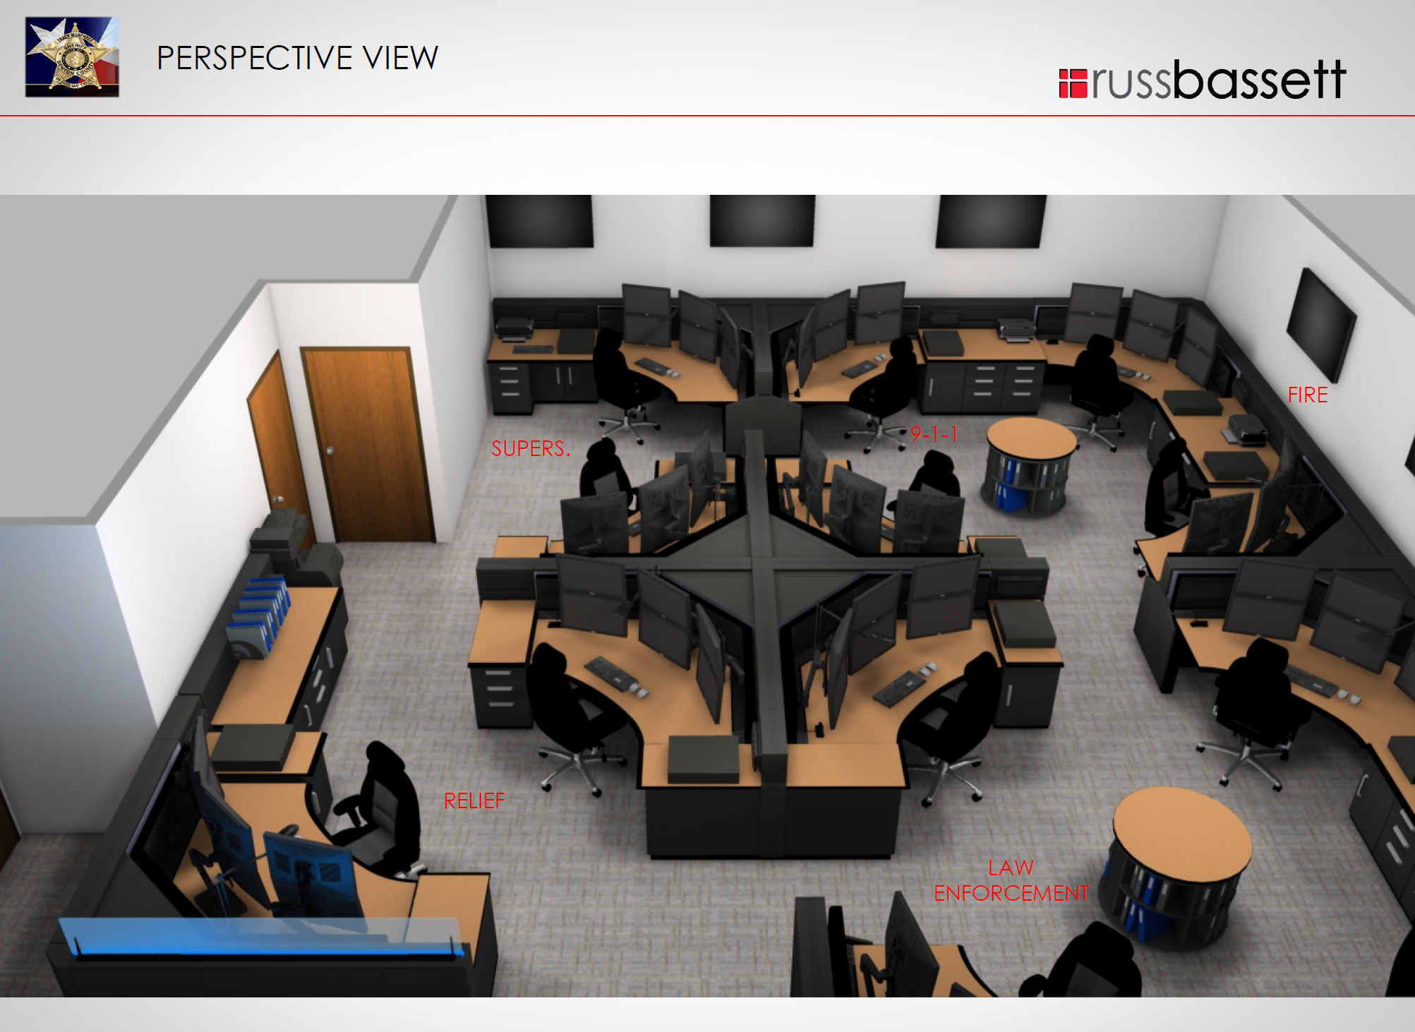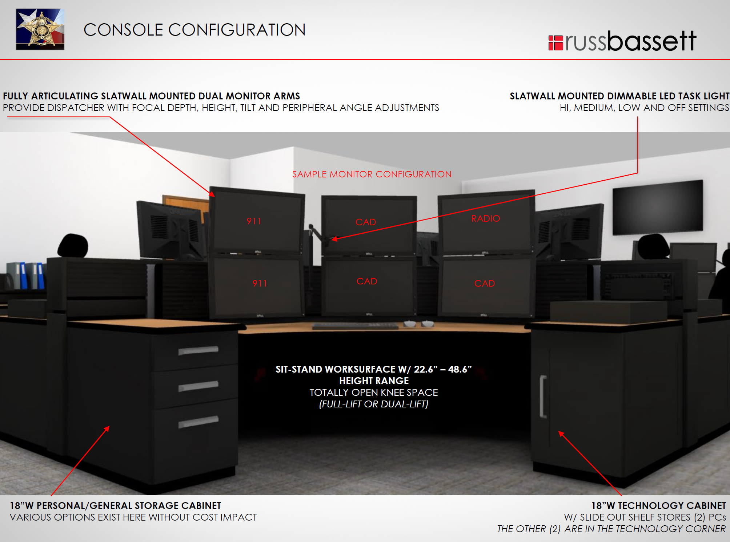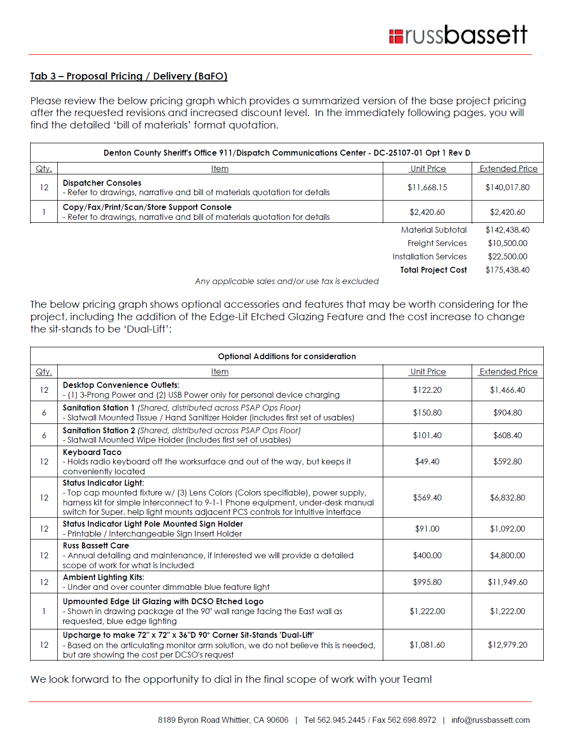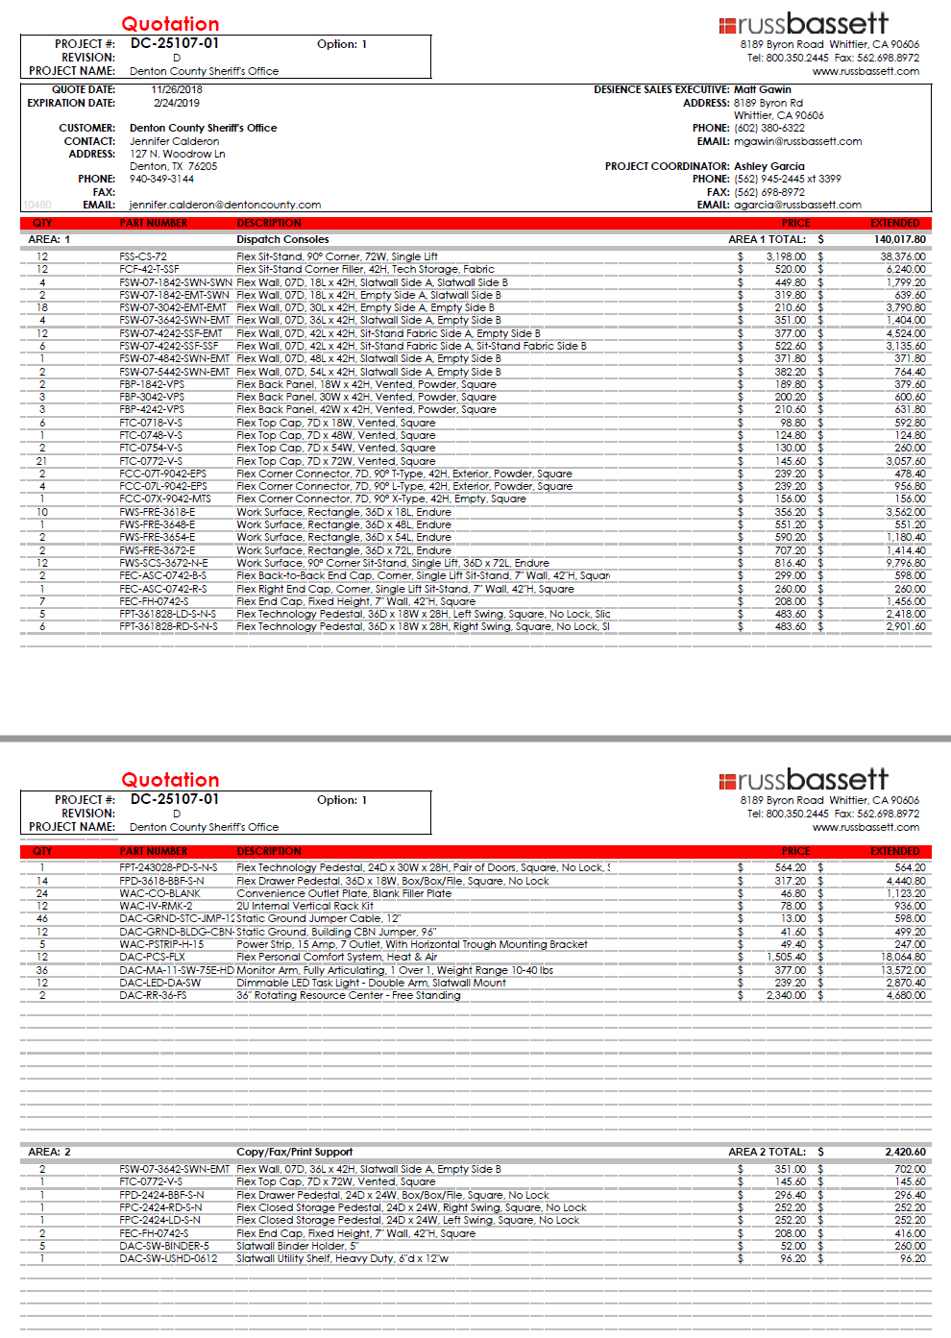

Shown from left to right: 2D floor plan, perspective view rendering, typical view 3D color rendering (middle), budgetary pricing graph, and detailed quotation excerpt

On behalf of the Russ Bassett Team, thank you for the opportunity to be considered as the provider for your Dispatch Console Furniture. If trusted with your business, we will deliver both a best-in-class console furniture solution and customer experience.

Please contact Peter Fink at (714) 425-1971 or pfink@russbassett.com with questions or concerns regarding Russ Bassett Corporation’s Response to Solicitation 00318 Category 10.

