Assessment Phase

Kyocera ADIMO SOW
assessment



COPYRIGHT

The report contained herein is the intellectual property of Kyocera Document Services and shall remain so throughout the project and after its completion. Under the terms of the project agreement, Kyocera agrees to license the Client to use this report to assist in the making of decisions related to your document technology environment.  Client shall not reproduce or redistribute any portion of this report without the expressed written consent of Kyocera. | Furthermore, Client agrees to hold the contents of Kyocera proprietary report in the strictest of confidence and not to share the information with any other third party.  Conversely, Kyocera acknowledges that the information provided by Client and its client is confidential in nature and has been disclosed solely for the purpose of generating this audit report. In consequence, Kyocera commits to not disclose it to any third party without Client’s express permission.

CONTENTS

- Introduction 5

  - Objective 5
  - Methodology 6
  - Deliverables 6
  - Data Ownership 6

- Scope 7

2.1 Locations and Sites 7

2.2 Data Captured 7
2.2.1 Equipment 7
2.2.2 Volume Data 8
2.2.3 Workflow Assessment 9
2.2.3.1 Defined Workflows 10
2.2.3.2 Ad Hoc Workflows 10
2.2.3 Environmental Data 10
2.2.4 Mapping 11
2.2.5 Security / Threat Data 12
2.2.6 Spend Assessment 12
2.2.7 End User Happiness 14

2.3 Client Responsibilities 16
2.3.1 General Client Responsibilities 16
2.3.2 IT Resources 16
2.3.3 Time Allocation 17

2.4 Assessment Factors 17

3.0 Conclusions and Next Steps 18


INTRODUCTION

- Introduction

Kyocera’s proven Global Managed Print methodology is designed to gain a clear understanding of our client’s environment, requirements and goals in order to deliver an exceptional customer experience.

This process is called ADIMO; which seeks to Assess your current environment and needs, Design a powerful go-forward solution, Implement that vision, Manage the environment on a consistent basis while limiting the burden on your own internal resources, and continuously Optimize the print/document fleet for ongoing improvements and further benefits.
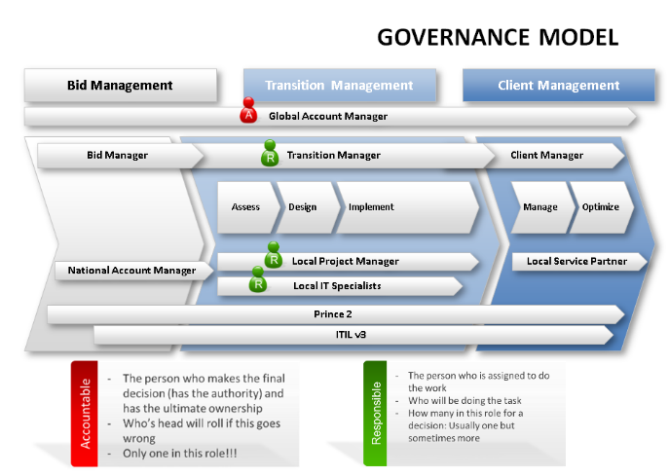
The ADIMO process utilized by Kyocera is the same process in every corner of the globe; focusing on delivering a unified customer experience and dependable results.

Since 1997 Kyocera Document Solutions has employed this methodology for our customers with outstanding results. Our customers have continued to enjoy the long-lasting benefits of a process that has been improved and perfected over the years.

  - Objective

The first, and most important part of the process, is the assessment of your existing environment, existing workflows and gain a clear understanding of what you want to accomplish.

Kyocera provides a physical onsite assessment of all client locations and sites within predetermined scope. The following outlines the process by which these assessments are conducted, the client-side resources required and the deliverables upon completion.

The goals of the specific assessment need to be clearly defined and understood by all parties. The following outlines Kyocera’s Key Performance Indicators as standard components of our offering:
- Understand Client specific security standards as well as provide a solution that meets generally accepted, industry standard security protocols
- Understand Client specific environmental objectives as well as providing a solution that is sustainable and minimized the impact on our collective planet.
- Understand Client specific workflows and business process
- Understand current costs and target for any cost savings
- Understand user concerns and specific goals as it relates to the print environment

  - Methodology

The process by which we seek to gain this understanding of the existing business process and workflows includes the following:
- Physical Walkthrough and device mapping
- Data collecting of existing volume information
- End-user interviews where practicable
- Environmental statistical analysis
- Spend analysis

  - Deliverables

Upon competition of the assessment Kyocera will provide a detailed report entitled “(Client name, Site) – Business Case”. This report will include:
- Assumptions used in the execution of the assessment
- General overview and findings
- Device and volume metrics
- Floorplan representation of devices
- Environmental analysis
- Spend analysis
- Recommendations

  - Ownership of Data

All data captured during the assessment will be the property of the client for use in any fashion the client should see fit. Any proprietary information such as logos, branding, or otherwise Kyocera specific content remains the sole property of Kyocera Document Solutions.

Kyocera will provide all data collected during the assessment to the client for future use.

Kyocera will not share any data collected with any party beyond the client unless otherwise authorized to do so by the client in writing. Kyocera may request the right to use some form of the data collected in future marketing collateral, but will do so only with the client’s express written consent.

- Scope

The following outlines the general terms and conditions of Kyocera’s proposed scope of service for the execution of a Managed Print Assessment for the client. The objective the preceding is to identify components of the scope of the assessment and clearly define roles and responsibilities. Additional components may be added to this section as seen relevant to the client or based on Kyocera recommendations.

  - Locations and Sites

All facilities or sites determined to be in scope for the assessment will be visited by a Kyocera representative or contacted via telephone. The determination of onsite visit or telephone interview is based on client request. Kyocera’s recommendation is that any facility with one hundred (100) employees or more receive an onsite assessment; locations with fewer than one hundred employees may only require a telephone interview.

For the purpose of this engagement the locations/sites considered in scope are outlined in Appendix A (Locations in Scope). The scheduling and completion of the assessments will be tracked in the following format and shared with the client throughout the engagement:

Site Name | Country | City | Address | Site Contact | Number of Users | Scheduled Date | Completion Date | Business Case Reviewed

Business Case reviews will be provided immediately upon completion and share with the client project team for validation. Changes to recommendations will be updated accordingly and added to the project summary.

  - Data Captured

The following outlines the information to be gathered during the assessment process.

2.2.1 Equipment

Unless otherwise specified Kyocera will capture all data related to office and production printing equipment within the client locations. The equipment to be analyzed includes:
- Single function network connected devices
- Single function locally connected devices
- Single function non-connected devices
  - Includes devices connected to specialized equipment
- Multifunction Peripherals
  - Defined as copiers, MFPs, MFDs
  - Network connected and stand alone
- Wide Format Devices
  - LED, Laser, and ink-based plotters, graphic reprographic wide format
- Impact Printers
- Label Printers
- Production or press equipment
  - LED, Laser, Thermal or ink based high-volume reprographic equipment

The data captured from equipment will include:
- Physical device location
- Condition of equipment
- Number of user in proximity
- Obstacles or shortcomings of equipment
- Configuration of equipment
  - Additional options or features
- Status pages from equipment when practicable

2.2.2 Volume Data

For the purposes of the assessment Kyocera will capture relevant usage data from any and all devices in scope. The preferred method of data capture is via an intelligent Data Collection Agent (DCA), see Data Collection Tools. The DCA will provide the most accurate account of volume information if it is pertinent to analyze print data over a protracted period of ninety (90) days. In the event that this timeframe is not suitable to the overall project objectives assumptions of volume data will be made.

The DCA will capture all volume information produced by the device MIB of network connected devices in scope. The scope for capture of network connected devices is defined as the network subnet ranges provided for the data capture.

The protocol utilized for the capture of data is SNMP Port 161. No data is disseminated to the network or devices during this process.

Once the data is captured for all devices in scope volume information will be captured denoting the current output meter of the devices. Most devices will report volume information in summary and with detail as type. Type is defined as:
- Media type; i.e. A3, A4, Letter, Legal
- Output type; i.e. Copy, print, fax
- Color / Mono
- Simplex / Duplex

Data captured will represent the current volume of the devices at time of data capture. This date will be noted on all future reviews of the data.

Calculations/Assumptions will be made based upon the captured data to determine a monthly average. The calculation used to determine this average is:
- Term or contact devices (i.e. devices on lease with a clearly defined installation date): Total volume divided by months in service.
- Devices with no clearly defined installation date: Total volume divided by number of months since device introduction date minus two.
  - This assumes that the devices were acquired new shortly after their introduction date and have remained in the same location since installation.
  - Although this method does not provide an exact monthly volume it does often provide a fairly representative estimate of monthly usage.

In the event that it is not prudent to run the DCA in the environment, the data capture will be conducted manually from each devices. This is done by printing a status/counter page from the device, or by noting the volume displayed on the devices’ internal counter.

For non-network connected devices, the data will be captured manually from any devices that are able to produce a usage status page.

Additional assumptions will be made based on access to devices or relevant data; these assumptions will be applied to devices in example:
- Not accessible at the time of assessment due to lack of physical access; i.e. in a locked room, in a room where it is not prudent to enter
- Locally connected devices by which capturing the data would cause a disruption
- Devices are in operable or otherwise in use thereby prohibiting capture of the data

In the event that assumptions are required this calculation will be made by:
- Using the average volume from like type devices
- Using a mutually agreed upon average estimate

The date provided to the client, as it relates to volume data, will include:
- Output statistics:
  - Mono vs. Color
  - Number of pages printed in summary and by device
- Utilization: Volume vs. manufacturer recommended volume
  - Not to be confused with Duty Cycle
- Summary of findings

2.2.3 Workflow Assessment

During the execution of our assessment Kyocera will attempt to gain a clear understanding of the document workflows of specific users, groups and departments.

The workflow analysis will be conducted by user interviews, data analytics, and process assessment. The business workflows will be either clearly defined or ad hoc. Additional Kyocera resources may be assigned for a more in-depth assessment of the business processes. Additional scope of work may be required for these assessments and will be clearly outlined before inception.

2.2.3.1 Defined Workflows

Defined Workflows are classified as business process that are identified as being a candidate for Business Process Automation (BPI) at the onset of the engagement. These business process may include areas such as:
- HR Onboarding
- Accounts Payable / Accounts Receivable Process
- Logistics
- Customer service management
- Digital content management
- Document management

These areas of focus are typically document intensive and may benefit from automation or BPI.

2.2.3.2 Ad Hoc Workflows

Ad hoc workflows are business process or document challenges that are identified throughout the course of the Kyocera assessment. These workflows are captured via user interviews, user comments in passing, or obviously challenged areas for improvement.

All recommendations will be made through the Business Case Review and will not be necessarily shared with the user at the time of the assessment to ensure project continuity.

All recommendations for BPI or automation will be made at the discretion of the client.

2.2.3 Environmental Data

During the course of the assessment, Kyocera will capture relevant data as it relates the environmental impact of the print environment. General data captured from the devices will include:
- Equipment TEC – Typical Energy Consumption
- Equipment CO₂ Output
- Estimated waste:
  - Captured via observations of waste left present on the device
  - General, mutually agreed upon, estimates of waste
- Consumable recycling process

The data used to calculate the TEC and CO₂ rating of the devices is based on publically available information provided by the manufacturer or independent resources; Kyocera utilizes Buyer Laboratory, Inc (BLI) data.

This information will be shared in the Business Case Review regardless of its relevance to the overall project or client objectives. Environmental Sustainability is a paramount cornerstone of any proposed Kyocera Go-Forward recommendation.

2.2.4 Mapping

During the assessment Kyocera will capture devices locations as they relate to the physical floorplan of the environment. This information is captured manually by utilizing a client provided floorplan or blueprint and noting the exact location of the devices.

This data will be provide to the client in the Business Case Review in MS PowerPoint format and is stored in Kyocera’s own internal MPS database for use in a go-forward managed solution. Each device in the “Current State” will be noted by a unique icon based on device type and a unique number which correlates to extended data. The purpose of the current state map is to provide a graphically representation of the device distribution and areas where consolidation may be prudent.

Kyocera will also provide a recommended “Future State” representation of a go-forward recommendation. This future state mapping is designed to be used as a client / Kyocera validation tool. Once the go-forward state is mutually agreed upon this future mapping will be used for the ongoing management of devices in-place. The Kyocera MPS team will utilize this data to more effectively service the equipment and support the user community.

Example Shown Below (used with client consent):
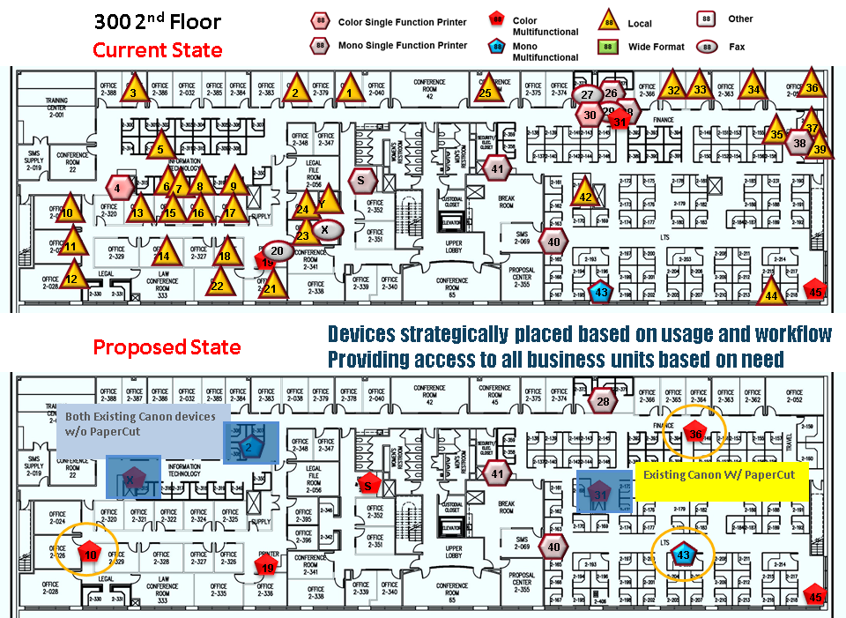

2.2.5 Security / Threat Data

Throughout the course of the assessment Kyocera will attempt to identify security threats and vulnerabilities. The identification of these threats will include, but not be limited to:
- Known vulnerabilities from specific device types
- Assumed vulnerabilities based on device age
- Obvious security risks; i.e. a USB cabling dangling from a network connected device

Our assessment may also include a detailed inspection of the network traffic as it relates to print identifying areas of potential concern. In order to complete this assessment Kyocera will require network access and express client permission to conduct the assessment.

Upon completion Kyocera will provide a detailed document as appendix to the Business Case outlining any potential threats and go forward recommendations for improvement and go-forward device settings. See Appendix B (Security WhitePapers) for more information.

2.2.6 Spend Assessment

A key component to the overall assessment and subsequent Business Case Review is the “Current State” spend analysis and recommended “Future State” spend estimate. Clearly this is a driver in any go-forward solution.

The assessment of current spend can be conducted based on quantitative or empirical data sets. The most accurate assessment of spend will be based on the following components:
- Copies of existing contract information
  - Device lease contacts
  - Existing maintenance agreement contracts
- P-Card spend reporting
- Accounts Payable payment history by category
- Other relevant spend data

Although having a clear, documented estate of the current spend provides the most accurate and actionable information for the purposes of the current state and impact of future recommendations it may not be practical to share. We understand and respect this fact.

In the event that the quantitative data is not shared Kyocera will make general assumptions of current spend based on industry averages and estimations. In our experience we have found that our estimated current costs are close to actual client spend. Any assumptions made will be made clear in the Business Case Review. The following outlines the general baseline for estimating current costs:

Consumable Spend (for non-contracted devices):

Kyocera will estimate the current spend on consumables such as toner by utilizing the average “street price” of the print cartridges based upon publically available data. Kyocera utilizes CDW.com for the cost of the toner less 20% (assuming that volume discounts are being achieved).

All toner has an estimated yield based on 5% coverage. Our proposed current state spend will be provided as cost per impression based on this calculation; cost of toner divided by yield equals cost per impression for toner.

Service Spend (for non-contracted devices):

If no actual data is available for existing service contracts, Kyocera will apply a general assumption, unless otherwise directed that assumes that maintenance kits are replaced based on manufacturers’ recommendation. The same calculation and process is used to determine this cost.

IMPORTANT NOTE: For non-contracted devices, Kyocera makes the assumption that there is zero service cost associated with the device. Although this may not be true, it provides a conservative estimate of actual cost and does not allow for including soft costs.

Lease Contract Spend:

For devices currently under contract or on lease, Kyocera will assign a monthly dollar amount to each device based on type; i.e. 45ppm Mono MFD = $200 / Month. All assumptive costs will be outlined in the Business Case and can be adjusted accordingly during or before data validation.

Contracted Service Spend:

The same general assumptions for existing cost per impression/page (CPI/CPP) will be made as it relates to mono and color “click” costs. All assumed costs will be disclosed and adjusted accordingly.

Energy Cost:

Unless otherwise directed, Kyocera will use current, publically available energy costs from Energystar.gov to represent an estimated cost of energy usage. This cost is determined by calculating the device at manufacturer specified “normal usage” TEC times the estimated cost per kilowatt hour.

Other Costs:

Any other costs that are included in the Business Case Current Spend Analysis will be clearly outlined as part of the Assumptions section of the review.

Kyocera will not add any soft costs as it pertains to the maintenance or support of the current environment. Any additional reductions in cost as part of our recommendations should been viewed as ancillary benefit.

2.2.7 End User Happiness

One of the key focuses with any managed solutions must be the effect it has on the individual end-user. Kyocera strives to deliver that makes and keeps users happy, not simply satisfied.

As a result, Kyocera requests the ability to conduct an online customer happiness survey that asks five simple, mutually agreed upon, questions designed to gauge how users feel about the current print environment.

Kyocera will develop, post, and share the survey as well as any results with the client.

Subsequently, Kyocera would recommend using this survey at least once annually to ensure that users’ needs are being met.

Kyocera utilizes SuveryMonkey.com to conduct and produce the survey.



SHARED
ASPECTS

  - Client Responsibilities

The following outlines the client responsibilities and estimated impact incurred during the execution of the assessment. It is our goal for our assessment process to cause as little disruption to business as is possible. Kyocera respects the client workplace and seeks to minimize the impact during this process.

    - General Client Responsibilities

- Provide a complete location list as well as client-site contact and contact information
- Provide time slots for assessments at each facility
  - If undefined Kyocera will assign dates and coordinate with local contacts
- Provide floorplans for each facility
  - Preferred electronic version in PDF
  - In the event the client is unable to secure these a copy of a fire escape map (found on premises) will suffice
    - Kyocera will require two copies of hard copy floor plans; one working, one for digitization
- Provide an escort for each facility
  - As a standard practice Kyocera will not conduct an assessment unescorted
  - POC escort should have a general understanding of device locations and facility workflow
- (If applicable) Access to a network recourse and space on a virtual server for the installation of the DCA
- Email communication to the user community informing them of the assessment (client preference)
- Current contract data; e.g., Invoices, contracts, other relevant spend data (client preference)

Kyocera will provide a detailed request outlining these requirements prior the scheduled assessment time to the facility POC.

    - IT Resources

In the event that Kyocera is conducting a security assessment or loading a DCA into the environment for the purposes of the assessment, additional client resources will be required. See server requirements for technical specifications.

Kyocera also requests access to file servers, in scheduled/client approved sessions, utilizing GoToMeeting. These sessions will be client controlled and conducted by an offsite Kyocera resource. Specific estimated time requirements will be communicated in advance. Kyocera will also require information as it relates to the network topology and the network subnets that contain print devices for discovery.

    - Time Allocation

The time frames to complete the onsite assessments or phone interviews will be determined by the physical logistics of the location/site and the number of users and devices within each facility. A general estimate of time frame in a typical office environment is: assessment of forty (40) units every two (2) hours for an onsite evaluation. Not all facilities are “typical” and the layout of the environment may greatly impact this timeline.

Kyocera will provide an estimated time to complete each assessment on the Assessment Schedule Checklist.

Phone interviews for smaller locations typically take between 15-30 minutes to conduct. Kyocera will utilize the same format and checklist for the execution of phone interviews to ensure the same data is captured for all locations.

Once the assessment is complete, Kyocera anticipates an average of one week to compile the captured data. Once this is complete, we will provide the findings in PDF format or via live/virtual meeting. The review of the Business Case is expected to have a duration of one hour.

  - Assessment Factors

During the assessment, multiple factors are taken into account to be included in our findings and conclusions. These factors are based on years of experience in conducting such assessments and focus primarily on the project goals and the wellbeing of the user community.

Some of these factors include obstacles that may lead to a hindrance of user productivity or performance such as:
- Device location as it relates to a communal break area:
  - A MFD next to a water cooler could create a bottle neck in productivity
- Floorplan or facility layout restrictions; e.g., a barrier or cubicles that cause a user to take longer to reach the device
- Distance between devices
- Functionality of devices readily available to a user
Other factors that are taken into account include job function and requirements:
- Genuine business requirement for color
- Types of jobs being reproduced
- Scanning requirements
- Fax capability
- Peak time production

All of these components are imperative to understand so that no recourse or tool that is currently being utilized is removed; or that any function that is required going forward is proposed and communicated during the Business Case Review.

- Conclusion and Next Steps

Kyocera’s goal is to provide a complete and thorough assessment of your current environment in an effort to better enable you to make more informed decisions related to your print strategy. It is our intention to communicate this data clearly and concisely, albeit with statistical data backup, in a fashion that is aligned with your specific goals.

Once the Assessment Phase of the ADIMO process is completed, and the data has been validated our next step is to Design the further state and outline how we will meet and exceed your expectations.

