Hewlett Packard Enterprise (HPE)
NASPO Data Communications Master Agreement # AR3228
Authorized Fulfillment Partners

To access HPE’s Authorized Fulfillment Partners for your State –
- http://government.hpe.com/
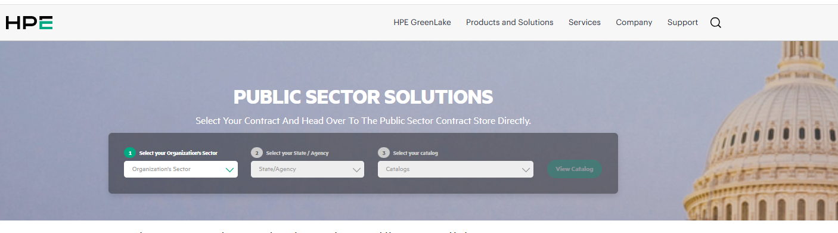

- Select your Organization’s Sector
Under the dropdown, choose <<State & Local Government and Education>>

- Select your State/Agency
Under the dropdown, choose your state

- Select your catalog
Under the dropdown, choose <<NASPO Data Comm>>

- View Catalog

Under Contract Documents, choose <<Indirect Subcontractor>> for a list of authorized resellers

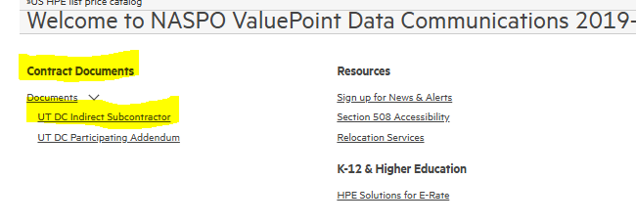

For further assistance, please email public-sled-sales-ams-contracts@hpe.com

