Gainwell’s Immunization Solution
Gainwell has more than 25 years of Immunization Information System (IIS) software development, operations, and maintenance experience. With our extensive history and accomplishments in public health support, Gainwell is a leading provider of IIS solutions and services that use technology to:
- Verify and forecast accurate immunization administration
- Increase physician adoption of IIS
- Raise overall immunization rates
- Improve public health outcomes
Our proven track record is complemented by an experienced Immunization System team of more than 120 employees with technical and industry expertise. Additionally, Gainwell is an active participant in the national immunization community that sets the standards and direction for national immunization systems. This industry experience and the insights we gain daily from collaboration with our clients have enabled us to build and propose a first-class product.

Product Description
Gainwell’s Immunization Solution is a modular, Software-as-a-Service (SaaS), COTS solution which is cloud-based for greatly increased throughput compared with alternate platforms. It conforms to Centers for Disease Control (CDC), Centers for Medicare and Medicaid Services (CMS), and Public Health Information Network (PHIN) standards. Specifically, the solution is aligned to the Public Health Informatics Institute (PHII) Functional Model, is built to meet the CDC’s IIS Functional Standards, and is designed to support the jurisdiction in meeting the CDC’s Health People 2030 goals. It allows for scalability to support periods of intense usage such as during a pandemic. The solution combines COTS benefits with single-tenant design, providing the security and flexibility needed for operational scheduling and controls.
Our IIS was created with performance and scalability as two of its cornerstones. In addition to these cornerstones, the following advantages enable our clients to process more requests at a greater speed, as well as continue to scale just as quickly and easily across additional services:
- Its streamlined code base has no bottlenecks inter-process calls, which reduces the number of needed processes running on the servers and lessens process waiting.
- Its small code base and minimal third-party dependencies reduce the memory footprint required to process requests.
- It was designed to be able to scale quickly with little to no configuration needed for additional instances.
Gainwell’s Immunization Solution provides a flexible, secure, and compliant system that focuses on a seamless end-user experience. Our solution reduces the need for multiple vendors and applications to run an effective immunization system. With Gainwell, jurisdictions can provide stakeholders, including providers, patients, and administrators, one location to adhere to program requirements and can grant health departments access to monitor and define actionable outcomes. Use of the Gainwell Immunization Solution is subject to adherence with the Terms and Conditions.
Key Features
The following are key features of our offering:
- Features and Benefits
Key Features | Benefits
  Compliance. Our unified cloud-based system meets Centers for Disease Control and Prevention (CDC) Functional Standards Version 4.1 and applicable data-quality standards. | The unified system provides a shared, user-friendly experience for patients, providers, the jurisdiction, and users.
  Collaborative. Public and private agencies can transmit data in a variety of formats and comply with federal, state, and local immunization best practices. | Robust data exchanges enable patients, providers, and healthcare partners to make informed, timely decisions together to improve health outcomes.
  Analytics Dashboards. Online tracking of immunizations and health screenings for patients in a variety of public/private healthcare provider sites. | Broad access to comprehensive immunization results that can be used to monitor health equity for children, adolescents, and adults.
  Software as a Service (SaaS). Our web-based solution delivers an integrated patient experience that is accessible on multiple devices. | SaaS eliminates the need to worry about the age of infrastructure, software versions, or capacity limitations.
  Single-Tenant Solution. Unlike competing solutions, our solution is based on a single-tenant service offering. | Single tenancy provides the jurisdiction with assurance its data is not intermingled with other clients’ data. It offers the flexibility of jurisdiction -specific operational scheduling and controls.

Our IIS allows agencies to make data-driven decisions, maintain compliance with industry requirements, and increase the effectiveness of public healthcare management and equitable delivery.
Core Functionality
Gainwell’s Immunization Solution is designed to be modular and highly configurable, enabling jurisdictions to customize and scale their solution to fit functional and budgetary needs. Our base solution possesses these core functional areas:
- Population and Deduplication Management. Accurate information for population management to assist in raising rate initiatives and jurisdiction and federal reporting. Our solution helps increase data quality by removing redundant patient records, preventing fragmented and duplicate information from being processed and ensuring that updates and queries apply to the correct patient for accurate reporting.
- Immunization Forecasting. Clinical decision support of immunizations due and the recommended doses. An automated process that determines the recommended immunizations needed for a patient and delivers these recommendations to the healthcare provider based on the Advisory Committee on Immunization Practices (ACIP).
- Data Exchange. Provides real-time data exchange and interactions with electronic health/medical record (EHR/EMR) systems, hospital systems, and so forth to provide a consolidated immunization record, help guide patient care and improve overall vaccination rates.
- Vaccine Inventory Management and Accountability. Tightly integrated with the CDC’s vaccine management and distribution system (VTrckS) to order and manage doses for the Vaccines for Children (VFC) population, managing and distributing doses, and providing the accountability reporting required at the jurisdictional and federal levels.
- Electronic Enrollments and Agreements. Leveraging the CDCs vaccine storage and handling toolkit, the solution allows for a fully electronic enrollment including electronic signature. The enrollment outlines the requirements of the VFC Program and while also allowing for other vaccine enrollment types to be managed and can easily be configured to support your jurisdiction’s needs.
- Analytic Reports. Delivers reporting capabilities at the patient, organization, city, county, and jurisdiction level to accurately outline coverage rates for vaccine-preventable diseases.
- School Record Management. Improves compliance rates with immunization requirements; can be configured for both school and childcare functionality.
These functional areas are utilized to improve the effectiveness of immunization management and delivery. Gainwell's Immunization Solution allows effective management and automation processes to improve immunization programs. Its robust analytics capabilities help transform data into the insights needed for effective decision making. Our solution helps meet jurisdiction -specific policy needs and provides services for implementation, operation, user support, and training.
Improved User Experience & Delivery
The COTS Gainwell Immunization Solution provides a unified experience for each stakeholder. The following figure illustrates the full user experience from all personas and how they drive better outcomes within the jurisdiction. Users also have the option to select from the following solution-wide language options included at no additional charge: English, French, German and Spanish. Additional languages can be configured by jurisdiction, pursuant to a mutually agreed upon fee.
- Driving Healthy Outcomes
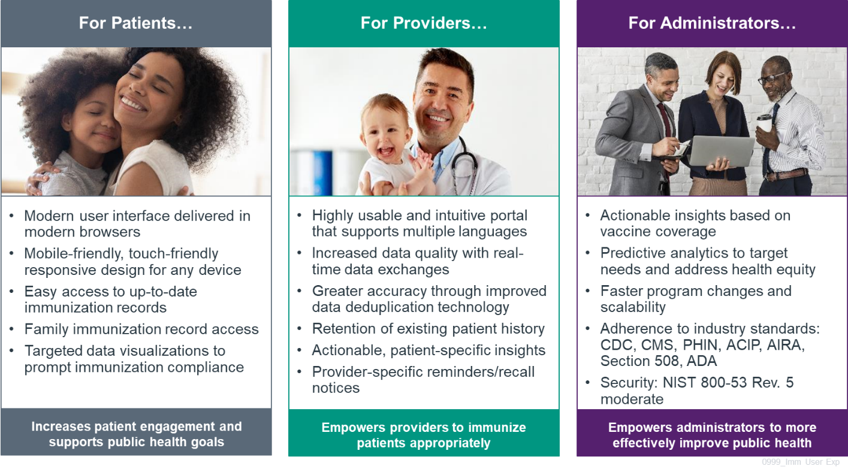
The tool’s responsive design allows for a best-in-class user experience for providers and jurisdiction users on devices that have a web browser. Because of the significant prevalence of smartphone use among program members, usability on the mobile device is critical. Additionally, the system supports two-step verification for improved security. A view of the security architecture is contained in Figure 2, below.

- Security Reference Architecture

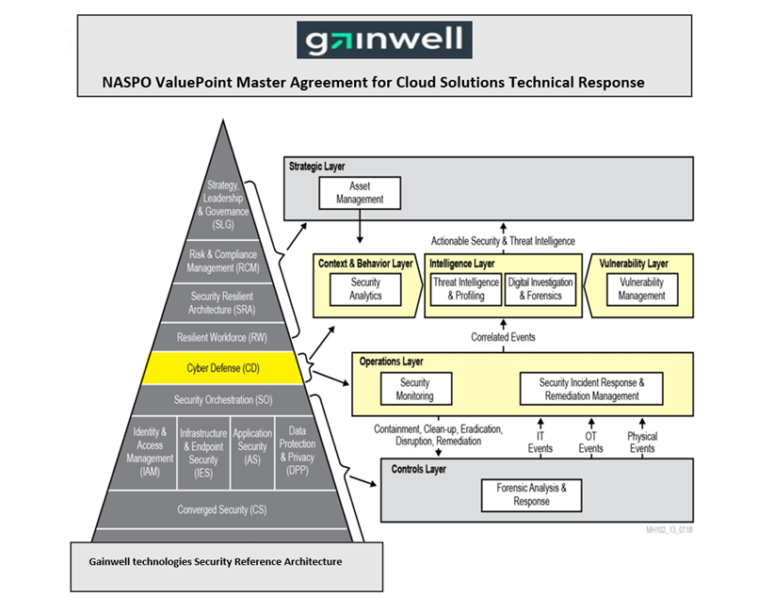

Our solution supports:
Faster delivery of changes through high levels of configurability and cloud-based scalability
Fast integration of optional additional modular capabilities, as needed
Adherence to industry standards, including CDC, Public Health Information Network (PHIN), ACIP, American Immunization Registry Association (AIRA), and Section 508
Scheduled releases at no additional cost to meet ever-changing industry standards
Secure and compliant with National Institute of Standards and Technology (NIST) 800-53 Rev. 5 moderate
Gainwell is using the CDC’s IIS Functional Standards related to user/organizational management. Our solution provides role-based access control (RBAC) to set, delete, and modify multiple levels of user roles and provide rigid controls for data security at the jurisdiction, organization, and user levels. It enables jurisdictional administrators to manage user roles and their permissions. Jurisdictions can configure the relationships between users and an organization.
This high configurability provides jurisdictions with a technology framework in which to advance best practices in user/organizational management.
Quality Results
Gainwell’s next-generation IIS supports better-quality public health outcomes and reduces vaccine-preventable diseases. Our solution delivers more accurate data about immunization history through automating greater real-time exchange of vaccine data and more effectively matching and deduplicating data records.
Individuals have quick access to their immunization records and clear reminders of next steps. Providers have reminders, recall notices, reports, and tools to order and administer vaccines. Public health officials and health plans have meaningful reporting, including predictive analytics, to help support equitable distribution of vaccines and to plan outreach to communities with barriers to vaccine access. As a result, programs achieve better return on investment, improved health outcomes, and enhanced operational efficiency.

Patient Match/Deduplication
Gainwell’s Immunization Solution provides improved functionality with real-time client deduplication and record merging at the patient and the immunization level. Per CDC guidance, the solution implements rules to remove redundant patient records from an agency’s immunization database, prevent incomplete or flawed information from being processed, and verify that updates and queries are applied to the correct record. Functionality includes using prebuilt screens to allow the end user to view matched/pended clients and merge or make distinct records.
This ability helps unify and simplify the collection, organization, and analysis of data by merging patient information into consolidated immunization records accessible by authorized personnel. The solution comes with knowledge about and rules for reconciling or rejecting the most common forms of data duplication and other conflicts that occur in healthcare data. It supports the ability to automatically identify incoming patient records as potential duplicates. It also supports the ability to instantly identify potential duplicates within existing patient records.
The solution applies industry standards published by AIRA. Immunization solutions often receive data from multiple sources using sets of rules to manage the deduplication process and verify data continuity. Data is sequenced, weighted, and then evaluated to produce the strongest match. Set variables, principles, and business rules validate the results. Our solution uses a “match to a patient” process on incoming patient records so the new information is linked to update the correct patient record or create a new patient record as needed.
Data Exchange and Industry Compliance
The Data Exchange component supports updates to a single consolidated immunization record through real-time data exchange with electronic health records (EHRs) and other EHR sources. Our standards for data exchange include:
- Value sets associated with the CDC-endorsed HL7 Implementation Guide for Immunization Messaging
- PHIN standards
Additionally, the system supports CDC Immunization Information Systems Support Branch (IISSB) Functional Standards. These standards address technical guidance for data transport and deduplication, clinical decision support for immunizations (forecasting vaccine), the CDC’s Immunization Gateway (IZGW), and the ability to exchange data among jurisdictions. Compliance with these standards improves data quality and gives public health officials better insight into where to expend resources to address the needs of vulnerable communities. Configurability also allows for jurisdiction -specific required data elements to be added.

Provider Interface and Management
The solution accommodates enrollment for VFC participants and providers; however, provider enrollment for the solution is not limited to VFC providers only. The enrollment functionality also allows providers that serve adults and special populations. With this functionality not limited to VFC providers, the Gainwell Immunization Solution can be used for enrolling providers in response to current and future public health emergencies. Electronic enrollments and agreements are easily configured for all provider types and provide centralized reporting for improved user experience of both providers and the jurisdiction.
Exchanging Data with EHRs in Real Time
Gainwell’s Immunization Solution provides real-time data exchange and interactions with Electronic Health Record (EHR/EMR) applications and other electronic health records sources to provide a consolidated immunization record for each patient. Gainwell interacts with various health and human services partners and providers through our existing contracts across the country; thus, we are intimately familiar with the intricacies of these entities and the security required to protect jurisdictions’ members during the data exchange process. Because we manage these services, our solution is built to use next-generation technology to increase satisfaction while protecting and securing data.
Documenting School/Childcare Audits by Local Public Health Agencies
Our School Record Management module can be configured for both school and childcare functionality. The benefit of this module is to improve compliance rates with immunization requirements. School nurses and staff can use this module to review children’s existing immunization records and enter medically verified historical immunizations that are missing in their IIS. The jurisdiction determines the documents to be considered as proof of medically verified historical immunization. Users can generate reports to determine compliance, determine individuals who may be missing immunization requirements, or determine who is susceptible to a vaccine-preventable disease. The benefits that providers will realize by promoting this module will be seen with the increased accuracy and completeness of immunization records. Data collected from schools and daycares can be configured to monitor compliance in geographic areas of excellence or areas of further opportunity for outreach and health education.

Vaccine Inventory Management and Accountability
One of the Gainwell solution’s core functional areas, Vaccine Inventory Management and Accountability, is designed to be tightly integrated with the CDC's VTrckS to order and manage doses for the VFC population. This includes managing and distributing doses and verifying the accountability reporting required at the jurisdictional and federal levels. This functionality enables a jurisdiction to manage the distribution of vaccines from jurisdiction resources to counties and individual providers enrolled in Gainwell’s Immunization Solution.
Supporting Online Vaccine Ordering
Gainwell’s solution fully supports online vaccine ordering for VFC providers. Features include inventory management of private and public vaccine supplies, and functionality to export data to VTrckS. Overall, the solution provides robust support for healthcare providers in meeting the requirements of the VFC program as well as jurisdiction vaccine programs.
Most notably, the solution improves jurisdictions’ capabilities in the following areas: order processing, reviewing/approving orders, dose decrementing, inventory reconciliation, transfers, wastage, and expiration. Gainwell’s Immunization Solution is fully designed to be configurable, unlike many solutions on the market. Configurability includes the jurisdiction’s ability to configure vaccine order sets. This helps jurisdictions determine which vaccines each facility is eligible to order.
Both private and public vaccines can be tracked in the vaccine inventory tiles. Using this functionality means vaccines are being monitored and used before expiration, lowering the risk of unadministered vaccines. The inventory management tools not only assist the facility in accountable inventory management but also enable the jurisdiction to forecast future vaccine needs, which supports efforts in responsible fiscal management. Additionally, the solution’s user functionality allows for the export of vaccine orders to VTrckS.
Immunization Forecasting
The Immunization Forecasting component notifies clinicians of immunizations due and recommended patient doses based on the CDC’s Advisory Committee on Immunization Practices (ACIP) guidelines.
Gainwell understands that both age and underlining conditions are factors in determining the immunization requirements for each patient/student. Gainwell’s Immunization Solution maintains the ACIP-recommended schedules for children, adolescents, and adults, including travel vaccines. The solution evaluates a patient's immunization history according to Clinical Decision Support for Immunization (CDSi) project guidance and delivers CDSi scenarios to AIRA’s Aggregate Analysis Reporting Tool (AART) for assessment and validity. As a value-added benefit, Gainwell analyzes proposed changes voted on by the ACIP and then updates the solution as necessary on your behalf near real-time. Lastly, the solution will store all prior immunization schedules to assist in validation assessment at the time the vaccine was administered as well as the corresponding test cases.

Reporting and Data Analytics
The solution offers visualizations that support the analysis of immunization coverage. Jurisdiction, county, provider, school, and geographic information systems are eligible functions that can figure into the development of dashboards, which include geographic information to identify risk and other critical factors in a visualization.
Population Management reports support accurate annual reporting to the CDC on immunization events and outcomes. Dashboard reporting enables jurisdictions to identify healthcare trends at the jurisdiction, provider, and school levels. Jurisdictions can also drill down on other data elements as determined by the data being displayed to verify adherence to the jurisdiction’s specific data release policies. Reports include:
- Vaccine use at the patient, clinic, and jurisdiction level
- Inventory auditing to support accountability for the distribution and use of publicly purchased vaccine supplies
- Changes in vaccine administration trends at different administration levels
Delivering Reminder/Recall Notices
Gainwell’s Immunization Solution provides the functionality to deliver reminders and recall notices at both the provider and jurisdiction levels (plus the county, regional, and/or territory levels). We support jurisdictions’ efforts to establish clear, efficient, and targeted communication between themselves, providers, and patients. Among its many features, the solution generates patient-specific reminders and recall notifications, assists providers in identifying specific age-group cohorts when sending reminders, generates patient lists and schedule calendars for reminder and recall communications, and generates vaccine recall notices by administering provider.
For instance, jurisdictions can use this functionality to target cohorts to raise overall immunization rates. Functionality can be streamlined to recall patients for one specific vaccine or multiple vaccines. The results can be used as a tool to aid leadership in determining appropriate public health interventions.
Providing HEDIS Functionality
Jurisdictions will determine the level of access necessary for health plan partners for the insured patient cohorts. For example, a jurisdiction could allow access to measure the percentage of children 2 years of age who had received four doses of diphtheria, tetanus, and acellular pertussis (DTaP); three doses of polio (IPV); one dose of measles, mumps, and rubella (MMR); three doses of Haemophilus influenzae type B (Hib); three doses of hepatitis B (HepB), one dose of varicella (VZV); four doses of pneumococcal conjugate (PCV); one dose of hepatitis A (HepA); two or three doses of rotavirus (RV); and two doses of influenza (flu) vaccines by their second birthday. The jurisdiction could also allow access to aid in assessing adolescents 13 years of age who had one dose of the meningococcal vaccine (MCV); one dose of the tetanus, diphtheria, and acellular pertussis (Tdap) vaccine; and the complete human papillomavirus vaccine (HPV) series by their 13th birthday. Jurisdiction rules would drive health plan access, and then each health plan could select the functionality and reporting they care to review. This may be accomplished through a query and response function, RBAC, and/or an ad hoc report.

Value-Add Modules for Customization
In addition to the core functions detailed above, the following modules are value-add options available to jurisdictions through NASPO:
- Vision Screening Module: Ability to record age-appropriate vision screening test results
- Hearing Screening Module: Ability to allow birthing hospitals to record hearing test results
- Refugee Health Module: Ability to manage refugee health assessments
- Vaccine Allocation Module: Ability for jurisdiction -level users to indicate specific vaccines to set ordering thresholds and allow easy adjustments based on vaccine allotments
- Influenza Prebook Module: Ability for providers to determine and allocate seasonal influenza doses by age, eligibility, and brand to assist the jurisdiction in determining and managing the VFC program’s total influenza vaccine need for the upcoming season
- Immunization Quality Improvement for Providers (IQIP) Module: Ability to use provider data to help promote and improve immunization rates
- Medical Countermeasures Module: Ability to distribute and monitor inventory of the United States’ national repository of antibiotics, vaccines, chemical antidotes, antitoxins, and other critical medical supplies
- Mass Vaccination Module: Ability to support mass vaccination operations, including requiring jurisdiction-defined patient demographic information offline or online during a mass vaccination clinic and supporting digital scanning of vaccine information.
- Perinatal Hepatitis B Module: Ability to track the status of HBsAg-positive pregnant women and to monitor the administration of post-exposure prophylaxis
- Blood Lead Testing Module: Ability to support bidirectional electronic transfers of blood lead test results; provides prompts when a child needs blood lead screening and confirmation and/or follow-up testing
- Parkinson’s Disease Module: Ability to view the history of diagnoses, treatments, clinicians, and medications for a patient’s Parkinson’s Disease history
- Consumer Access Module: Ability for authenticated consumers to directly access their personal IIS record per jurisdictional policy. Users can see their information and immunization records.

Technical Specifications
Gainwell’s Immunization Solution supports multiple options for importing and exporting data. It is fully compliant with the most recent Health Level Seven (HL7) Implementation Guide for Immunization Messaging using Simple Object Access Protocol (SOAP)-based transport by using the standard CDC’s Web Services Description Language (WSDL). The solution also supports flat-file imports for a variety of file submissions.
We deliver our Immunization solution in a cloud-based environment, using Gainwell and COTS products delivered as SaaS, minimizing dependence on traditional on-premises IT infrastructure. We host the solution in a jurisdiction-dedicated Virtual Private Cloud (VPC) on the AWS cloud. As an AWS Partner, we take advantage of AWS capabilities to provide high levels of automation, transparency, consistency, reliability, and security. Our cloud-native digital platform provides an advanced DevOps CI/CD for rapid and flexible deployment.
We periodically update our tooling to take advantage of new product capabilities and stay abreast of changing market standards and security needs. Modern cloud tools support us in delivering a system with high levels of responsiveness, security, uptime, and flexibility to expand or shrink compute levels to match jurisdiction needs.

Additional Terms and Conditions for
Gainwell’s Immunization Solution

Gainwell will work with the Participating Entity to document the services and associated fees in a mutually agreed upon Service Level Agreement. Notwithstanding anything to the contrary contained in the Master Agreement, such Service Level Agreement together with the service description and associated assumptions supersedes and replaces the requirements set forth in the Solicitation and response to the Solicitation and shall be the operative contractual document for the purposes of Gainwell’s Immunization Solution.

- License, Access, and Use:
  - During the period in which Participating Entity maintains a subscription, Gainwell grants Participating Entity a non-exclusive License to use and access Gainwell’s Immunization Solution and its associated documentation (“Documentation”). As reasonably necessary, Participating Entity may make and distribute copies of the Documentation in connection with its use of the Immunization Solution and must include all copyright and other proprietary notices as presented in the original Documentation.

  - Participating Entity acknowledges that the Immunization Solution contains valuable trade secrets of Gainwell and its licensors. Participating Entity and its users shall not: (a) use the Immunization Solution in violation of any applicable law including U.S. export, import and sanctions regulations; (b) sell, sublicense, distribute, assign, pledge, lease, transfer, copy, republish, disclose, or in any way encumber the Immunization Solution, except as otherwise expressly permitted under the Master Agreement and/or Order; (c) use or allow the use of the Immunization Solution in a computer service business, third-party outsourcing service, on a membership or subscription basis, on a service bureau basis, on a time-sharing basis, or on behalf of any third party; (d) modify, create derivative works of, adapt, translate, reverse engineer, decompile, or otherwise attempt to discover the source code in the Immunization Solution; (e) remove or alter any copyright or proprietary notices associated with the Documentation; or (f) unbundle any components of the Immunization Solution.

1.3 Access/Use. (a) Access to and use of the Immunization Solution is limited to Participating Entity and its users; (b) Participating Entity is fully responsible for maintaining the confidentiality of the user credentials and the security of its account, and all activities that occur regarding a user, including a user’s breach of the Master Agreement, Participating Addendum and/or Order; (c) User credentials cannot be shared or used by more than one individual; (d) Participating Entity agrees to comply with all applicable laws and regulations in connection with its access to and use of the Immunization Solution; (e) Participating Entity agrees to: (i) use commercially reasonable efforts to promptly stop any unauthorized access to the Immunization Solution known to Participating Entity that is attributable to use of the Immunization Solution by Participating Entity or a user; and (ii) promptly notify Gainwell of any security incident or threat known to Participating Entity that may involve the Immunization Solution and cooperate with Gainwell in the investigation of any such security incident or threat; (f) Participating Entity may allow a contractor to access and use the Immunization Solution solely on Participating Entity’s behalf for ancillary services provided the contractor, provided that the contractor, (i) is not a competitor of Gainwell or any of its Affiliates; and (ii) complies with the terms of this License Agreement; (g) Participating Entity and its users shall not (i) engage in any unlawful, invasive, infringing, defamatory, or fraudulent conduct; (ii) interfere with any technology or equipment used to provide the Immunization Solution; (iii) alter, disable, interfere with or circumvent any aspect of the Immunization Solution; and/or (iv) use the Immunization Solution in a manner not authorized by Gainwell. Without limiting any of Gainwell’s termination rights under the Master Agreement, Participating Addendum and/or Order, if any use of the Immunization Solution by Participating Entity and/or any user reasonably threatens the security or integrity of Gainwell’s information

systems and/or information systems network, Gainwell may suspend access to the Immunization Solution until such time as the threat is eliminated.

1.4 OTHER THAN AS PROVIDED IN THE MASTER AGREEMENT, GAINWELL MAKES NO EXPRESS OR IMPLIED REPRESENTATIONS OR WARRANTIES WITH RESPECT TO GAINWELL’S IP OR THE IMMUNIZATION SOLUTION OR THEIR CONDITION, MERCHANTABILITY, FITNESS FOR ANY PARTICULAR PURPOSE, OR ITS USE BY PARTICIPATING ENTITY.

2. Title and Feedback:

2.1. All rights, title, and interest in and to Gainwell’s IP, the Immunization Solution and Documentation (including their copies, improvements, enhancements, updates, revisions, modifications, and derivative works) shall at all times remain with Gainwell and as applicable, its licensors, and Participating Entity’s interest therein is only that of having temporary possession in order to use and access the Immunization Solution.

2.2. If Participating Entity or any of its users provide Feedback, Participating Entity hereby assigns and transfers to Gainwell, without further consideration, all right, title and interest in and to such Feedback automatically upon the creation or disclosure of the same. For clarity, nothing in this License Agreement or otherwise will: (a) restrict the right of Gainwell and its affiliates to use or disclose Feedback; (b) obligate Gainwell to credit Participating Entity or a user as the source of the Feedback; or (c) require Gainwell to provide any compensation to Participating Entity or any user with respect to the Feedback. For the purposes of this Section, “Feedback” means any communication by Participating Entity to Gainwell regarding the performance of the Software Program including issues, errors, suggested changes, or modifications concerning the Software Program.

3. Confidential Information:

3.1 The following shall be added to the definition of “Confidential Information” in the Master Agreement. Confidential Information shall also include all non-public Gainwell information provided, displayed, or made available by Gainwell under the Agreement, Participating Agreement and/or Order which would be reasonably understood to be confidential under the circumstances of disclosure, or that is marked, designated, or communicated by Gainwell to Participating Entity to be confidential. Confidential Information of Gainwell includes without limitation all materials, processes and process flows, programs, software systems and documentation, information management systems, code, logic, analytical methodologies and algorithms, reports, analyses, data, associated proprietary forms of data organization and reports, all Gainwell IP (as defined below), or any other information, or other work product whether or not disclosed to Participating Entity by or on behalf of Gainwell. Gainwell intellectual property (“Gainwell IP”) means, collectively, Gainwell’s analyses, tools, designs, database rights, processes and process flows, programs, software, materials, works of authorship, inventions (whether or not patentable), trade secrets, patents, trademarks, trade names, systems and documentation, analytical methodologies and algorithms, information management systems, associated proprietary forms of data organization, whether or not confidential, all enhancements, modifications, improvements or derivatives thereof, and all intellectual property and proprietary rights whether arising by operation of law, contract, license, or otherwise in and to the foregoing. In the event of a state or federal open records or freedom of information act request for disclosure of any Confidential Information related to or arising out of the Master Agreement, Participating Addendum or an Order, Participating Entity shall provide written notice to Gainwell to allow Gainwell the opportunity to respond to the open records or other freedom of information act requester and protect any Confidential Information.

