The Lead State approved pricing for DiscountCell can be found in the link below:
http://www.discountcell.com/wsca
To access your State pricing, please use the following instructions:
- Click on the BLUE hyperlink below:
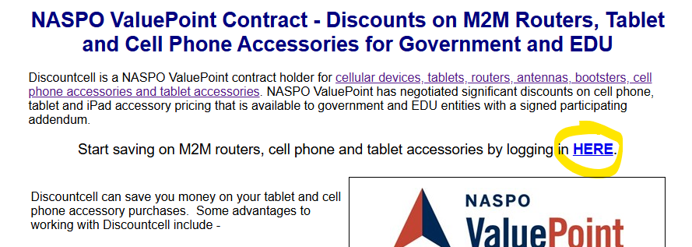

- Enter WSCA as the company code, then select your State and Purchase Type -> Government.

