Description of Google Cloud Platform (GCP) Services

Overview
This overview is designed to help you understand the overall landscape of Google Cloud Platform (GCP). Here, you'll take a brief look at some of the commonly used features and get pointers to documentation that can help you go deeper. Knowing what's available and how the parts work together can help you make decisions about how to proceed. You'll also get pointers to some tutorials that you can use to try out GCP in various scenarios.

GCP resources
GCP consists of a set of physical assets, such as computers and hard disk drives, and virtual resources, such as virtual machines (VMs), that are contained in Google's data centers around the globe. Each data center location is in a global region. Regions include Central US, Western Europe, and East Asia. Each region is a collection of zones, which are isolated from each other within the region. Each zone is identified by a name that combines a letter identifier with the name of the region. For example, zone a in the East Asia region is named asia-east1-a.
This distribution of resources provides several benefits, including redundancy in case of failure and reduced latency by locating resources closer to clients. This distribution also introduces some rules about how resources can be used together.

Accessing resources through services
In cloud computing, what you might be used to thinking of as software and hardware products, become services. These services provide access to the underlying resources. The list of available GCP services is long, and it keeps growing. When you develop your website or application on GCP, you mix and match these services into combinations that provide the infrastructure you need, and then add your code to enable the scenarios you want to build.

Global, regional, and zonal resources
Some resources can be accessed by any other resource, across regions and zones. These global resources include preconfigured disk images, disk snapshots, and networks. Some resources can be accessed only by resources that are located in the same region. These regional resources include static external IP addresses. Other resources can be accessed only by resources that are located in the same zone. These zonal resources include VM instances, their types, and disks.
The following diagram shows the relationship between global scope, regions and zones, and some of their resources:

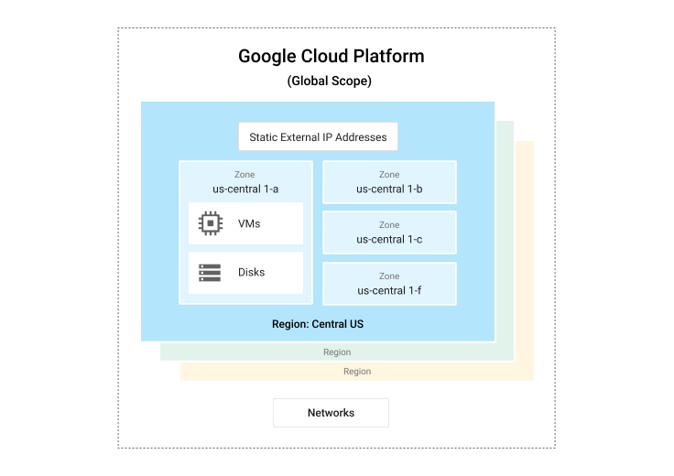
The scope of an operation varies depending on what kind of resources you're working with. For example, creating a network is a global operation because a network is a global resource, while reserving an IP address is a regional operation because the address is a regional resource.
As you start to optimize your GCP applications, it's important to understand how these regions and zones interact. For example, even if you could, you wouldn't want to attach a disk in one region to a computer in a different region because the latency you'd introduce would make for very poor performance. Thankfully, GCP won't let you do that; disks can only be attached to computers in the same zone.
Depending on the level of self-management required for the computing and hosting service you choose, you might or might not need to think about how and where resources are allocated.
For more information about the geographical distribution of GCP, see Geography and Regions.

Projects
Any GCP resources that you allocate and use must belong to a project. You can think of a project as the organizing entity for what you're building. A project is made up of the settings, permissions, and other metadata that describe your applications. Resources within a single project can work together easily, for example by communicating through an internal network, subject to the regions-and-zones rules. The resources that each project contains remain separate across project boundaries; you can only interconnect them through an external network connection.
Each GCP project has:
- A project name, which you provide.
- A project ID, which you can provide or GCP can provide for you.
- A project number, which GCP provides.
As you work with GCP, you'll use these identifiers in certain command lines and API calls. The following screenshot shows a project name, its ID, and number:
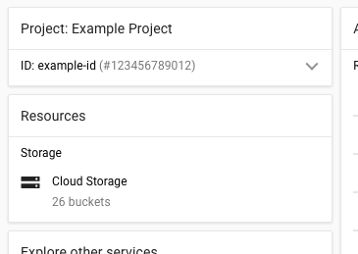
In this example:
- Example Project is the project name.
- example-id is the project ID.
- 123456789012 is the project number.
Each project ID is unique across GCP. Once you have created a project, you can delete the project but its ID can never be used again.
When billing is enabled, each project is associated with one billing account. Multiple projects can have their resource usage billed to the same account.
A project serves as a namespace. This means every resource within each project must have a unique name, but you can usually reuse resource names if they are in separate projects. Some resource names must be globally unique. Refer to the documentation for the resource for details.

Ways to interact with the services
GCP gives you three basic ways to interact with the services and resources.

Google Cloud Platform Console
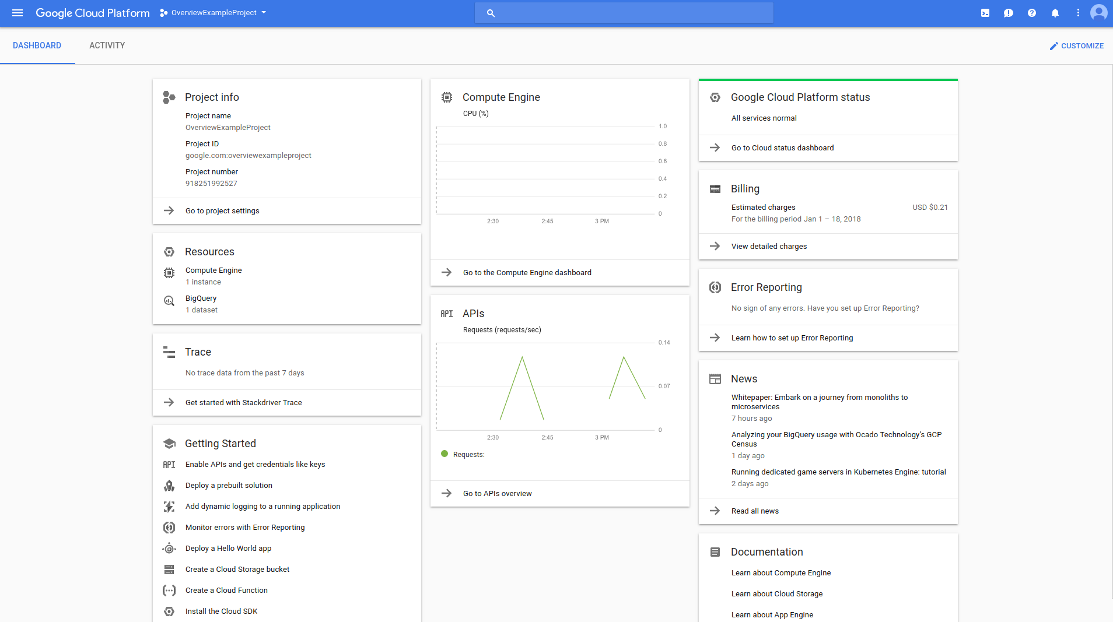
The Google Cloud Platform Console provides a web-based, graphical user interface that you can use to manage your GCP projects and resources. When you use the GCP Console, you create a new project, or choose an existing project, and use the resources that you create in the context of that project. You can create multiple projects, so you can use projects to separate your work in whatever way makes sense for you. For example, you might start a new project if you want to make sure only certain team members can access the resources in that project, while all team members can continue to access resources in another project.

Command-line interface
If you prefer to work in a terminal window, the Google Cloud SDK provides the gcloud command-line tool, which gives you access to the commands you need. The gcloud tool can be used to manage both your development workflow and your GCP resources. See the gcloud reference for the complete list of available commands.
GCP also provides Cloud Shell, a browser-based, interactive shell environment for GCP. You can access Cloud Shell from the GCP console. Cloud Shell provides:
- A temporary Compute Engine virtual machine instance.
- Command-line access to the instance from a web browser.
- A built-in code editor.
- 5 GB of persistent disk storage.
- Pre-installed Google Cloud SDK and other tools.
- Language support for Java, Go, Python, Node.js, PHP, Ruby and .NET.
- Web preview functionality.
- Built-in authorization for access to GCP Console projects and resources.
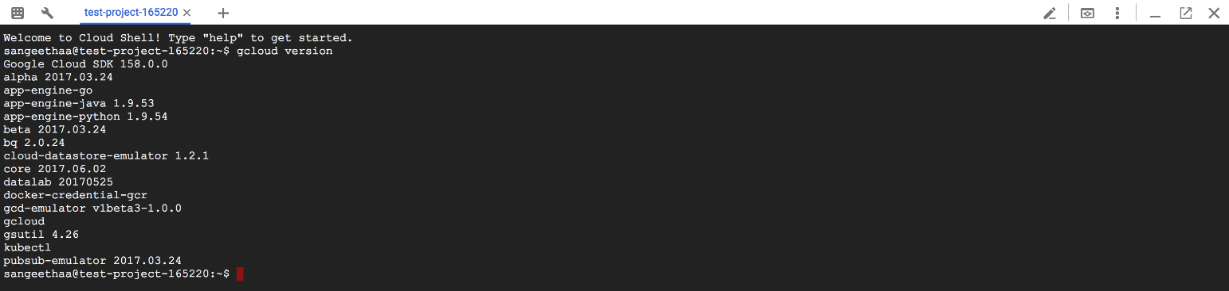

Client libraries
The Cloud SDK includes client libraries that enable you to easily create and manage resources. GCP client libraries expose APIs for two main purposes:
- App APIs provide access to services. App APIs are optimized for supported languages, such as Node.js and Python. The libraries are designed around service metaphors, so you can work with the services more naturally and write less boilerplate code. The libraries also provide helpers forauthentication and authorization.
- Admin APIs offer functionality for resource management. For example, you can use admin APIs if you want to build your own automated tools.
You also can use the Google API client libraries to access APIs for products such as Google Maps, Google Drive, and YouTube.

Pricing
To understand Google's principles about how pricing works on GCP, see the Pricing page. To understand pricing for individual services, see the product pricing section.
You can also take advantage of some tools to help you evaluate the costs of using GCP.
- The pricing calculator provides a quick and easy way to estimate what your GCP usage will look like. You can provide details about the services you want to use, such as the number of Compute Engine instances, persistent disks and their sizes, and so on, and then see a pricing estimate.
- The total cost of ownership (TCO) tool evaluates the relative costs for running your compute load in the cloud, and provides a financial estimate. The tool provides several inputs for cost modeling, which you can adjust, and then compares estimated costs on GCP and AWS. This tool does not model all components of a typical application, such as storage and networking.

About the GCP Services
This overview introduces some of the commonly used Google Cloud Platform (GCP) services. For the full list of services, see the Products and Services page.
This overview covers the following types of services:
- Computing and hosting
- Storage
- Networking
- Big data
- Machine learning

Computing and hosting services
GCP gives you options for computing and hosting. You can choose to:
- Work in a serverless environment.
- Use a managed application platform.
- Leverage container technologies to gain lots of flexibility.
- Build your own cloud-based infrastructure to have the most control and flexibility.
You can imagine a spectrum where, at one end, you have most of the responsibilities for resource management and, at the other end, Google has most of those responsibilities:
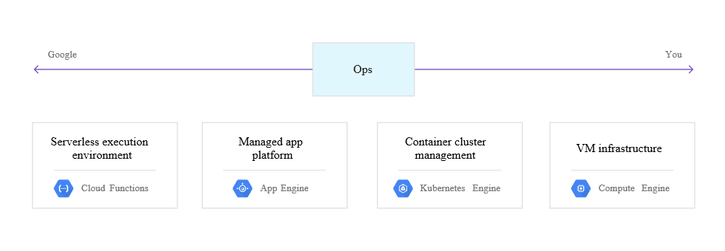

Serverless computing
Google Cloud Functions, GCP's functions as a service (FaaS) offering, provides a serverless execution environment for building and connecting cloud services. With Cloud Functions, you write simple, single-purpose functions that are attached to events raised by your cloud infrastructure and services. Your Cloud Function runs when a watched event is raised. Your code executes in a fully managed environment; you don't need to provision any infrastructure or worry about managing any servers.
You write Cloud Functions using Javascript, and execute them in a Node.js v6.11.5 environment on GCP. You can run your Cloud Function in any standard Node.js runtime, which makes portability and local testing easy.
Cloud Functions are a good choice for use cases that include:
- Data processing and ETL operations, for scenarios such as video transcoding and IoT streaming data.
- Webhooks to respond to HTTP triggers.
- Lightweight APIs that comprise loosely coupled logic into applications.
- Mobile backend functions.

Application platform
Google App Engine is GCP's platform as a service (PaaS). With App Engine, Google handles most of the management of the resources for you. For example, if your application requires more computing resources because traffic to your website increases, Google automatically scales the system to provide those resources. If the system software needs a security update, that's handled for you, too.
When you build your app on App Engine, you can:
- Build your app on top of the App Engine standard environment runtimes in the languages that the standard environment supports, including: Python 2.7, Java 8, Java 7, PHP 5.5, and Go 1.8, 1.6.
- Build your app on top of the App Engine flexible environment runtimes in the languages that App Engine flexible supports, including: Python 2.7/3.6, Java 8, Go 1.8, Node.js, PHP 5.6, 7, .NET, and Ruby. Or use custom runtimes to use an alternative implementation of a supported language or any other language.
- Let Google manage app hosting, scaling, monitoring, and infrastructure for you.
- Use the App Engine SDK to develop and test on your local machine in an environment that simulates App Engine on GCP.
- Easily use the storage technologies that App Engine is designed to support in the standard and flexible environments.
Google Cloud SQL is your SQL database, supporting either MySQL or PostgreSQL. App Engine Datastore is your schemaless, NoSQL datastore. Google Cloud Storage provides space for your large files.
In the standard environment, you can also choose from a variety of third-party databases to use with your applications such as Redis, MongoDB, Cassandra, and Hadoop.
In the flexible environment, you can easily use any third-party database supported by your language, if the database is accessible from the Google App Engine instance.
In either environment, these third-party databases can be hosted on Compute Engine, hosted on another cloud provider, hosted on-premises, or managed by a third- party vendor.
- Use Cloud Endpoints in the standard environment to generate APIs and client libraries that you can use to simplify data access from other applications. Endpoints makes it easier to create a web backend for web clients and mobile clients, such as Android or iOS.
- Use built-in, managed services for activities such as email and user management.
- Use Cloud Security Scanner to identify security vulnerabilities as a complement to your existing secure design and development processes.
- Deploy your app by using the App Engine launcher GUI application on Mac OS X or Microsoft Windows or by using the command line.
- For the standard environment, run your app from the Central US or Western Europe regions.
For a complete list and description of App Engine's features, see the App Engine documentation.

Containers
With container-based computing, you can focus on your application code, instead of on deployments and integration into hosting environments. Google Kubernetes Engine, GCP's containers as a service(CaaS) offering, is built on the open source Kubernetes system, which gives you the flexibility of on-premises or hybrid clouds, in addition to GCP's public cloud infrastructure.
When you build with Kubernetes Engine, you can:
- Create and manage groups of Compute Engine instances running Kubernetes, called clusters. Kubernetes Engine uses Compute Engine instances as nodes in a cluster. Each node runs the Docker runtime, a Kubelet agent that monitors the health of the node, and a simple network proxy.
- Declare the requirements for your Docker containers by creating a simple JSON configuration file.
- Use Google Container Registry for secure, private storage of Docker images. You can push images to your registry and then you can pull images to any Compute Engine instance or your own hardware by using an HTTP endpoint.
- Create single- and multi-container pods. Each pod represents a logical host that can contain one or more containers. Containers in a pod work together by sharing resources, such as networking resources. Together, a set of pods might comprise an entire application, a micro-service, or one layer in a multi-tier application.
- Create and manage replication controllers, which manage the creation and deletion of pod replicas based on a template. Replication controllers help to ensure that your application has the resources it needs to run reliably and scale appropriately.
- Create and manage services. Services create an abstraction layer that decouples frontend clients from pods that provide backend functions. In this way, clients can work without concerns about which pods are being created and deleted at any given moment.
- Create an external network load balancer.

Virtual machines
GCP's unmanaged compute service is Google Compute Engine. You can think of Compute Engine as providing an infrastructure as a service (IaaS), because the system provides a robust computing infrastructure, but you must choose and configure the platform components that you want to use. With Compute Engine, it's your responsibility to configure, administer, and monitor the systems. Google will ensure that resources are available, reliable, and ready for you to use, but it's up to you to provision and manage them. The advantage, here, is that you have complete control of the systems and unlimited flexibility.
When you build on Compute Engine, you can:
- Use virtual machines (VMs), called instances, to build your application, much like you would if you had your own hardware infrastructure. You can choose from a variety of instance types to customize your configuration to meet your needs and your budget.
- Choose which global regions and zones to deploy your resources in, giving you control over where your data is stored and used.
- Choose which operating systems, development stacks, languages, frameworks, services, and other software technologies you prefer.
- Create instances from public or private images .
- Use GCP storage technologies or any third-party technologies you prefer.
- Use Google Cloud Launcher to quickly deploy pre-configured software packages. For example, you can deploy a LAMP or MEAN stack with just a few clicks.
- Create instance groups to more easily manage multiple instances together.
- Use autoscaling with an instance group to automatically add and remove capacity.
- Attach and detach disks as needed.
- Use SSH to connect directly to your instances.

Combining computing and hosting options
You don't have to stick with just one type of computing service. For example, you can combine App Engine and Compute Engine to take advantage of the features and benefits of each. For an example of using both App Engine and Compute Engine, see Reliable Task Scheduling on Google Compute Engine.
For a detailed look at options for serving websites, see Serving Websites.

Storage services
Whatever your application, you'll probably need to store some data. GCP provides a variety of storage services, including:
- A SQL database in Cloud SQL, which provides either MySQL or PostgreSQL databases.
- A fully managed, mission-critical, relational database service in Cloud Spanner that offers transactional consistency at global scale, schemas, SQL querying, and automatic, synchronous replication for high availability.
- Two options for NoSQL data storage: Cloud Datastore and Cloud Bigtable.
- Consistent, scalable, large-capacity data storage in Cloud Storage. Cloud Storage comes in several flavors:
  - Multi-Regional provides maximum availability and geo-redundancy.
  - Regional provides high availability and a localized storage location.
  - Nearline provides low-cost archival storage ideal for data accessed less than once a month.
  - Coldline provides the lowest-cost archival storage for backup and disaster recovery.
- Persistent disks on Compute Engine, for use as primary storage for your instances. Compute Engine offers both hard-disk-based persistent disks, called standard persistent disks, and solid-state persistent disks (SSD).
You can also choose to set up your preferred storage technology on Compute Engine by using persistent disks. For example, you can set up MongoDB as your NoSQL storage.
To understand the full range and benefits of storage services on GCP, see Choosing a Storage Option.

Networking services
While App Engine manages networking for you, and Kubernetes Engine uses the Kubernetes model, Compute Engine provides a set of networking services. These services help you to load-balance traffic across resources, create DNS records, and connect your existing network to Google's network.

Networks, firewalls, and routes
Compute Engine provides a set of networking services that your VM instances use. Each instance can be attached to only one network. Every Compute Engine project has a default network. You can create additional networks in your project, but networks cannot be shared between projects.
Firewall rules govern traffic coming into instances on a network. The default network has a default set of firewall rules, and you can create custom rules, too.
A route lets you implement more advanced networking functions in your instances, such as creating VPNs. A route specifies how packets leaving an instance should be directed. For example, a route might specify that packets destined for a particular network range should be handled by a gateway virtual machine instance that you configure and operate.

Load balancing
If your website or application is running on Compute Engine, the time might come when you're ready to distribute the workload across multiple instances. Compute Engine's server-side load balancingfeatures provide you with the following options:
- Network load balancing lets you distribute traffic among server instances in the same region based on incoming IP protocol data, such as address, port, and protocol. Network load balancing is a great solution if, for example, you want to meet the demands of increasing traffic to your website.
- HTTP/HTTPS load balancing enables you to distribute traffic across regions so you can ensure that requests are routed to the closest region or, in the event of a failure or over-capacity limitations, to a healthy instance in the next closest region. You can also use HTTP/HTTPS load balancing to distribute traffic based on content type. For example, you might set up your servers to deliver static content, such as images and CSS, from one server and dynamic content, such as PHP pages, from a different server. The load balancer can direct each request to the server that provides each content type.

Cloud DNS
You can publish and maintain Domain Name System (DNS) records by using the same infrastructure that Google uses. You can use the Google Cloud Platform Console, the command line, or a REST API to work with managed zones and DNS records.

Advanced connectivity
If you have an existing network that you want to connect to GCP resources, Google Cloud Interconnect offers three options for advanced connectivity:
- Carrier Interconnect enables you to connect your infrastructure to Google's network edge through highly available, lower-latency connections by using service providers. You can also extend your private network into your private Compute Engine network over Carrier Interconnect links by using a VPN tunnel between the networks.
- You can establish a direct peering connection between your business network and Google’s. With this connection, you can exchange Internet traffic between your network and Google’s at one of Google's broad-reaching Edge network locations. Visit Google's peering site to find out more information about edge locations.
- Cloud VPN lets you connect your existing network to your Compute Engine network via an IPsec connection. You can use VPN to connect two Compute Engine VPN gateways to each other.

Big data services
Big data services enable you to process and query big data in the cloud to get fast answers to complicated questions.

Data analysis
BigQuery provides data analysis services. With BigQuery, you can:
- Create custom schemas that organize your data into datasets and tables.
- Load data from a variety of sources, including streaming data.
- Use SQL-like commands to query massive datasets very quickly. BigQuery is designed and optimized for speed.
- Use the web UI, command-line interface, or API.
- Load, query, export, and copy data by using jobs.
- Manage data and protect it by using permissions.
To try out BigQuery quickly and easily, try using the Web UI Quickstart to query a public dataset. For an end-to-end example of using BigQuery to process real-time data, see Real-time Data Analysis with Kubernetes, Redis, and BigQuery.

Batch and streaming data processing
Cloud Dataflow provides a managed service and set of SDKs that you can use to perform batch and streaming data processing tasks. Dataflow works well for high-volume computation, especially when the processing tasks can clearly and easily be divided into parallel workloads. Dataflow is also great for extract-transform-load (ETL) tasks, which are useful for moving data between different storage media, transforming data into a more desirable format, or loading data onto a new storage system.

Asynchronous messaging
Cloud Pub/Sub is an asynchronous messaging service. Your application can send messages, as JSON data structures, to a publishing unit called a topic. Because Cloud Pub/Sub topics are a global resource, other applications in projects that you own can subscribe to the topic to receive the messages in HTTP request or response bodies. You can try Cloud Pub/Sub with some short experiences. For an end-to-end example that uses Pub/Sub for a big data scenario, see Real-time Data Analysis with Kubernetes, Pub/Sub, and BigQuery.
Cloud Pub/Sub's usefulness isn't confined to big data. You can use Cloud Pub/Sub in many circumstances where you need an asynchronous messaging service. For an example that uses Cloud Pub/Sub to coordinate App Engine and Compute Engine, see Reliable Task Scheduling on Compute Engine.

Machine learning services
GCP Cloud AI offers a variety of powerful machine learning (ML) services. You can choose to use APIs that provide pre-trained models optimized for specific applications, or build and train your own large-scale, sophisticated models using a managed TensorFlow framework.

ML APIs
GCP offers a variety of APIs that enable you to take advantage of Google's ML without creating and training your own models.
- Google Cloud Video Intelligence API lets you use video analysis technology that provides label detection, explicit content detection, shot-change detection, and regionalization features.
- Google Cloud Speech API lets you convert audio to text, recognizing over 110 languages and variants, to support your global user base. You can transcribe the text of users dictating to an application’s microphone, enable command-and-control through voice, or transcribe audio files, among other use cases.
- Google Cloud Vision API lets you easily integrate vision detection features, including image labeling, face and landmark detection, optical character recognition (OCR), and tagging of explicit content.
- Google Natural Language API lets you add sentiment analysis, entity analysis, entity-sentiment analysis, content classification, and syntax analysis.
- Google Cloud Translation API lets you quickly translate source text into any of over a hundred supported languages. Language detection helps out in cases where the source language is not known.
- Dialogflow Enterprise Edition lets you build conversational interfaces for websites, mobile applications, popular messaging platforms, and IoT devices. You can use it to build interfaces, such as chatbots, that are capable of natural and rich interactions with humans.

Cloud ML Engine
Cloud Machine Learning Engine combines the managed infrastructure of GCP with the power and flexibility of TensorFlow. You can use it to train your machine learning models at scale, and to host trained models to make predictions about new data in the cloud.
Cloud ML Engine enables you to train machine learning models by running TensorFlow training applications on GCP, and hosts those trained models for you, so you can use them to get predictions about new data. Cloud ML Engine manages the computing resources that your training job needs to run, so you can focus more on your model than on hardware configuration or resource management.

