Attachment 09.4
COST PROPOSAL AND NARRATIE FOR CATEGORY 4 - VALUE ADDED SERVICES
Per Attachment 02, Scope of Work, VII. Offerors may propose value added services related to Offender Electronic Monitoring. The Lead State and NASPO reserves the right not to allow additional services proposed by the Contractor in the Master Agreement.

Awards for Category 4 will not be given to Offerors who do not also qualify for an award in Category 1, 2, or 3.

Contractors awarded Category 4 may not provide Category 4 Services to Purchasing Entities who are not also utilizing the Contractor’s services from Category 1, 2, or 3.

Offerors shall provide cost and a narrative for all Value Added Services proposed. This narrative must be accompanied by all proposed pricing. The written narrative must include an overview of the proposed Value Added Service(s), functionality, system requirements, benefits to the Purchasing Entity, how it aligns with services proposed for Category 1, 2, or 3, and any other necessary information pertaining to the Value Added Service(s).

Value Added Service

a.Check
Allied Universal Electronic Monitoring offers the a.Check mobile app – a customizable check-in app using biometric recognition to ensure reliable participant monitoring. It empowers officers to efficiently communicate with and supervise participants from their phones while in the field.
Not only does a.Check provide a broad range of supervision tools, but it’s straightforward and easy to use for both parties. To get started, the officer selects the required service(s) in EM Manager, enters the check-in schedule, and has the participant download and install a.Check from the App Store or Google Play.

Key Benefits
- Text and Video Chat – communicates via two-way video or text messaging between the agency staff and participant
- Biometric Identification – confirms the participant’s identity using fingerprint identification, facial recognition, and voice verification
- Self-Reporting – bridges the gap between mobile and desktop as participants answer a list of supervision-related questions and responses are automatically reported in EM Manager
- GPS Location and Zones – captures GPS location points during check-ins and compares with inclusion and exclusion zones
- Document Upload – lets participants upload required case management documentation
- Calendar – schedules and displays appointments
- Community Resource Page – provides a customized list of community resources available to the participant

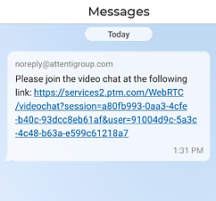
Communication
a.Check gives agency staff two secure messaging options — text messaging and video chat. The officer initiates messages through EM Manager or Mobile EM Manager. Communications are secure, and all text messages and video calls are logged and timestamped with the date and time.

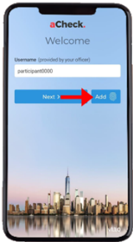
Biometric Check-In
a.Check offers three types of biometric identification — fingerprint identification, facial recognition, and voice recognition — and offers both scheduled and random check-ins.

Fingerprint Identification
During enrollment, participants have the option of adding their fingerprint to access a.Check in lieu of creating a password. Once fingerprint identification is set up, the participant simply touches the mobile phone screen where prompted to sign into the system.

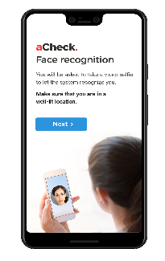
Facial recognition
During enrollment, the officer has the participant take a video “selfie” that ensures facial verification. At the scheduled check-in time, a push notification is sent to the phone to prompt the participant to respond, then the app instructs him/her to take up to three photos to complete the facial verification process.

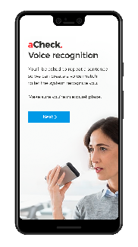
Voice Recognition
During enrollment, the officer has the participant follow the screen prompts and recite a sentence that will be used for voice recognition. At the scheduled check-in time, a push notification is sent to the phone to prompt the participant to respond, who then follows the simple 3-step verification prompts on the smartphone screen.
If the participant misses a check-in, fails the facial or voice verification, or is unavailable, the designated officer receives an alert.

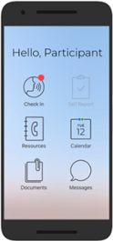
Self-Report
a.Check also includes the self-report function that prompts the participant to answer a few yes or no questions such as “Did you change your home address?” and finalizes the process through Face or Voice Recognition.

Additional Benefits
Additional benefits of a.Check include the Calendar to schedule appointments and visits, Community Resource Information based on officer referrals, and the Document Upload feature for required case management documents.

Price Schedule
Product Description | Quantity | Per Unit/Per Participant
a.Check | 1+ | $1.00

AUEM Watch
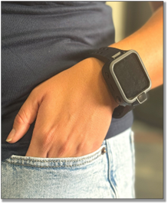
The AUEM Watch is Allied Universal Electronic Monitoring’s newest wrist-worn GPS tracking solution that is less intrusive and provides discretion for the participant while offering full GPS monitoring functionality.The AUEM Watch lowers the stigma associated with current electronic monitoring products while continuing to ensure consistent GPS tracking and two-way communication. The Watch functions similarly to other GPS tracking devices by recording events, alerts, and positions, as well as providing a regular status check.
In addition to reducing stigma, the AUEM Watch is a solution which can accommodate a variety of special needs and health conditions with its sleek wrist-worn design.

GPS Location and Zones
For precise tracking, GPS location points are captured. Inclusion and exclusion zones further enhance monitoring by defining specific areas for compliance.

Multiple Communication Options
Officers and participants can maintain seamless and secure encrypted communication through voice calls and text messages, ensuring constant and effective interaction.

Charging
The device has a 24-hour battery life with the convenience of wireless charging. For additional flexibility, recharge the device using a USB connection, ensuring devices are always powered up and ready to go.

Tamper and Strap Alerts
Alerts are triggered and sent through the system if tampering with the device or strap is detected, ensuring immediate response to potential security breaches.

Unique Design
Designed with the end user in mind, the device features soft, rounded corners and a slim, discreet profile.

AUEM Watch
Product | FCC ID
AUEM Watch | NC3-6605AVL

Battery Life
Device | Battery Life
AUEM Watch | 36 hours

Alerts Available for Set-up
The alerts vary based on which GPS tracking option the Participating Entity selects. The list below is based on AUEM’s most popular device utilized by NASPO customers – the AT1. Many of these alerts are also reported by the RTC and the AUEM Watch.

Events and Alerts
All events and alerts recorded by the GPS devices offered are date- and time-stamped and downloaded to our central computer system. The device records and notifies on the following:
- Inclusion Zone | - GPS Jamming
- Exclusion Zone | - Shielding
- Strap Tamper | - Motion No GPS
- Device Tamper | - Unable to Connect
- Cellular Jamming | - Battery Low/Critical Battery Low

AUEM Watch Price Schedule – Please see attached Excel File

