Changelog:
- Update pricing for Accenture Reach Platform offering
- Update pricing for services under ERP and CRM Support Services value added services
- Update pricing for services under Cloud Application Services value added services
- Update pricing for services under Independent Verification & Validation (IV&V) Services value added services
- Update pricing for services under Accenture Cloud Transformation Advisory value added services
- Update pricing for services under SaaS Platform Implementation Services value added services

Offering Title: Accenture Reach Platform
Service Description:
No change to service description.

Portfolio Category:
- SaaS (Software as-a-Service)
Additional Terms & Conditions: None.

Offering List Pricing:

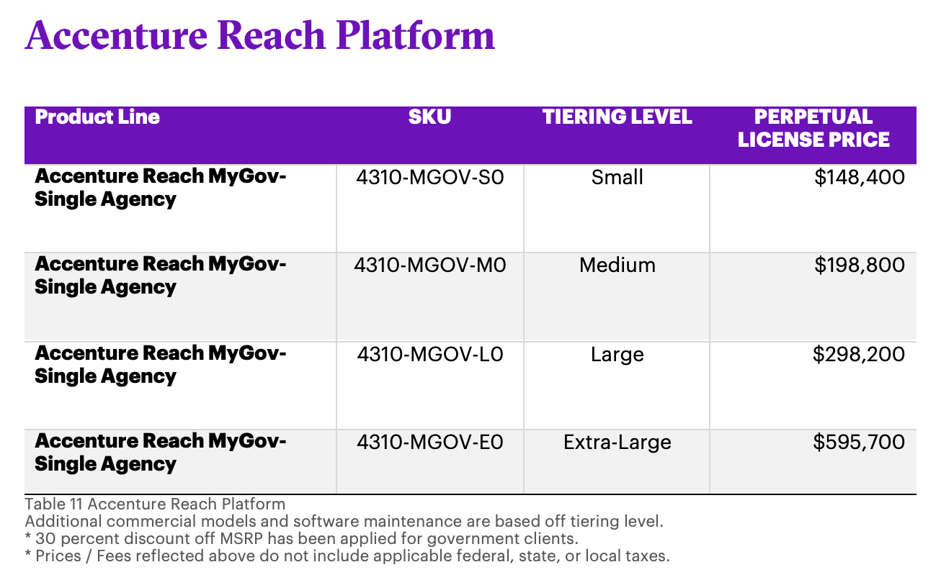

Offering Title: Accenture ERP & CRM Support Services
Service Description:
No change to service description.

Portfolio Category:
- SaaS (Software as-a-Service)

Additional Terms & Conditions: None.

Offering List Pricing:

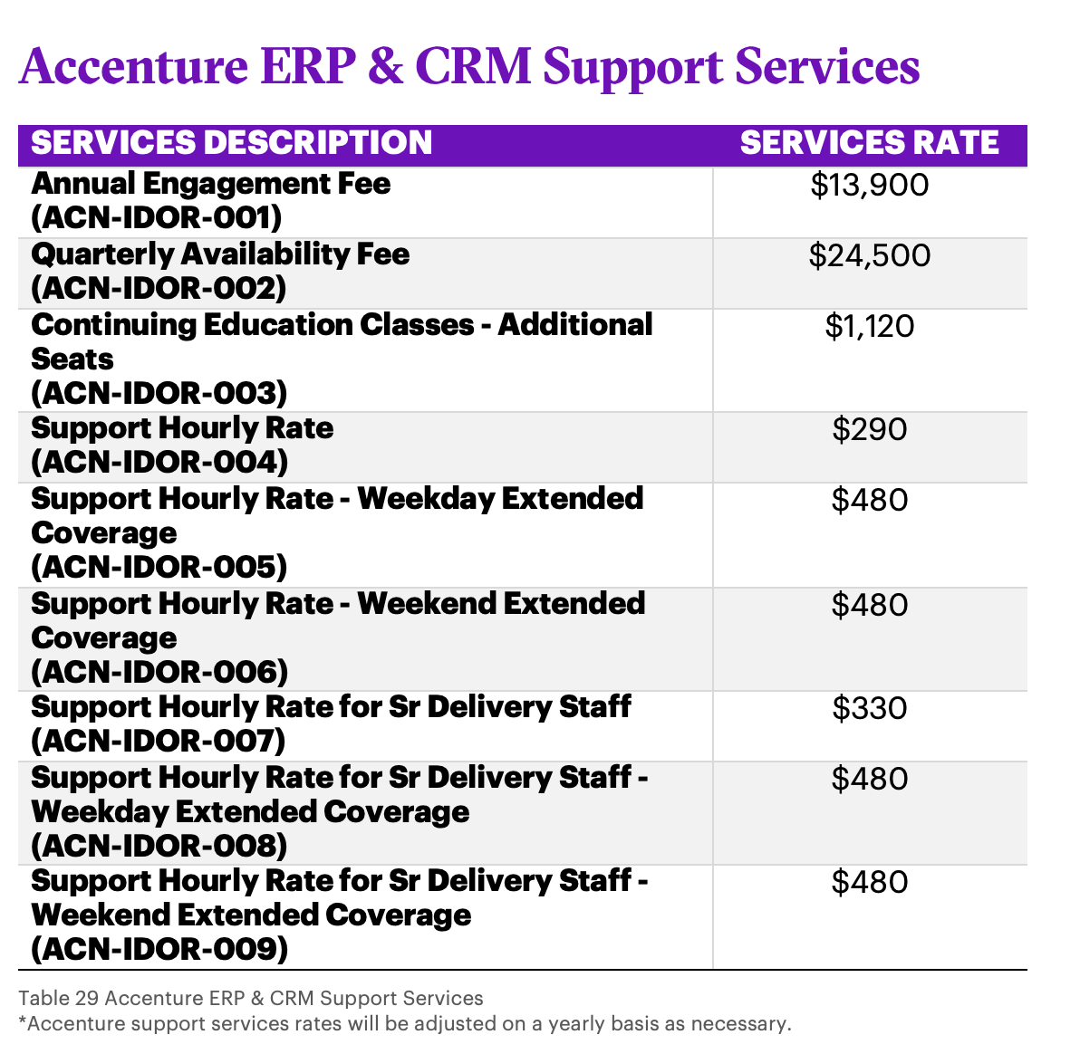

Offering Title: Accenture Cloud Application Services
Service Description:
No change to service description.

Portfolio Category:
- SaaS (Software as-a-Service)
Additional Terms & Conditions: None.

Offering List Pricing:
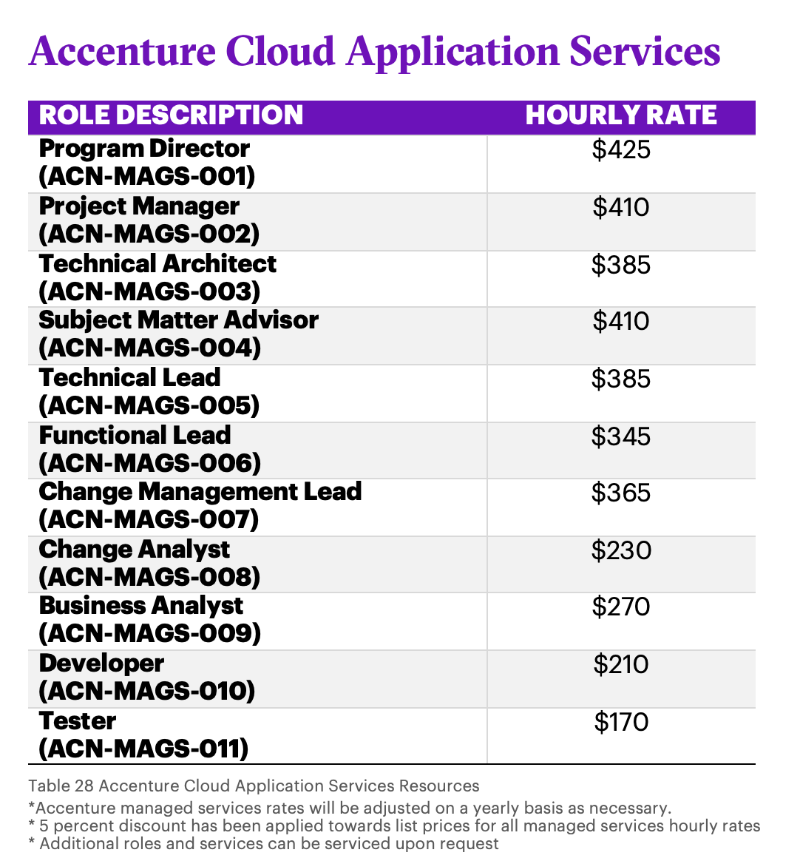

Offering Title: Accenture Independent Verification & Validation (IV&V) Services
Service Description:
No change to service description.

Portfolio Category:
- SaaS (Software as-a-Service)
Additional Terms & Conditions: None.

Offering List Pricing:

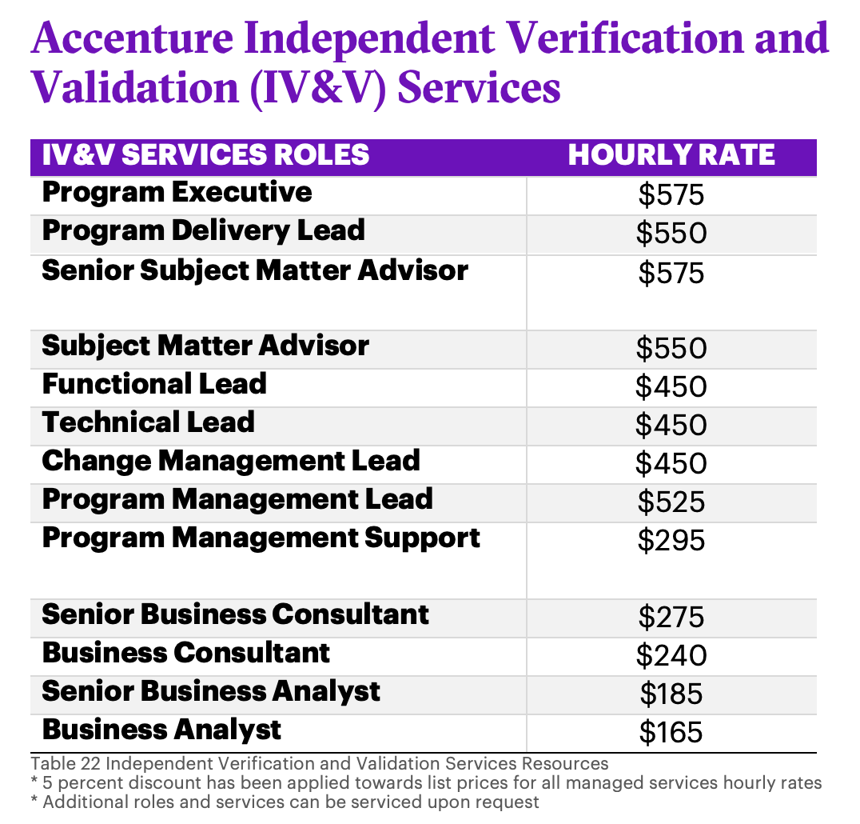

Offering Title: Accenture Cloud Transformation Advisory
Service Description:
No change to service description.

Portfolio Category:
- SaaS (Software as-a-Service)
Additional Terms & Conditions: None.

Offering List Pricing:

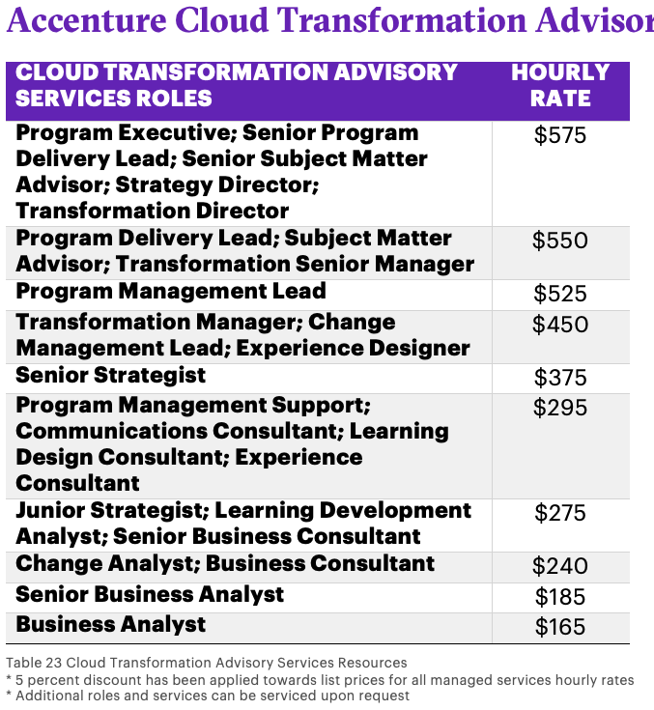

Offering Title: Accenture SaaS Platform Implementation Services
Service Description:
- No change to service description.

Portfolio Category:
- SaaS (Software as-a-Service)
Additional Terms & Conditions: None.

Offering List Pricing:

