A&T is your Fully Qualified NASPO Cloud Provider for Amazon Web Services

(CH16012- Cloud Solutions)

A&T Systems has served Public Sector clients for over 30 years in the IT and telecom industries, and cloud services since 2012. A&T is an Amazon Web Services (AWS) Advanced Consulting Partner and an Authorized Government Reseller and Value Added Partner with an AWS Partner Letter of Supply for all 40,000 AWS offerings for Government clients. A&T serves as an AWS Authorized Government Partner able to provision and manage deployments in the GovCloud region and an AWS Authorized Government Competency Partner.
A&T offers NASPO members both tools and solutions that solve unique business challenges. Moving to the cloud is an all-inclusive process that includes infrastructure, business data, applications, security and business processes.
A&T provides a full package of Cloud Solutions, AWS Certified Subject Matter Experts, Cloud Migration Services and Cloud Professional Services.
A&T offers NASPO members: Discounted Usage Costs, Competent and Certified AWS Professional Consulting Services, DevOps Assistance and Guidance, Managed Cloud O&M with support from A&T’s on premise 24x7 Secure NOC and Help Desk.
A&T is NASPO ValuePoint’s Dedicated AWS Partner qualified to provide Cloud Solutions

Figure 1. A&T Executives with DC HBX Project Team—A&T CEO Ashok Thareja, far left; CTO Mureed Nazir, 2nd from right; VP Fred Sanders, far right
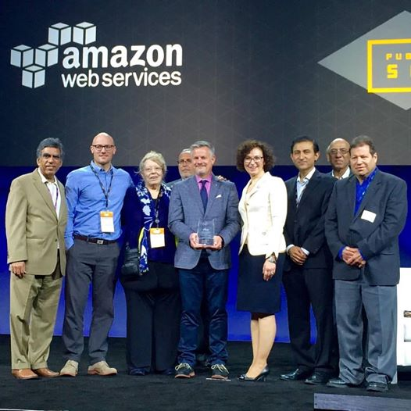
Our partnership with Amazon and extensive experience providing Cloud Solutions to Public Sector, State, and local governments positions A&T to assist clients who need to select, acquire, establish, implement, and maintain secure, robust, scalable capabilities in the cloud with platforms for Development, Test, Staging, Production, or Training.
A&T is a responsive, capable small business that is currently providing numerous Federal and State agencies with a full lifecycle range of Dev/Ops cloud services—from initial assessment and discovery all the way through long-term Managed Services and Technology Refresh activities.
Award-Winning Support for the District of Columbia Health Benefit Exchange Cloud Services Contract (DCHBX)
At its 2016 Public Sector Summit, AWS awarded a City on a Cloud “Best Practices” citation to the District of Columbia Health Benefit Exchange Authority for innovations on its Cloud Services project. As a prime contractor on this project, A&T provided AWS IaaS, PaaS, and the security ATO that contributed to the project’s success. DCHBX officials invited A&T to join them as they received the AWS award (Figure 1).
The City on a Cloud Innovation Challenge is a global competition of local and regional government and technology partners using AWS to deploy innovative solutions to move government forward on behalf of their citizens. Washington, D.C.’s public health insurance marketplace won for its ability to “accelerate innovation" and improve customer experience in the city's health insurance marketplace.
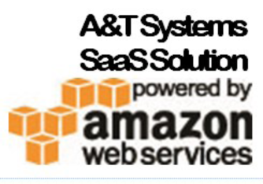
In addition to Infrastructure-as-as-Service (IaaS) and Platform-as-a-Service (PaaS), A&T offers NASPO members powerful SaaS Solutions hosted in the AWS Cloud.

Electronic Invoicing
Using Tungsten Network’s eInvoicing software hosted in the AWS Cloud, A&T provides automated financial services that help buyers and suppliers accelerate trade and improve critical processes. Our electronic invoicing, workflow, analytics and supplier financing services bring a new level of transparency, accuracy and efficiency to our customers’ global businesses.
This SaaS solution is in use at the Department of Veterans Affairs, General Motors, GlaxoSmithKline, IBM and the U.S. Federal Government

Telecom Lifecycle Management Platform for Wired and Wireless Assets
Using Rivermine’s TEM software hosted in the AWS cloud, A&T offers a unique automated Telecom Expense Management (TEM) for wired and wireless with a comprehensive multi-carrier managed service capability,
This SaaS solution is in use at the Veterans Administration, Federal Communication Commission and the Office of Personnel Management

Suite for First Responders
Using GER HC’s emergency response software, A&T provides decision makers with real-time monitoring and tracking of patients and key assets such as EMS, hospitals, hospital beds, and clinical resources during emergency and daily operations,
This SaaS solution provides a flexible, real-time situational awareness platform that allows your organization to enhance emergency support function & capabilities.

