Attachment 13

Toshiba FMAudit
Site Survey
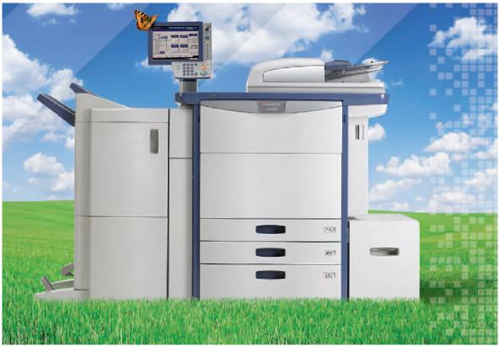
The information in this survey allows Toshiba to provide the highest level of quality service. By filling out this survey, you authorize Toshiba FMAudit Support to contact the individuals for implementation and account management purposes.

Part I: Dealer Contact Information
1. Primary Contact Information
Contact Name:
Job Title:
Job Function:
Tel:
Email:

Part II: End-User Organizational Information
- Company Information
*Company Name: | NASPO ValuePoint
Company Address:
- Primary Contact Information
Contact Name:
Job Title:
Job Function:
Tel:
Email:
- IT Administration
Same as Primary:
Contact Name:
Job Title:
Job Function:
Tel:
Email:

*Note: Please do not change the Company Name. It must state, “NASPO Valuepoint.”

Part III: Hosting System
 |  | What operating system will FMAudit Onsite be run on?
 |  | Is this operating system installed using 32 or 64 bit?
 | Does the server/workstation meet the following minimum hardware requirements?
 |  | • | 2.4 GHz processor
 |  | • | 1 GB memory
 |  | • | 1 GB free disk space
 |  | Does the server/workstation meet the following
 |  | minimum software requirements?
 |  | • | One of the following Microsoft operating systems:
 |  |  | - Windows XP
 |  |  | - Microsoft Windows 2003
 |  |  | - Microsoft Vista/7/8
 |  | • | Internet Explorer 7.0
 |  | • | Windows .NET 2.0 Framework with SP2

Part IV: Network Infrastructure
Is SNMP traffic (port 161) blocked or restricted on the network?
What SNMP community name is used for communication with printer related devices?
(i.e. PUBLIC)
Are all printers on the WAN accessible from the server/workstation where Onsite will be installed?

Part V: Proxy / Firewall Restrictions
Answer the following questions if a proxy and/or firewall are present.
Is there a domain authenticated proxy?
Is there an IE passport authenticated proxy?
Will port 80 (HTTP) allow outgoing printer related data to be transferred from the Onsite application back to the Central application located within another facility?
Will port 443 (SSL / HTTPS) allow license related data to be exchanged between the Onsite application and the FMAudit license server?
Is there a firewall or router that will block outgoing XML (SOAP) traffic?
(Note: some older Cisco products detect the XML data exchange format as invalid HTTP traffic)

Part VI: Network Connected Printer Infrastructure
Approximately how many network connected printers will be monitored?
Are any printers connected via Jet Direct or compatible devices?
Is there a workstation firewall installed; if so what product and version?
(i.e. Windows XP sp2 firewall)

(i.e. Windows XP sp2 firewall)
Is the Windows SNMP Provider service installed?

Part VII: Items to Prepare
- Please attach a list of subnets where printer related products will be discovered.
(i.e. 10.0.1.1-254, 10.0.1-254.1-254)
- Please attach a list of networked printer names that will be monitored. These
will be cross referenced with known supported device lists to flag any potential issues.
(i.e. HP LaserJet 2300)

