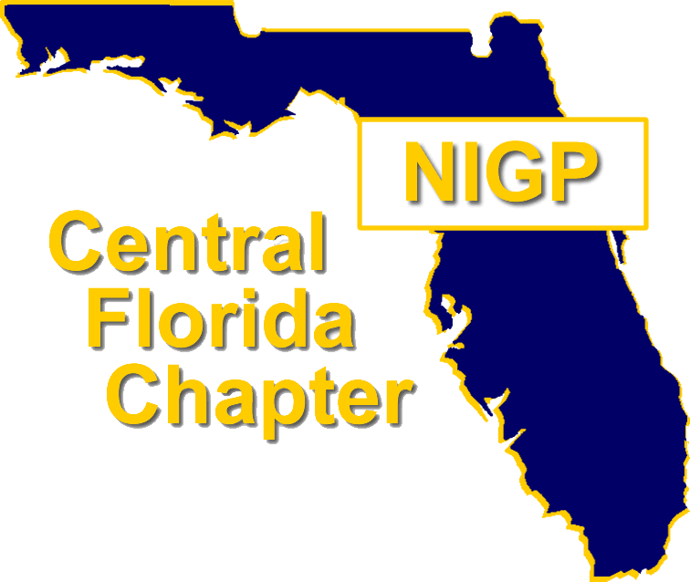
NIGP FORUM EMERGING PROFESSIONAL
SCHOLARSHIP APPLICATION

Central Florida Chapter of NIGP
WWW.CFCNIGP.ORG | WWW.NIGP.ORG

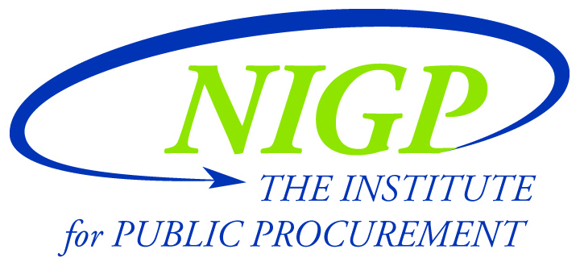

Scholarship is limited to a maximum of $2,500 once-in-a-lifetime toward NIGP Forum registration, hotel reimbursement* and airfare reimbursement*. Reimbursements can be made to individuals or agencies.

* Advance payment is not provided for travel and lodging; the submission of paid receipts are required for reimbursement of airfare and hotel.

Member Name:
Agency:
Phone: |  | Email:

By signing this application I hereby confirm the following:

- I am an Active member of CFC-NIGP
- My career in public procurement does not yet exceed 3-years
- I am seeking CFC-NIGP funding to attend NIGP Forum
- I have not previously attended NIGP Forum
- If selected, I further commit to writing a newsletter article for the Central Florida Chapter of NIGP documenting my experience as a first-timer.

Member Signature: |  | Date:

Authorized Travel or Personal Leave for the applicant of this scholarship has been pre-approved contingent upon obtaining funding from the Central Florida Chapter of NIGP toward attendance at NIGP’s Annual Forum.

Manager/Director Signature: |  | Date:

Submit to VICEPRESIDENT@CFCNIGP.ORG on or before
February 29, 2016, 12:59 PM EST
NIGP FORUM EMERGING PROFESSIONAL
APPLICATION CRITERIA

Answer each of the following questions in narrative format.
Responses shall be a minimum of 300 words and a maximum of 500 words per question.

- Provide a brief biography narrating the journey that led you to a career in Public Procurement.

- What is the value of attending NIGP Forum?

- Summarize your career goals and indicate how this scholarship supports your goals.
- How do you intend to share what you have learned upon return from NIGP Forum?

- Provide a statement asserting why you are the best candidate for this scholarship.

