Thursday, 11th October 2018

“Learning from the Aga Khan Award for Architecture”
(A Four-Week Long Academic Program by the
Bengal Institute for Architecture, Landscapes and Settlements)

SUMMARY REPORT

Session: “Learning from the Aga Khan Award for Architecture”: September 2018 Session organised by the Bengal Institute for Architecture, Landscape and Settlements, sponsored by the Education Programme of the Aga Khan Trust for Culture.

Duration: 9th September to 3rd October 2018
Venue: Gyantapas Abdur Razzaq Bidyapeeth, Dhanmondi, Dhaka
Faculty: Jalal Ahmad, Kazi Khaleed Ashraf, Ashraful Hassan, Khondaker Hasibul Kabir, Suha Ozkan, Hassan Radoine, Alim Ur Rahman, Eike Roswag-Klinge and Marina Tabassum.

Discussion Forums Panelists: Salauddin Ahmed, Zainab Faruqui Ali, Saif Ul Haque, Ehsan Khan, Nurur Rahman Khan, Fuad Hassan Mallick and Fuad Quayyum.

Program description:

In light of the rich and voluminous archive and resources of the Aga Khan Award for Architecture (AKAA) and the Aga Khan Historic Cities Programme (AKHCP), the Bengal Institute proposed an academic course articulated for the enrichment of younger generations by providing them additional academic and learning experiences beyond or part of their current coursework.

The Bengal Institute and the AKTC jointly organised this program targeting senior undergraduate students of Bangladeshi universities and young professionals that focused on learning from primarily projects in the region that won the Aga Khan Award for Architecture. The variety of projects, the communities they engage, and the architects who built these were all involved in this program in various capacities. The students were given the opportunity to directly learn on the ground, with the communities involved and the Award winning architects as guides and instructors.

Program themes:

The program was organised in four themes over four weeks.

Week 1: History and Overview

In the first theme of the session, the focus was on a historical and critical assessment of the Aga Khan Award for Architecture, using literature and its overall impact on global architectural culture, with visual media provided by AKAA.

During the first week, the faculty discussed the history of the Aga Khan Award for Architecture and the global impact made by the award-winning projects. Issues of modernity, architectural modernism, and regionalism were also discussed, all of which were formed a major core in the formation of the AKAA.

Week 2: Architecture with Social and Communal Impact:

One of the biggest contributions of AKAA has been to recognise and highlight projects that have had a deep impact on community-building, especially in economically challenging environments. For the second week, the focus was on examples of these types of projects from AKAA laureates and beyond.

Through lectures and discussion forums, local faculty discussed how community members worked together to build shelters and homes in remote and disaster stricken areas. The discussions highlighted the benefits of involvement and participation of community members in the design process, as well as how much architects themselves got to learn from them.

Week 3: Public Spaces and Civic Buildings

Diverse projects premiated by the Aga Khan Award for Architecture focus on the public realm of a neighbourhood and broader urban and regional scales. The third theme of the session focused on some of these projects.

During the third week, faculty questioned how public spaces can be defined and what can be done to understand them better. They raised questions about ownership of the public realm and its role in the general public’s lives.

Week 4: Urban Regeneration and Landscape Design

Amidst the frantic growth of our cities, a focus on urban-regeneration and landscape design is critical to create both ecologically and socially sensitive conditions. Several intriguing projects have emerged as “green” and community-driven examples amid the typical urban commercial growth. This week intended to focus on cities, landscapes and projects that intervene in these territories with apt solutions.

In the last week of the session, faculty from both home and abroad discussed guidelines for urban transformation and what could be done to transform cities in the future.

Participants’ Statistics:

Applicants | 95
Female | 50 | 52.63%
Male | 45 | 47.37%
Selected | 55 | 57.89%
Female | 30 | 54.55%
Male | 25 | 45.45%
Confirmed Participants | 41 | 74.55%
Female | 23 | 56.10%
Male | 18 | 43.90%

Faculty and Brief of Activities:

Jalal Ahmad

Jalal Ahmad is the Vice President of the Institute of Architects Bangladesh (IAB) and the Principal Architect at J. A. Architects.

During the second week of the session, Jalal Ahmad discussed some of his community-based projects developed in disaster struck areas, that have not only successfully provided shelter for the communities, but also helped them develop means of livelihoods. He was a panelist at the discussion forum on Subaltern Architecture, where he emphasised how necessary it is to reach out to those who have no access to the service of professionally trained architects.

Salauddin Ahmed

Salauddin Ahmed is a contemporary Bangladeshi architect. He is the Principal Architect at Atelier Robin Architects based in Dhaka. He is a member of the Executive Board of Bengal Institute for Architecture, Landscapes and Settlements.

He was a panelist at the discussion forum on Design in the Public Realm during the third week of the session, where he discussed the aspect of privacy and importance of imagination in the public realm. He also pointed out how the success of a public space lies in the intimate nooks and crannies, which he believes was done rightly at the south plaza of the National Assembly Building by Louis Kahn.

Zainab Faruqui Ali

Zainab Faruqui Ali is a professor at Department of Architecture and Director of Student Affairs at BRAC University.

At a discussion forum on Design in the Public Realm, she briefly presented her ideas and examples of designing in the public realm. She believes graffiti is a good way of involving public space with the community. It creates awareness and gives glimpses to a region’s history.

Kazi Khaleed Ashraf

Kazi Khaleed Ashraf is an architect, urbanist and architectural historian, and Director-General of Bengal Institute for Architecture, Landscapes and Settlements.

During the third week of the session, he spoke about the public realm and how it is defined differently by people from various disciplines. At the discussion forum moderated by him, he mentioned that while there is no strict boundary in the public realm, it must have a qualitative character which we have to think about.

Eike Roswag-Klinge

A Berlin-based architect, Eike Roswag-Klinge works with his firm ZRSBerlin globally on natural buildings and their cultural, climatic and traditional values. His aim is to work on buildings made of earth, bamboo and timber, reflecting the options and potentials of the post-fossil society – the society of change. He won the Aga Khan Award for Architecture in 2007 with Anna Heringer for the School in Rudrapur.

He talked about working in Rudrapur using local materials and involving the local communities in building a two storied mud and bamboo school. Roswag gave a public titled “Creating Natural Change for the Built Environment“ where he said, “We are adapting traditional building materials on old houses and modernising them, and these constructions reduce strain on resources.”

Khondaker Hasibul Kabir

Khondaker Hasibul Kabir is a Bangladeshi landscape architect and sustainability advocate who works with Bangladeshi development agencies in rural and sustainable architecture. He has also been working on disaster-resilient housing projects in Bangladesh and in Haiti.

During the second week of the session, he talked about his experience of working with the community in Jhenaidah through the process of ‘co-creation’ and building each house with just 1,000,000 BDT.

Ehsan Khan

Ehsan Khan is the Principal Architect of Ehsan Khan Architects Ltd. He was nominated for the Aga Khan Award for Architecture in 2010 for designing Nishorgo Oirabot Nature Interpretation Centre.

At a discussion forum on Urban Transformations, he pointed out the critical issues which are affecting Dhaka’s development - high population, urban growth and expansion at the periphery. He believes the aspect of ownership among citizens is important in maintaining the city. To help restore the sense of ownership, he said we should think of typologies that will bring back the traditional neighbourhood spirit.

Nurur Rahman Khan

Nurur Rahman Khan is a Partner at Tanya Karim N.R. Khan and Associates. He has been a winner of IAB Design Awards and the first Bangladesh juror for ARCASIA Awards.

He was a panelist at the discussion forum on Design in the Public Realm, where he talked about various public activities that previously took place on the south plaza of the National Assembly Building and how putting up a boundary has changed all of it now. He also shared his belief about how a city gets its narrative from the naming of its places, not its physical dimensions.

Saif Ul Haq

Saif Ul Haque is the Principal Architect at Saif Ul Haque Sthapati, Dhaka, and is involved in practice, research and education. Currently he is the Director of the Research and Design Program of Bengal Institute for Architecture, Landscapes and Settlements.

He moderated the discussion forum on Subaltern Architecture where he pointed out how architects have a responsibility in serving the society. He also emphasised the importance of Aga Khan Award for Architecture winners in highlighting projects that have been successful in serving communities in a larger geographical context, beyond the developed parts of the world.

Ashraful Hassan

Ashraful Hassan is the Managing Director of Grameen Telecom. He started his career in Grameen Bank in 1984. During his 15 years of tenure with the Bank, he held various key positions including the Chief of Engineering section.

At a lecture during the session, he talked about how the Grameen Bank Housing Programme was successfully developed in 1985 without the involvement of architects, and how the community came together to build each house with only $200.

Fuad Hassan Mallick

Fuad Hassan Mallick is the Dean of School of Design at BRAC University. He has been a technical reviewer for the Aga Khan Award for Architecture and a member of the Aga Khan Education Program’s thinking group.

At a discussion forum on Urban Transformations, he talked about how architects and planners misunderstand the concept of green cities. According to him, environmental consciousness has to be comprehensive on a macro level. He also believes urban transformation has to have environmental consequences.

Suha Ozkan

Suha Ozkan is an architect, architectural theorist, and the former Secretary General of the Aga Khan Award for Architecture. Working from 1982-2006, he helped establish the AKAA as one of the premier architectural institutions of the world dedicated to the recognition and celebration of work of highest excellence.

In the first week of the session, Suha Ozkan discussed how the Aga Khan Award for Architecture was developed and focused on some of the winning projects from the first cycle to the latest one. He also discussed the ideologies of Hassan Fathy, especially through the design of some of his notable works like the New Gourna Village in Egypt.

Fuad Quaium

Fuad Quaium is the founder of GHORAMI.JON, an organization that provides consultancy for sustainable habitat and landscape planning schemes, mostly for marginalised communities.

At a discussion forum on Subaltern Architecture, he mentioned that access to information and technology has made a revolutionary impact for the people and changed their lives. He believes a system like an app or website could serve a larger community of people through informative and accessible service.

Hassan Radoine

Hassan Radoine is an architecture curator, critic, educator, author and consultant. He is currently the Director of the School of Architecture, Urbanism and Design at University Mohammed VI Polytechnic in Morocco. He has worked as an expert for UNESCO, UN-Habitat and the Aga Khan Award for Architecture.

During the last week of the session, he talked about the architecture in the Middle East and his involvement as juror for the Aga Khan Award for Architecture winner, Tabiat Pedestrian Bridge. He also gave a public lecture titled “Architecture in the Middle East”, where he talked about the transformations in Middle Eastern architecture.

Alim Ur Rahman

Alim Ur Rahman Khan is an avid musician, scholar and father of the co-founder of Friendship NGO. During a lecture, he talked about the AKAA winning project Friendship Centre in Gaibandha. He mentioned how it was inspired by the Nalanda Mahavira and Aristotle’s view of peripeteia.

Marina Tabassum

Marina Tabassum is the Principal Architect of MTA (Marina Tabassum Architects), and Director of Academic Program at the Bengal Institute for Architecture, Landscapes and Settlements. In 2016, her project Bait Ur Rouf Mosque was one of the six winners of the Aga Khan Award for Architecture. She is currently on the Steering Committee for the fourteenth cycle of the AKAA.

In her lecture, she spoke from her own experience of designing public spaces and buildings with community and public functions. She believes a city’s social health is defined by its public realm and hence, the public realm plays an important role in citizens’ lives.

Program arrangement:

Number of days of activities | 15
Number of lectures | 12
Number of discussion forums | 3
Number of public lectures | 2

Seminar arrangements:

The seminar room on Level 3 of Gyantapas Abdur Razzaq Bidyapeeth served as the classroom for the entire duration of the session, where all lectures and forums were held. The room accommodated 45 people including faculty.

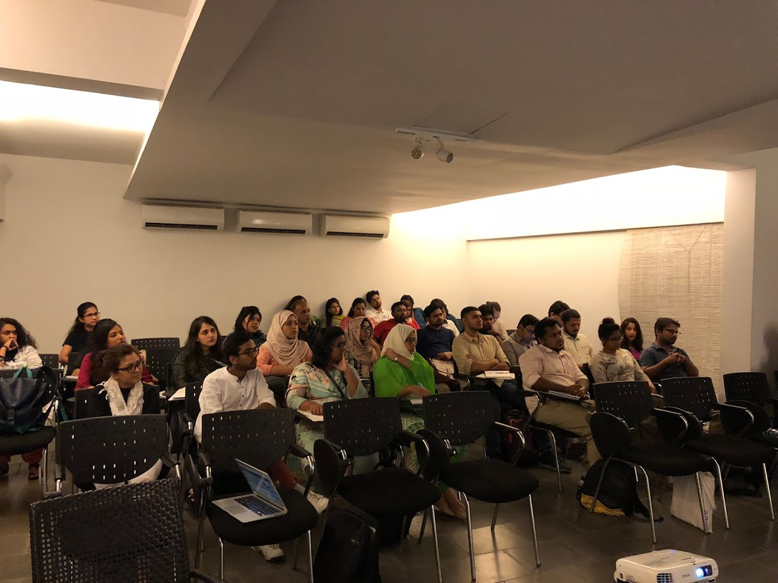

A lobby right outside the seminar room served as the break-out space. A projection on the lobby wall continuously showed AKAA winning exemplary projects. Marina Tabassum generously lent some books related to AKAA that were kept for the participants to read.

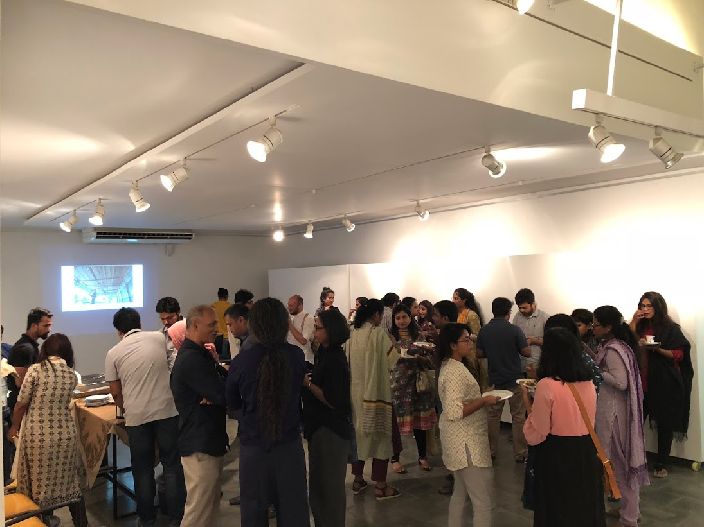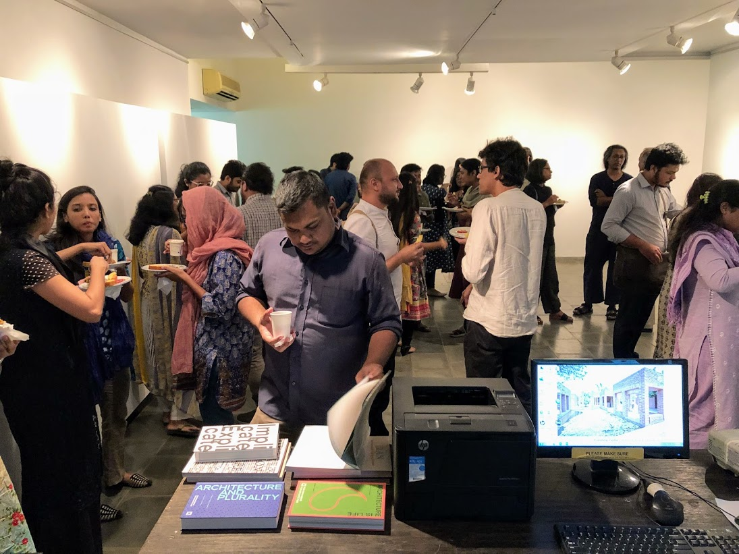
Left image: Breakout space, with projection of AKAA winners showing on the back wall
Right image: Participant looking through books related to AKAA

Reception and Response by Participants:

On a scale of 0-10 (10 being the highest and 0 being the lowest), 36.4% of participants rated the overall quality session to be 10/10.

Notable responses from participants:

I have enjoyed the program from the beginning till the end, all the faculty members were so charismatic and charming personalities, learned a great deal about alternate approaches in architectural design. this program has helped me set goals for my career, actually what i want to do with my life and my profession, thank you for that.

Open discussions and architects' presence were encouraging. I would be happier if we could reflect more on Friendship Center, National Parliament House and METI school. I have learnt new things about "public realm" but the highlight for me is the Engineer's lecture, that contained little architecture, yet was very inspiring.

I came to know different aspects of Architecture and scopes.Architecture is beyond visible building project.It is about understanding lifestyle of the user group and deal accordingly. This lecture series has been a great experience for me to learn Architecture and its possibilities,and I am pleased.

The general content of the course was really engaging. The topics and the related discussions was helpful to develop a new perspective to look at architecture.

Comments regarding faculty members:

Hassan Radoine; his classes really made me think about the notions of physical/ materialistic spaces or objects in a very different point of view. Really humble way of putting seeds of thought in one's mind.

The faculty from our country and abroad are simply amazing...their contribution to societies and willingness to spread their experiences and knowledge among us were really great. In every lecture sessions all of them remain humble with their projects and understandings and made every discussion easy to understand.

I have enjoyed lectures of Ar. Khaleed Ashraf and Ar. Hasan Radoine so much, as i am always interested in urban public realms and spaces, they helped me a great deal to increase my understanding of urban space and how to think about problems and go for a sustainable solutions. Their Depth of knowledge and confidence in expressing what they believe has impressed me so much!

Documentation and Archiving:

Throughout the entire duration of the session, all activities were documented in audio and video formats. All public lectures, forums and class lectures conducted were extensively photographed; most of them have been live-streamed on Facebook. Images and updates on the session were constantly updated on social media through Facebook, Instagram and Twitter. All videos of the session can be found here: http://bit.ly/BISept2018

All class materials have been archived and shared constantly with participants throughout the session. Participants have also been given access to some of the selected publications related to the Aga Khan Award for Architecture, including several digital copies of the magazine, Mimar.

Report by:

Farhat Afzal
Academic Associate
Bengal Institute for Architecture, Landscapes and Settlements

