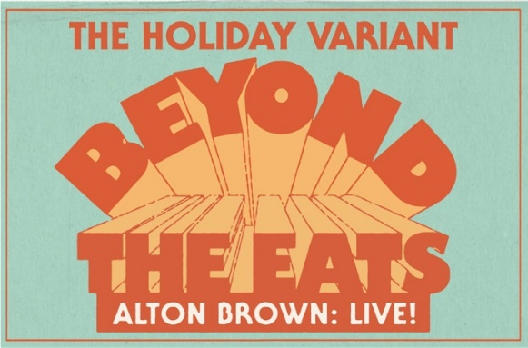

Suggested Interview Questions for Alton Brown

What has gone into the planning for the Holiday Variant tour? I’m sure you have some surprises planned.
Can we expect a big extravagant holiday cooking demonstration this year?
What is your favorite part of the show and what do you enjoy the most about being in front of the live audience?
Are you going to have volunteers from the audience?
Any fun stories from past live shows you can share?
Do you have a favorite holiday tradition?
Favorite holiday drink?
Favorite holiday dish?
What do you hope audiences will get out of the show and is there something specific you want to them to leave with?

Guidelines for Alton Brown Interviews

Alton’s name is pronounced Al-ton, like Al Capon, NOT All-ton.

This is incredibly important and we suggest that you speak with your writer or reporter to make sure they say his name correctly.

We prefer taped only zoom interviews - no live zooms please.
We have a list of suggested questions to share with reporters to keep interviews on track about the holiday show.
Interviews will be in 15-minute blocks.
Alton will call the reporter directly or be on the zoom alone.
Please do not go over 15 minutes.
Alton is very punctual. Please reconfirm with your reporter the day of the interview.

