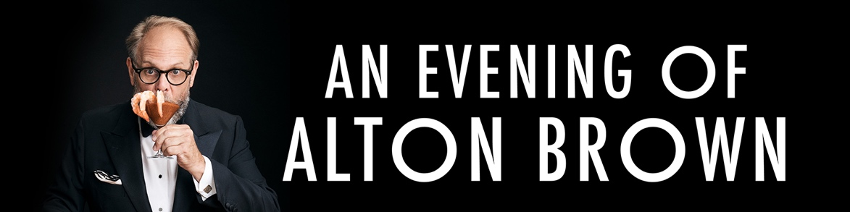

Show Description:

Although he’s keeping the details under wraps, Brown has said that with An Evening of Alton Brown he’s “stirring up some twists on his greatest hits,” and “spicing things up with new demonstrations, music, and slightly scaled-down mayhem.” No matter what, An Evening of Alton Brown will present Brown as you’ve never seen him — unless, of course, you’ve been invited to his house.
Best known for creating and hosting groundbreaking television such as Good Eats, Iron Chef America, Cutthroat Kitchen, and Food Network Star, Brown has also built one of the most successful culinary touring franchises ever, performing live in more than 300 cities for well over half a million fans. With An Evening of Alton Brown, he strips away the spectacle in favor of connection, spontaneity, and storytelling, delivering a show that is equal parts humor, science, food, and heart.

