Plessy v. Ferguson (1896)
Argued: April 13, 1896
Decided: May 18, 1896
Background and Facts
In 1890, Louisiana passed a law called the Separate Car Act. This law said that railroad companies must provide “separate but equal” train cars based on race. Black people had to sit with each other and White people had to sit with each other. This is called segregation. Anyone who broke this law would have to pay $25 or go to jail for 20 days.
Homer Plessy believed that this law violated the Constitution. Plessy was a citizen of the United States. He was biracial and a resident of the state of Louisiana. On June 7, 1892, Plessy bought a first-class ticket from New Orleans to Covington, Louisiana. He sat in the car for White passengers. Railroad officials knew Plessy was coming and arrested him for violating the Separate Car Act.
Plessy argued in court that the Separate Car Act violated the 14th Amendment to the Constitution, which requires that the government treat people equally. John Howard Ferguson was the judge hearing the case. He declared the law constitutional and found Plessy guilty.
Plessy appealed the case to the Louisiana Supreme Court, which agreed that the Louisiana law was constitutional. Plessy then took his case to the Supreme Court of the United States.
Constitutional Question
Does the Separate Car Act violate the 14th Amendment?
Arguments for Plessy (petitioner)
- The 14th Amendment applies to this case. It says that people should be treated equally under the law. That means that Black people and White people should have access to the same services and goods.
- Laws should not separate Black and White people. When laws do this, they are really saying that Black people are inferior to White people.
- This law was not created to promote the public good. Instead, it promotes racial prejudice.
Arguments for Ferguson (respondent)
- The 14th Amendment only applies to whether Black people and White people are equal by law. The Separate Cars Act does not prohibit African Americans from using the railroad.
- The 14th Amendment does not apply to whether Black people and White people are socially equal. Laws cannot change how people view one another. Therefore, racial prejudice cannot be addressed in a law.
- This law was created to promote the public good. During this time period, many White people in power believed that mixing races would disrupt the way of life, particularly in Southern states. This law upholds order between the races.
Decision
In a 7–1 decision, the Supreme Court ruled against Homer Plessy. The majority rejected Plessy’s 14th Amendment argument. Instead it agreed with the doctrine of “separate but equal.”
In the majority opinion, the justices said that the 14th Amendment “could not have been intended to abolish distinctions based upon color, or to enforce social…equality.” According to the Court, the 14th Amendment was only concerned with legal equality. It was not concerned with social equality.
In addition, the justices said that separation of the races by law does not “stamp the colored race with a badge of inferiority.” They said that racial prejudice could not be overcome by forcing people of different races to interact with each other.
The justices also decided on whether this law promoted the public good. They agreed that the law helped with “the preservation of the public peace and good order.” As long as separate facilities were actually equal, they said that the Constitution did not prohibit segregation.
Justice John Marshall Harlan dissented from the majority opinion. He argued that “separate but equal” laws allowed society to believe that the two races were not equal.
Impact of the Case
Although not specifically written in the decision, Plessy set the precedent that “separate” facilities for Black people and White people were constitutional as long as they were “equal.” The “separate but equal” doctrine was quickly extended to cover many areas of public life, such as restaurants, theaters, restrooms, and public schools. Often, facilities for Black people were far inferior to facilities for White people. The laws creating separate facilities and enforcing racial segregation became known as Jim Crow laws.
Justice John Marshall Harlan’s dissent in Plessy was very important to the Brown v. Board of Education school segregation case that came to the Court in 1954. Harlan said that these “separate but equal” laws promoted and perpetuated the belief that Black people were inferior to White people. He argued that these laws must be struck down. He said that the government could not “permit the seeds of race hate to be planted under the sanction of law.” Justice Harlan believed that the Constitution could allow “no superior, dominant ruling class of citizens.” Because segregation had the effect of creating such classes, he judged, it was unconstitutional.
Source Information: This is a secondary source written by the non-profit organization Street Law, Inc. It has been reviewed by Constitutional law experts and teachers.

Plessy v. Ferguson / Glossary
- 14th Amendment: Section 1 of the 14th Amendment to the U.S. Constitution says “All persons born or naturalized in the United States, and subject to the jurisdiction thereof, are citizens of the United States and of the state wherein they reside. No state shall make or enforce any law which shall abridge the privileges or immunities of citizens of the United States; nor shall any state deprive any person of life, liberty, or property, without due process of law; nor deny to any person within its jurisdiction the equal protection of the laws.”
- Appealed: apply to a higher court for a reversal of the decision of a lower court.
- Constitutional: allowed by or contained in the Constitution.
- Dissented: differed in opinion.
- Doctrine: a belief or set of beliefs.
- Jim Crow laws: state and local laws that legalized racial segregation. These laws existed mostly in the South from the 1890s–1960s. They prevented African Americans from voting and required the segregation of schools, parks, libraries, restrooms, restaurants, and many other places.
- Precedent: a court decision on a legal question that guides future cases with similar questions.
- Prejudice: a negative opinion formed without good reasons.
- Segregation: the policy or practice of separating people of different races, classes, or ethnic groups, as in schools, housing, and public or commercial facilities, especially as a form of discrimination.
- “Separate but equal”: a legal doctrine that allowed for racial segregation as long as the facilities provided for each race were equal. In reality, most facilities provided for Black people were inferior to facilities provided for White people.
- Socially: in a way that relates to how people live together.

Plessy v. Ferguson / Primary Source #1
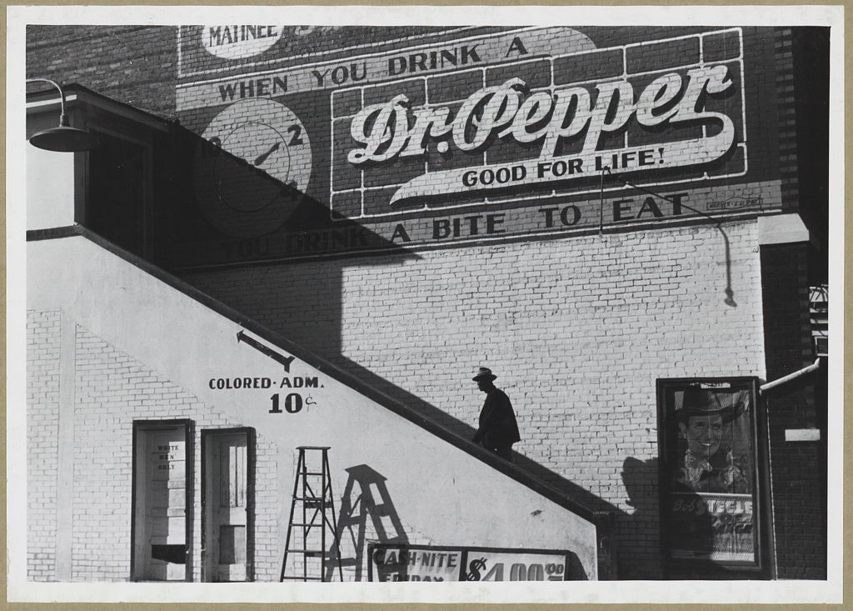
Source Information: This image was taken in October 1939 by Marion Post Wolcott, a government photographer originally from the northern part of the United States. The image is titled, “Negro going in colored entrance of movie house on Saturday afternoon, Belzoni, Mississippi.”
Questions to Consider
- Source: Who created this photograph? When was this photograph created? What do we know about the photographer’s perspective and how might it impact the information provided in the picture? The photographer probably believes…
- Context: Who was the audience for this photograph? What else was going on at the time of this photograph? The photographer may have been influenced by…
- Claim Development: What claims does the photographer make about the “separate but equal” doctrine? This evidence is useful in determining if anything can be done when the Supreme Court makes a decision that is unjust because…

Plessy v. Ferguson / Primary Source #2
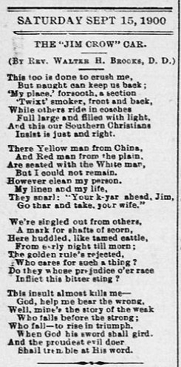

Source Information: This is a poem from the September 15, 1900 issue of a newspaper in Richmond, Virginia. The newspaper was called the Richmond Planet, and it was a newspaper written by and created for African Americans. The author, Rev. Dr. Walter Henderson Brooks, was born enslaved in Richmond in 1851 and served as a pastor of Baptist churches in Washington, DC, and Richmond, VA.
Questions to Consider
- Source: Who wrote this article? When was this article written? What do we know about the newspaper’s perspective and how might it impact the information provided in the article? The author probably believes…
- Context: Who was the audience for this article? What else was going on at the time of this article? The author may have been influenced by…
- Claim Development: What claims does the author make about the “separate but equal” doctrine? This evidence is useful in determining if anything can be done when the Supreme Court makes a decision that is unjust because…

Plessy v. Ferguson / Primary Source #3
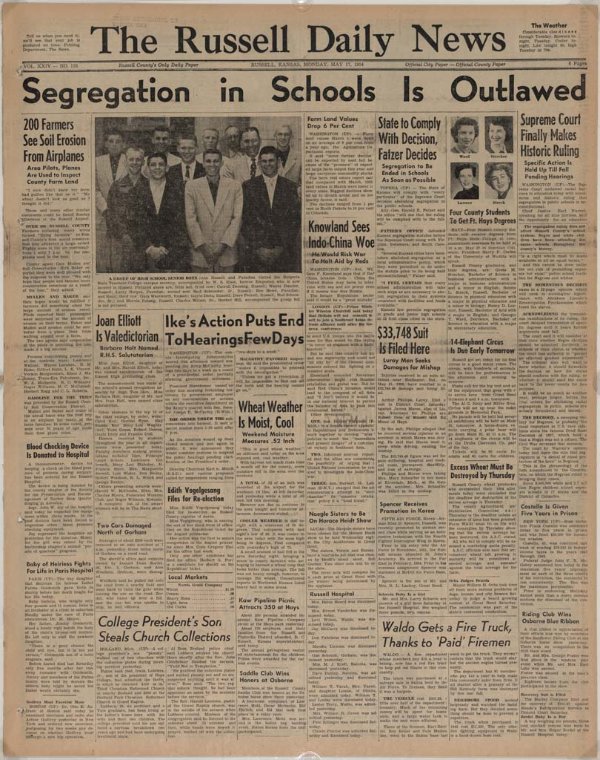

Source Information: This is an image of a May 1954 newspaper front page from Russell, Kansas. The Brown v. Board of Education case was decided by the Supreme Court on this day. This newspaper was printed on the evening that the case was decided.
Questions to Consider
- Source: Who wrote this headline (and other headlines related to the primary headline, including “Supreme Court Finally…” and “States to Comply with Decision…”)? When were these headlines written? What do we know about the newspaper’s perspective and how might it impact the information provided in the headlines? The author(s) probably believes…
- Context: Who was the audience for this newspaper? What else was going on at the time of this newspaper’s release? The author may have been influenced by…
- Claim Development: What claims does the author make about the “separate but equal” doctrine? This evidence is useful in determining if anything can be done when the Supreme Court makes a decision that is unjust because…

Plessy v. Ferguson / Essential Question
Today, Americans view the Supreme Court’s decision in Plessy v. Ferguson as morally wrong. Many people at the time of the decision agreed, as well. Can anything be done when the Supreme Court makes a decision that is unjust?
Use the case summary, source information, and the sources themselves to support your answer.
- Develop a claim that responds to the question.
- Explain how one source supports your claim.
- Use another source to support your claim OR explain how another source does not support your claim.
- Use details and examples from the selected sources to support your response.
__________________________________________________________________________________________________________________________________
__________________________________________________________________________________________________________________________________
__________________________________________________________________________________________________________________________________
__________________________________________________________________________________________________________________________________
__________________________________________________________________________________________________________________________________
__________________________________________________________________________________________________________________________________
__________________________________________________________________________________________________________________________________

Plessy v. Ferguson / Suggested Resources
- Landmark Cases: Plessy v. Ferguson (https://www.landmarkcases.org/cases/plessy-v-ferguson): Street Law’s LandmarkCases.org includes leveled readings, definitions of legal concepts, and teaching activities. The materials and activities are geared toward middle and high school students.
- Plessy v. Ferguson Opinion Reenactment (https://www.loc.gov/exhibits/civil-rights-act/multimedia/plessy-v-ferguson.html): This is a short video clip from a 1956 reenactment of the readings of the Plessy opinion. It contains excerpts from the majority opinion and the dissent. This could provide background for teachers or it could be used with students.
- Primary Documents in American History—Plessy v. Ferguson (1896) (https://www.loc.gov/rr/program/bib/ourdocs/plessy.html): This webpage from the Library of Congress contains links and references to a wide variety of additional resources related to Plessy v. Ferguson. It would be most useful to help teachers add resources and extensions to lessons about Plessy.
- Plessy v. Ferguson (https://whut.pbslearningmedia.org/resource/bf09.socst.us.const.plessy/plessy-v-ferguson/): This short video from PBS provides an overview of Plessy v. Ferguson and its historical context. Along the right side of the webpage are links to additional videos related to the case, including two videos on the 14th Amendment. This could provide background for teachers or it could be used with students.
- “Jim Crow is Watching” (https://www.tolerance.org/classroom-resources/texts/jim-crow-is-watching): This article from Teaching Tolerance provides background information about the time period in which Plessy v. Ferguson occurred. Note that the reading is on higher reading level than Street Law’s case summary for Plessy. This could provide background for teachers or it could be used with students.
- “Realities of Life in the Jim Crow Era” Lesson Plan (https://whut.pbslearningmedia.org/resource/fyr12.socst.us.1950pres.lpreallif/realities-of-life-in-the-jim-crow-era/): This PBS lesson plan with accompanying videos can help contextualize Plessy v. Ferguson. It could provide background for teachers or it could be used with students.

Source: Marion Post Wolcott, Negro going in colored entrance of movie house on Saturday afternoon, Belzoni, Mississippi, October 1939, Photograph, https://www.loc.gov/pictures/item/2017754826/.
Source: “The ‘Jim Crow’ Car” The Richmond Planet, September 15, 1900, https://chroniclingamerica.loc.gov/lccn/sn84025841/1900-09-15/ed-1/seq-8/.
Source: The Russell Daily News (Russell, Kansas), May 17, 1954, Historic Events Newspaper Collection, Serial and Government Publications Division, Library of Congress, http://www.loc.gov/exhibits/brown/brown-brown.html#obj84.

