Marbury v. Madison (1803)
Argued: February 11, 1803
Decided: February 24, 1803
Background and Facts
In the early 1800s, the Constitution was still very new. There were a lot of questions about what it meant and what powers it gave to the different branches of the government. This was true when it came to the powers of the Supreme Court. Many of the powers the Supreme Court has today, like the power to declare laws unconstitutional, did not yet exist. This case is important because it explains how the Supreme Court got that power.
In 1801, President John Adams appointed many judges just before the end of his presidential term. Secretary of State John Marshall was supposed to finish the paperwork and deliver it to the new judges, but he did not deliver the papers to 17 of these judges. When Thomas Jefferson became president, he appointed James Madison as his new secretary of state. President Jefferson told Madison not to deliver the papers. He belonged to a different political party than President Adams and many of the judges he appointed. President Jefferson wanted to appoint his own judges from his own political party instead. Without the papers, the judges that President Adams appointed could not take office.
William Marbury was one of the judges who did not receive his paperwork. He sued James Madison and asked the Supreme Court to issue an order that would require Madison to deliver his papers. Marbury said that the Judiciary Act of 1789 gave the Supreme Court the power to issue these orders to U.S. government officials.
Constitutional Question
Does the Supreme Court have the power to order Madison to deliver the papers?
Arguments for Marbury (petitioner)
- Marbury should be appointed because President Adams ordered it.
- The Judiciary Act of 1789 gives the Supreme Court the power to order Madison to deliver the papers.
- James Madison is a government official. He is required to follow President Adams’s official act by delivering the papers. The Supreme Court should use its power to require Madison to deliver them.
Arguments for Madison (respondent)
- Marbury’s appointment did not happen because his papers were not physically delivered before the end of President Adams’ term.
- The question of whether Marbury’s appointment was lawful is a political question, not a judicial issue. Political questions are issues that the Court should not decide. Sometimes this is because the Constitution does not give the Court enough guidance to decide the issue. Sometimes this is because the issue is one for another branch of government (the legislative branch or executive branch) to decide.
Decision
In a unanimous decision, the Supreme Court ruled that Marbury had a right to receive the papers. However, the Court also said that they did not have the power to order Madison to deliver the papers.
The opinion was written by Chief Justice Marshall. It held that Marbury had a right to the papers because all the correct procedures were followed: the papers were properly signed and sealed. However, the Court also held that the Constitution did not give the Supreme Court the power to order Madison to deliver the papers. The Court said that the Judiciary Act of 1789 conflicted with the Constitution. They thought the law gave the Supreme Court more power than the Constitution did. Therefore, according to the Constitution, the Supreme Court did not have the power to decide this case.
The Supreme Court then declared that the Constitution was the supreme law of the land. They pointed to the Supremacy Clause in Article VI of the Constitution. This means that when laws conflict with the Constitution, they must be struck down as unconstitutional. If a law is struck down, it is no longer a law. Congress would need to change the law so that it no longer conflicts with the Constitution. The Court also said that it is the job of judges and Supreme Court justices to interpret laws and to decide when they are in violation of the Constitution. Therefore, the Supreme Court has the power to strike down actions of the legislative and executive branches when they conflict with the Constitution.
Impact of the Case
Marbury v. Madison established the concept of judicial review. This means that the judicial branch has the power to decide whether executive orders and laws passed by Congress or the states conflict with the Constitution. If the court thinks that the law and the Constitution are in conflict, the law is unconstitutional and will be struck down. This case said that the Constitution is the supreme law of the land and that the Supreme Court has the power to decide what it means.
Source Information: This is a secondary source written by the non-profit organization Street Law, Inc. It has been reviewed by Constitutional law experts and teachers.

Marbury v. Madison / Glossary
- Appointed: to assign someone to a job or position.
- Executive branch: the part of the government that is responsible for carrying out laws. The president is the head of the national executive branch.
- Executive order: an order to the executive branch by the president. This has the same effect as a law, except it is not passed by Congress.
- Judicial branch: the part of the government that decides the meaning of laws and how they should be applied.
- Judicial issue: a problem that can be decided by the courts.
- Judicial review: the power of the court to decide whether a law or decision by the government conflicts with the Constitution.
- Judiciary Act of 1789: a law passed by Congress that gave the Supreme Court the power to issue orders requiring U.S. government officials to carry out certain duties.
- Legislative branch: the part of the government that writes and passes laws. Congress is the national legislative branch.
- Political party: a group of people who share the same beliefs and opinions about the way the country should be run.
- Political question: a problem that the Court should not decide because either 1) the Constitution does not give the Court enough guidance to decide the issue or, 2) the issue is one for another branch of government (legislative or executive) to decide.
- Secretary of state: a person appointed by the president to deal with foreign affairs and lead the Department of State.
- Sued: when a person uses the legal process to force another person, company, organization, or the government to give them something or do something.
- Unanimous: agreed upon by everyone.
- Unconstitutional: not allowed by or contained in the Constitution. If a law is found to be unconstitutional, it will be struck down, meaning it is no longer a law.
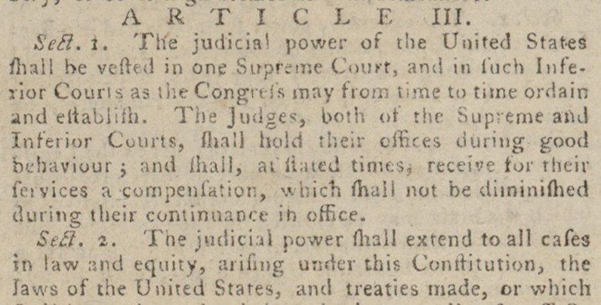
Marbury v. Madison / Primary Source #1
Excerpted transcription: “The judicial power of the United States shall be vested in one Supreme Court . . . . The judicial power shall extend to all cases in law . . . arising under this Constitution, the laws of the United States . . . ”

Source Information: This is one of two excerpts from the Constitution that were cited in the Marbury v. Madison decision that granted the Supreme Court the power of judicial review.
Questions to Consider
- Source: What type of document is this source? When was it written? Why was this source created? Based on the source information, I understand this document differently because…
- Context: How might the circumstances in which the document was created affect its content?
- Claim Development: What does this document say about the role of the Supreme Court in the government? Based on this evidence, I think the Supreme Court’s role in the government should be…

Marbury v. Madison / Primary Source #2

Source Information: This is the second of two excerpts from the Constitution that were cited in the Marbury v. Madison decision that granted the Supreme Court the power of judicial review.
Questions to Consider
- Source: What type of document is this source? When was it written? Why was this source created? Based on the source information, I understand this document differently because…
- Context: How might the circumstances in which the document was created affect its content?
- Claim Development: What does this document say about the role of the Supreme Court in the government? Based on this evidence, I think the Supreme Court’s role in the government should be…

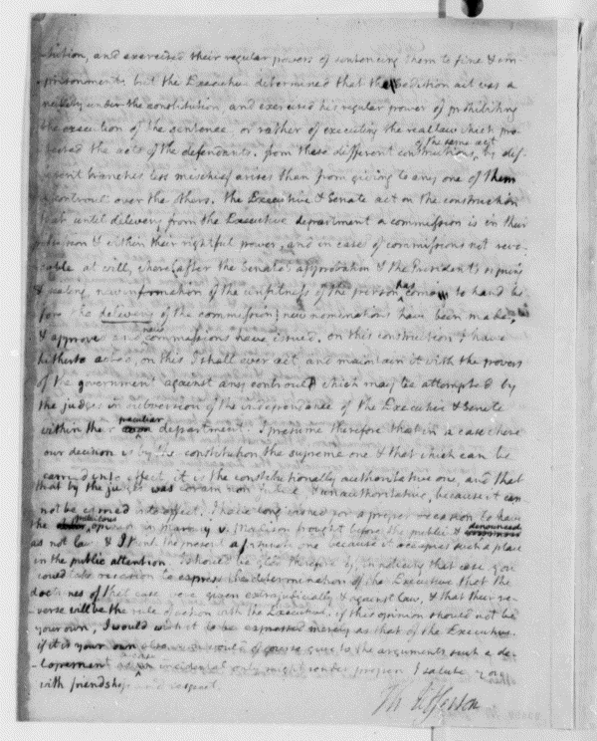
Marbury v. Madison / Primary Source #3
Excerpted transcription: “I have long wished for a proper occasion to have the gratuitous opinion in Marbury v. Madison brought before the public and denounced as not law.”

Source Information: This line is from a letter written by President Thomas Jefferson on June 2, 1807. The letter is to George Hay, a lawyer and judge from Virginia.
Questions to Consider
- Source: Who wrote this letter? When was this letter written? What do we know about the author’s perspective and how might it impact the information provided in the letter? The author probably believes…
- Context: Who was the audience for this letter? What else was going on at the time of this letter? The author may have been influenced by…
- Claim Development: What claims does the author make about the role that the Supreme Court should play in the government? Based on this evidence, I think the Supreme Court’s role in the government should be…
Marbury v. Madison / Essential Question
What role should the Supreme Court play in the way that the government works?
Use the case summary, source information, and the sources themselves to support your answer.
- Develop a claim that responds to the question.
- Explain how one source supports your claim.
- Use another source to support your claim OR explain how another source does not support your claim.
- Use details and examples from the selected sources to support your response.
__________________________________________________________________________________________________________________________________
__________________________________________________________________________________________________________________________________
__________________________________________________________________________________________________________________________________
__________________________________________________________________________________________________________________________________
__________________________________________________________________________________________________________________________________
__________________________________________________________________________________________________________________________________
__________________________________________________________________________________________________________________________________
_________________________________________________________________
_________________________________________________________________

Marbury v. Madison / Suggested Resources
- Landmark Cases: Marbury v. Madison (https://www.landmarkcases.org/cases/marbury-v-madison): Street Law’s LandmarkCases.org includes leveled readings, definitions of legal concepts, and teaching activities. The materials and activities are geared toward middle and high school students.
- Separation of Powers Lesson Plan (https://constitutioncenter.org/learn/educational-resources/lesson-plans/separation-of-powers): This lesson plan can provide students with needed background information in preparation for examining the case. It helps students identify the ways in which the three branches of government check and balance one another.
- Marbury v. Madison (https://www.thirteen.org/wnet/supremecourt/democracy/landmark_marbury.html): This short reading from PBS provides background information for preparing to teach about the case.
- “The 200th Anniversary of Marbury v. Madison: The Reasons We Should Still Care About the Decision, and The Lingering Questions It Left Behind” (https://supreme.findlaw.com/legal-commentary/the-200th-anniversary-of-marbury-v-madison.html): This article discusses the impact of the Marbury decision. It is best suited for teachers’ background reading.

Source: United States, United States Constitutional Convention, John Carter, and Constitutional Convention Broadside Collection. We, the people of the United States, in order to form a more perfect union. [Providence: Printed by John Carter, 1787] Pdf. https://www.loc.gov/item/90898138/.
Source: United States, United States Constitutional Convention, John Carter, and Constitutional Convention Broadside Collection. We, the people of the United States, in order to form a more perfect union. [Providence: Printed by John Carter, 1787] Pdf. https://www.loc.gov/item/90898138/.
Source: Thomas Jefferson to George Hay, June 2, 1807. Manuscript/Mixed Material. https://www.loc.gov/item/mtjbib017245/.

