*Mapp v. Ohio* / Opinion Analysis

Justice Clark wrote the Majority Opinion of the Court:

The **exclusionary rule**was established in *Weeks v. United States* (1914) when the Supreme Court decided evidence seized in violation of the Fourth Amendment could not be admitted as evidence in a federal trial.

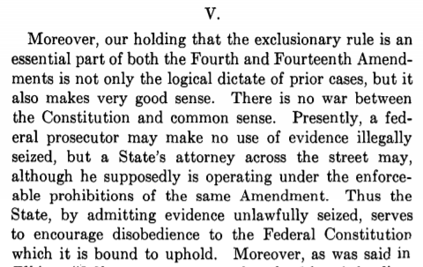

**Source:** Clark, Tom Campbell Clark and Supreme Court of the United States, “U.S. Reports: Mapp v. Ohio, 367 U.S. 643. 1960,” Periodical, <https://www.loc.gov/item/usrep367643/> .

Constitutional Provisions

***Fourth Amendment to the U.S. Constitution***

“The right of the people to be secure in their persons, houses, papers, and effects, against unreasonable searches and seizures, shall not be violated, and no Warrants shall issue, but upon probable cause, supported by Oath or affirmation, and particularly describing the place to be searched, and the persons or things to be seized.”

***14th Amendment to the U.S. Constitution, Section 1***

“… nor shall any State deprive any person of life, liberty, or property, without due process of law; nor deny to any person within its jurisdiction the equal protection of the laws.”

Vocabulary

1. Define the following terms below and others you are not familiar with in your own words. You may wish to consult a legal dictionary at <https://dictionary.law.com/> or <https://www.nolo.com/dictionary>.
2. federal:
3. prohibitions:
4. prosecutor:
5. seized:
6. Other words you need to define:

Observe

1. What do you notice first about the words in this text?

Reflect

1. Put this part of the opinion in your own words:
2. What is the purpose of this piece of the opinion?
3. Who is the primary audience for this opinion?

Question

1. What do you still wonder about this source?