*Mapp v. Ohio* / Document Analysis

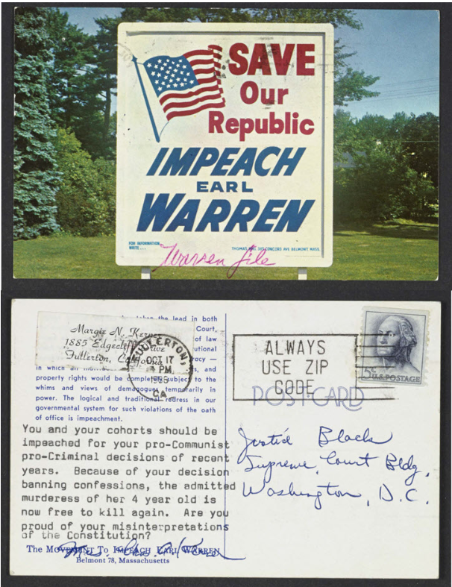

“Save Our Republic: Impeach Earl Warren,” October 17, 1966, Postcard, Hugo L. Black Papers, Manuscript Division, Library of Congress, <https://www.loc.gov/law/help/digitized-books/miranda-v-arizona/miranda-documents.php>.

Background

Earl Warren was the Republican governor of California. He was nominated by President Dwight D. Eisenhower (also a Republican) to be Chief Justice of the United States. In 1954, he was confirmed by the Senate. President Eisenhower expected Chief Justice Warren to make conservative decisions; however, in his first term on the Supreme Court he wrote the unanimous opinion in *Brown v. Board of Education of Topeka, Kansas,* which desegratated public schools. By the mid-1960s the Warren Court made many decisions to protect the rights of the accused including *Mapp v. Ohio* (1961), which extended the exclusionary rule to states; *Gideon v. Wainwright* (1963), which required states to provide attorneys for poor defendants; and *Miranda v. Arizona* (1966), which required police to inform people in custody of their right to stay silent in order to not incriminate themselves and their right to have an attorney provided.

An “Impeach Earl Warren” movement was started by people who opposed the Warren Court’s decisions. However, as stated in Article III of the U.S. Constitution, justices “*shall hold their Offices during good Behaviour*” meaning they have life terms. Article II states that civil officers, including justices, may only be impeached for “*Treason, Bribery, or other high Crimes and Misdemeanors*.”

Observe

What do you notice first about the front of the postcard?

What do you notice first about the back of the postcard?

Reflect

Why do you think someone sent this postcard?

What can you tell about the point of view of the person who sent the postcard?

What do you learn about the reaction of some people to the decision in *Mapp v. Ohio* (1961) and others that protected the rights of the accused from this postcard?

Do you think everyone had this reaction to the decisions?

Article III of the U.S. Constitution states this about the life terms of Supreme Court justices: “The Judges, both of the supreme and inferior Courts, shall hold their Offices during good Behaviour.” Article II states that public officers such as justices “shall be removed from Office on Impeachment for, and Conviction of, Treason, Bribery, or other high Crimes and Misdemeanors.” Considering these two constitutional provisions, do you think Chief Justice Earl Warren could be impeached?

Question

What do you still wonder about?