Mapp v. Ohio / Fourth Amendment Analysis
The Fourth Amendment to the Constitution as proposed and ratified:
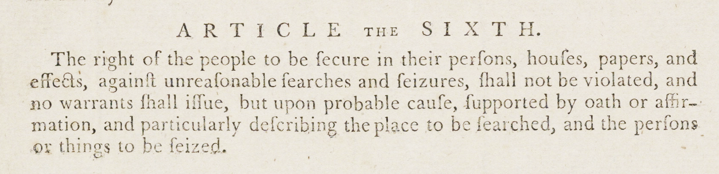
“The right of the people to be secure in their persons, houses, papers, and effects, against unreasonable searches and seizures, shall not be violated, and no warrant shall issue, but upon probable cause, supported by oath or affirmation and particularly describing the place to be searched and the persons or things to be seized.”
Source: United States Congress (1789), Thomas Greenleaf, and James Madison Pamphlet Collection. https://www.loc.gov/item/92838253/.
Vocabulary
- Define the following terms below and others you are not familiar with in your own words. You may wish to consult a legal dictionary at https://dictionary.law.com/ or https://www.nolo.com/dictionary.
  - affirmation:
  - probable cause:
  - searches:
  - secure:
  - seizures:
  - unreasonable:
  - violated:
  - warrant
  - Other words you need to define:
Observe
- What do you notice first about this 1789 printing of the proposed Bill of Rights?
- What do you notice first about the words in this amendment?
Reflect
- Who is protected by the Fourth Amendment?
- Whose actions are limited by the Fourth Amendment?
- What rights does the Fourth Amendment guarantee in your own words?
- Why do you think the Framers of the Bill of Rights included the Fourth Amendment?
Question
- What do you still wonder about this source?

