*Gideon v. Wainwright* / Opinion Analysis

Justice Hugo Black wrote the Majority Opinion of the Court:

***writ of habeas corpus*** is legal term for an order from a higher court asking for all records of a case so they can review it. A person applies (petitions) for a *writ of habeas corpus* when they ask a court to review their case.

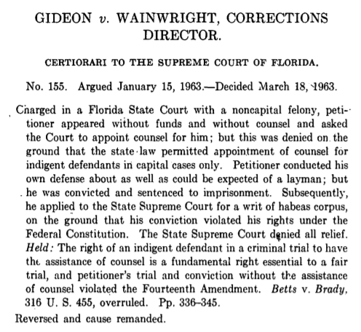

**Source:** Hugo Lafayette Black and Supreme Court of the United States, “U.S. Reports: Gideon v. Wainwright, 372 U.S. 335. 1962,” Periodical, https://www.loc.gov/item/usrep372335/.

Constitutional Provisions

***Sixth Amendment to the U.S. Constitution***

“In all criminal prosecutions, the accused shall enjoy the right to a speedy and public trial, by an impartial jury of the State and district wherein the crime shall have been committed, which district shall have been previously ascertained by law, and to be informed of the nature and cause of the accusation; to be confronted with the witnesses against him; to have compulsory process for obtaining witnesses in his favor, and to have the Assistance of Counsel for his defence.”

***14th Amendment to the U.S. Constitution, Section 1***

“… nor shall any State deprive any person of life, liberty, or property, without due process of law; nor deny to any person within its jurisdiction the equal protection of the laws.”

Vocabulary

1. Define the following terms below and others you are not familiar with in your own words. You may wish to consult a legal dictionary at <https://dictionary.law.com/> or <https://www.nolo.com/dictionary>.
2. counsel:
3. federal:
4. felony:
5. fundamental right:
6. indigent:
7. layman:
8. non-capital:
9. petitioner:
10. Other words you need to define:

Observe

1. What do you notice first about the words in this text?

Reflect

1. Put this part of the opinion in your own words:
2. What is the purpose of this piece of the opinion?
3. Who is the primary audience for this opinion?

Question

1. What do you still wonder about this source?