Gideon v. Wainwright / Newspaper Analysis
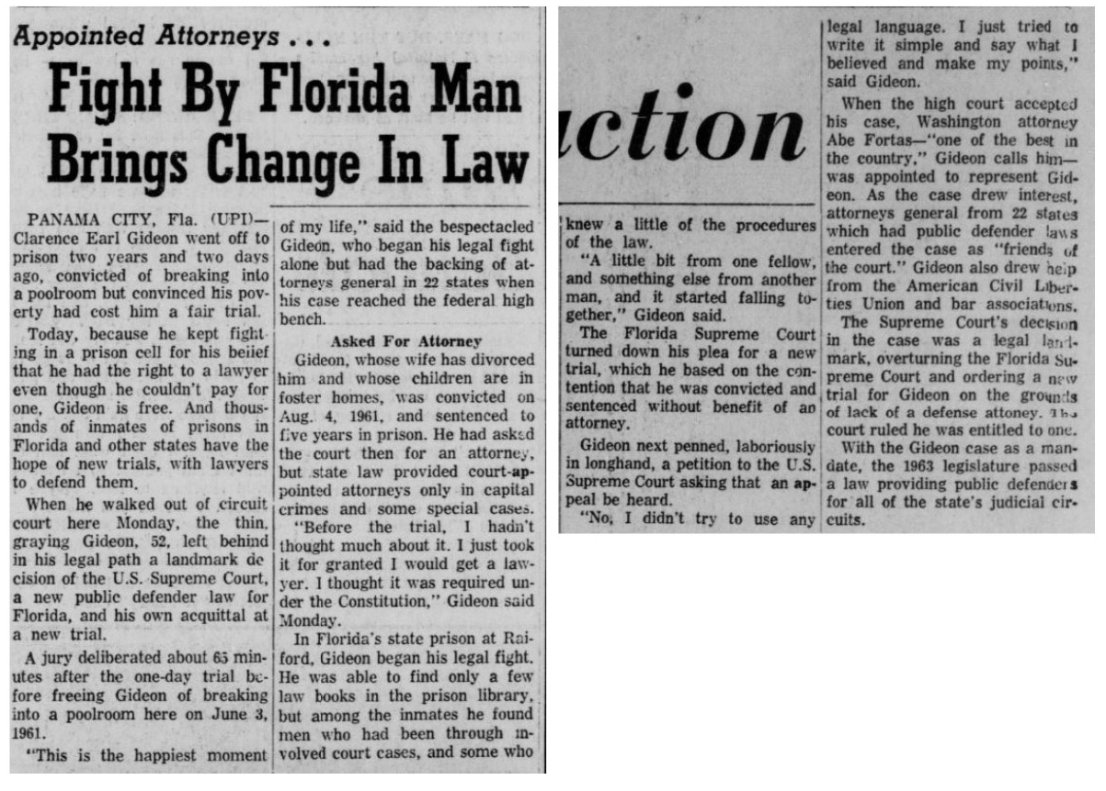
Source: The Chronicle. (Pascagoula, Miss.), 07 Aug. 1963. Chronicling America: Historic American Newspapers. Lib. of Congress. https://chroniclingamerica.loc.gov/lccn/sn87065526/1963-08-07/ed-1/seq-11/.
Observe
- What text do you notice first?
- What do you learn just from the titles and subtitles?
- Where and when was this article published? What is the significance?
Reflect
- What can you tell about what was important at the time and place of publication?
- What can you tell about the point of view of the people who wrote and published this article?
- What do you learn about the importance of the decision in Gideon v. Wainwright (1963) from this article?
Question
- What do you still wonder about this source?

