Gideon v. Wainwright / Inquiry-based Task:
Will You Sign the Resolution?
Before you begin:
- Read Gideon v. Wainwright case summary
- Optional: Complete Classifying Arguments Activity
- Complete Sixth Amendment Analysis (Activity 1)
- Complete Opinion Analysis (Activity 2)
- Complete Newspaper Analysis (Activity 3)
Background:
As a result of the decision in Gideon v. Wainwright, states were required to set up a system to provide attorneys to defendants who could not afford them. Many states established public defenders’ offices and hired attorneys full time for this job.
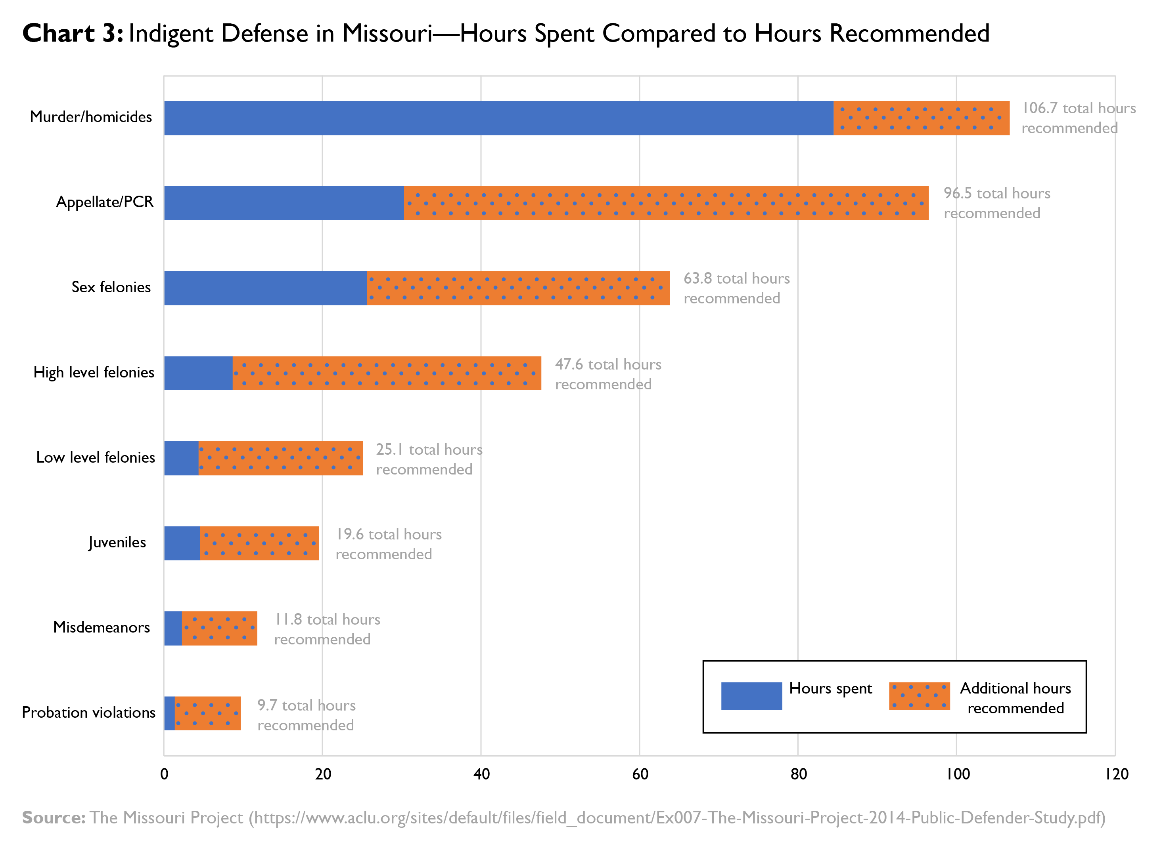
On the 50th anniversary of the decision in Gideon v. Wainwright, the U.S. Department of Justice issued a statement that included the following assessment: “Despite the significant progress that has been made over 50 years after the decision, the promises of Gideon remains unfulfilled. The quality of criminal defense services varies widely across states and localities. Many defenders struggle under excessive caseloads and lack adequate funding and independence, making it impossible for them to meet their legal and ethical obligations to represent their clients effectively.” The chart on page 1 illustrates this problem in the state of Missouri.
Your task:
You were recently elected as your district’s representative to the United States House of Representatives. Tomorrow you must vote on whether to support House Resolution 108. To make an informed decision you should consider the following questions:
- Read House Resolution 108 (pages 4 and 5). Do you agree with the numbered provisions? Why or why not?
(1)
(2)
(3)
- How do you think the House of Representatives might “support strategies to improve the criminal justice system to ensure that indigent defendants in all felony cases are adequately represented by counsel” as encouraged in the resolution?
- If H.Res.108 is successful, what might the impact (if any) be? If it fails?
- Will you vote “yea” or “nay” on H.Res.108? What informed your decision?
- Create an “elevator speech” (a short, persuasive speech that lasts no longer than one minute) encouraging your fellow representatives to vote with you.
- Do you think H.Res.108 passed? Why or why not?
- What questions do you still have about H.Res.108?
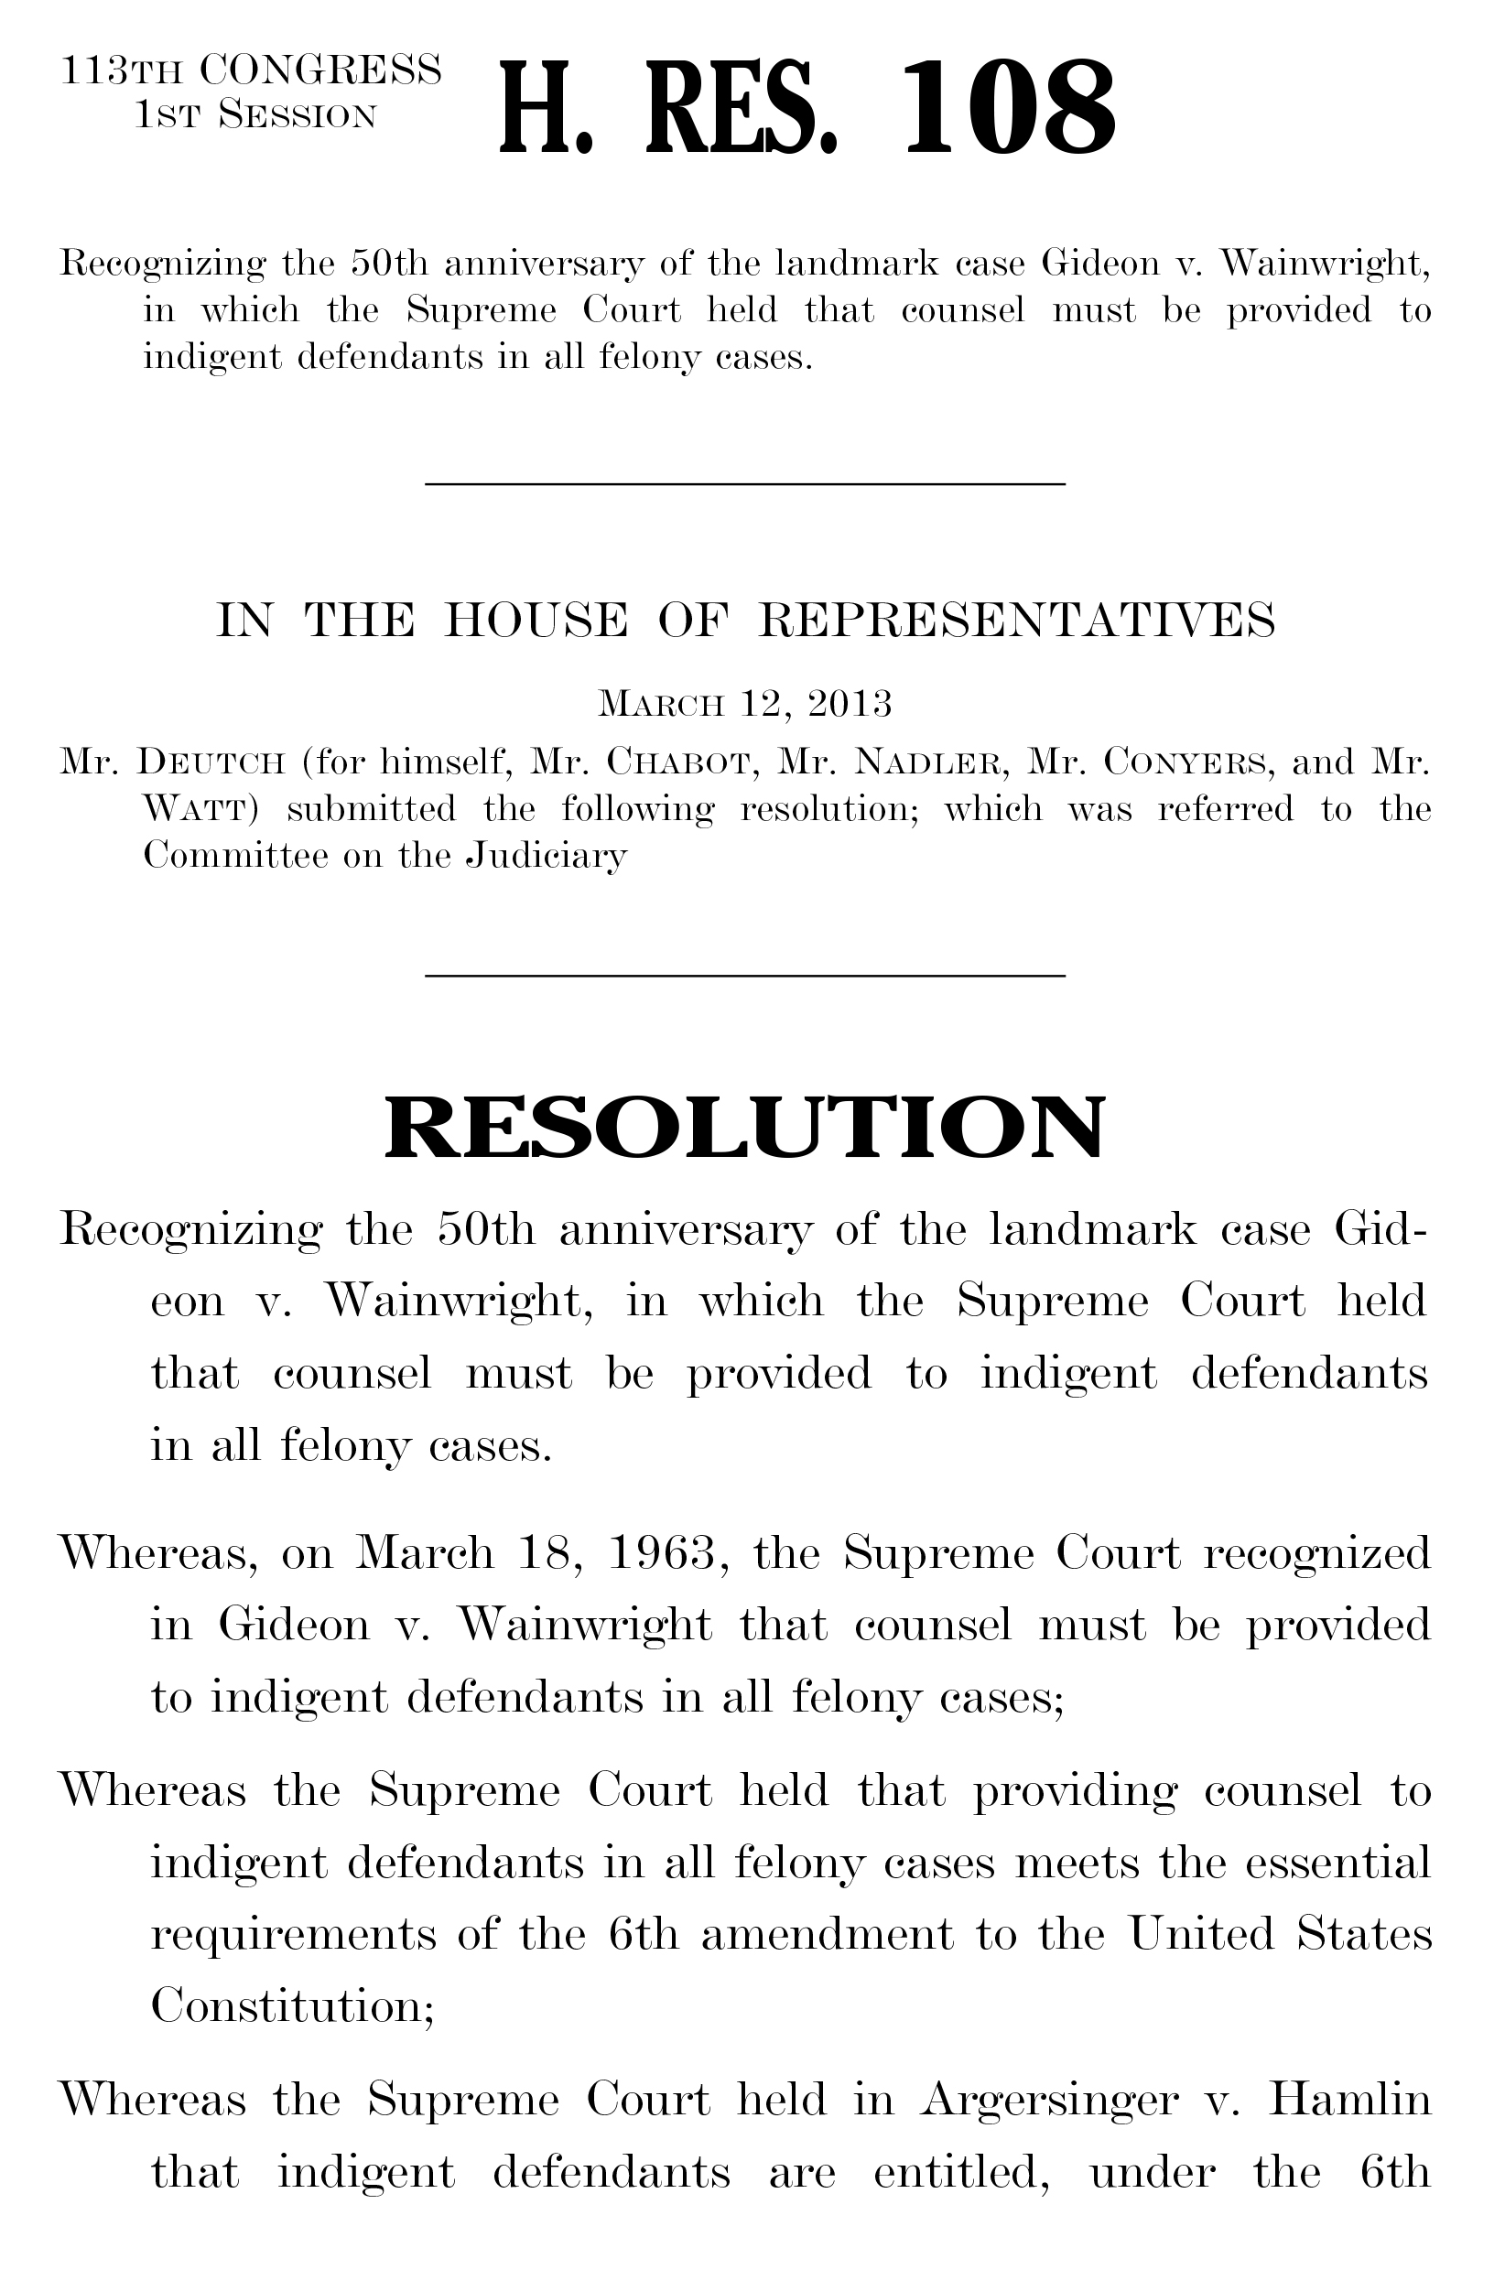
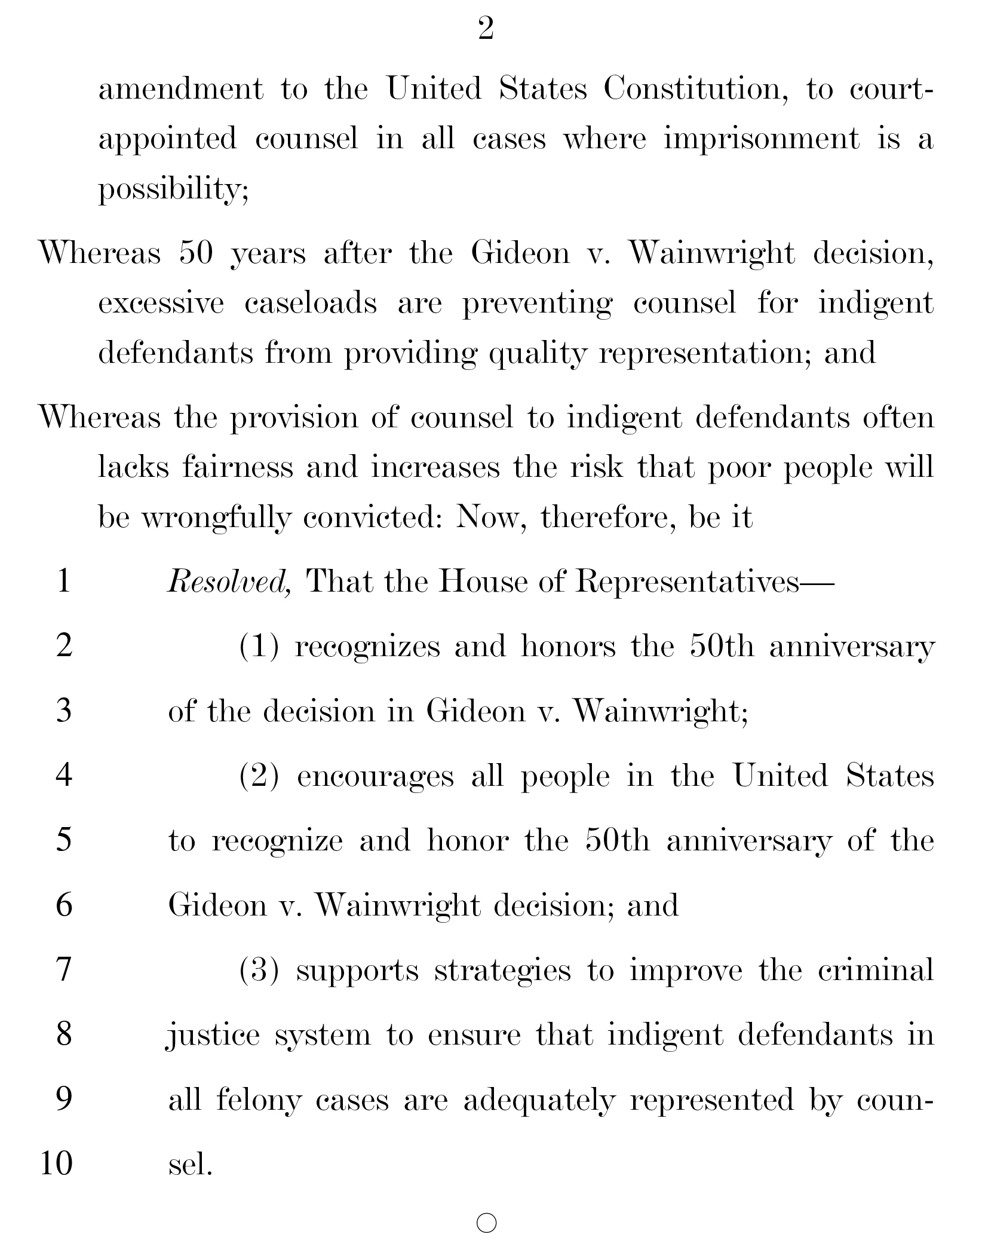

House Resolution 108 was introduced into the Judiciary Committee by Representative Theodore Deutch (D-FL) on March 12, 2013, https://www.congress.gov/bill/113th-congress/house-resolution/108.

