Gideon v. Wainwright (1963)
Argued: January 15, 1963
Decided: March 16, 1963
Background
Part of the Bill of Rights, the Sixth Amendment to the U.S. Constitution protects the rights of people accused of crimes. Among these protections is the right to have a criminal defense lawyer’s assistance. That means that the government cannot prevent someone from consulting with a lawyer and having a lawyer represent them in court. Not everyone who has been accused of a crime, however, can afford to hire a lawyer. In 1938, the U.S. Supreme Court ruled that, in federal criminal courts, the government must pay for a lawyer for indigent defendants who cannot afford one themselves. People are considered indigent if they are so poor that they are unable to afford the necessities of life like food and shelter. Gideon v. Wainwright is a case about whether or not that right must also be extended to indigent defendants charged with crimes in state courts, where most crimes are prosecuted.
The 14th Amendment says that states shall not “deprive any person of life, liberty, or property, without due process of law.” The Supreme Court has ruled that some of the constitutional rights that at first only protected people from infringement by the federal government, are so fundamental to the concept of liberty (protected by the 14th Amendment) that they must also apply to state governments. In 1963, the Supreme Court reconsidered whether, in criminal cases, the right to counsel paid for by the government was one of those fundamental rights, even though it had held the opposite only 21 years before.
Facts
In 1961, someone burglarized the Bay Harbor Pool Room in Panama City, Florida. Based partly on eyewitness reports, police arrested Clarence Earl Gideon after he was found nearby with a pint of wine and some change in his pockets. Gideon, who could not afford a lawyer, asked the Florida court to appoint one for him. The judge denied his request. At that time Florida law required appointment of counsel for indigent defendants only in capital (death penalty) cases. Gideon defended himself at trial, but the jury found him guilty of breaking and entering and petty larceny, which are felonies under Florida law.
While serving his five-year sentence in a Florida state prison, Gideon began studying law. His study reaffirmed his belief that his rights were violated when the Florida Circuit Court refused his request for appointed counsel. Gideon filed a habeas corpus petition, arguing that he was improperly imprisoned because he had been refused a free lawyer during his trial, thus violating his constitutional rights guaranteed by the Sixth Amendment. The Florida Supreme Court ruled against him. From his prison cell, Gideon hand-wrote a petition to the U.S. Supreme Court, asking the Court to hear his case. The Supreme Court agreed and appointed lawyer Abe Fortas, who was later named as a justice to the Supreme Court, to argue on his behalf.
Issue
Does the Sixth Amendment’s right to counsel in criminal cases extend to defendants in state courts, even in cases in which the death penalty is not at issue?

Constitutional Amendments and Supreme Court Precedents
- Sixth Amendment to the U.S. Constitution
“In all criminal prosecutions, the accused shall enjoy the right . . . to have the Assistance of Counsel for his defense.”
- 14th Amendment to the U.S. Constitution
“…nor shall any State deprive any person of life, liberty, or property, without due process of law….”
- Powell v. Alabama (1932)
Nine teenagers were accused of assaulting two women. All nine were tried on one day within a week after being indicted and were found guilty in Alabama state court and sentenced to death. No lawyer represented the teens. The Supreme Court ruled that accused persons in a capital case have the right to counsel for their defense, which includes the right to have sufficient time to consult with counsel and to prepare a defense. The Court said that this is one of the fundamental rights that must be applied to the states under the 14th Amendment. The Court also said that state courts must appoint counsel, whether requested or not, when the defendant is incapable of making an adequate defense because of “ignorance, feeble-mindedness, illiteracy or the like.”
- Johnson v. Zerbst (1938)
The Supreme Court said that the Sixth Amendment requires that, in federal criminal cases that could be punishable by imprisonment, lawyers must be provided for defendants too poor to hire their own lawyer, unless the accused person waives that right.
- Betts v. Brady (1942)
Betts was convicted of robbery in Maryland under circumstances very similar to Gideon’s. Despite Betts’ request that a lawyer be appointed for him, the Supreme Court ruled that the 14th Amendment did not require states to provide counsel to the poor in non-death-penalty cases.
Arguments for Gideon (petitioner)
- Fair trials cannot be assured unless everyone has the assistance of a lawyer. The average person does not have the knowledge, resources, and skill required to provide an adequate legal defense for themself.
- The Supreme Court has ruled that the right to counsel in death penalty cases is fundamental and applies to the states (Powell v. Alabama), but not in non-death-penalty cases (Betts v. Brady). This is not logical, and Betts v. Brady should be overturned. The Sixth Amendment does not distinguish between types of criminal cases, and neither does the 14th Amendment. Even non-capital crimes can result in long prison sentences, which is depriving someone of their liberty. There is no “trivial” criminal case because a person’s liberty is at stake.
- Society changed its thinking about the right to counsel between 1942, when Betts v. Brady was decided, and 1963, when Gideon came before the Court. At the time of the Betts v. Brady decision, fewer than half of the states required appointment of counsel to the poor. At the time of Gideon’s arrest, over 45 states required it.
- There is broad support to overturn Betts v. Brady. Twenty-two states filed amicus curiae, (“friend of the court”) briefs to support the application of the Sixth Amendment right to counsel to state courts regardless of the type of offense.
Arguments for Wainwright (respondent)
- Betts v. Brady established that in any criminal case a defendant is entitled to counsel if they can claim special circumstances that show they would be denied a fair trial without counsel. Gideon did not claim such circumstances.
- The United States has a federal system in which the federal government may not exercise arbitrary power over the states. Imposing an inflexible rule on states that all defendants are entitled to counsel if they cannot afford one would allow the Supreme Court (the federal government) to intrude into states’ powers. A state should be free to adopt any system it chooses, experimenting and adopting the types of rules and procedures it feels are necessary in its own courts.
- It is possible for a defendant without a lawyer to have a fair trial. Several judges may be involved in the processing of a defendant including arraignment, pretrial, and the trial. This exposure to multiple judges protects the defendant who is without a lawyer, as each judge knows the law and will ensure that the defendant is treated fairly. In any case, representation by a lawyer does not automatically guarantee a fair trial.
- The Supreme Court should uphold Betts v. Brady, which was decided only 21 years before Gideon. The Court considered this issue then and issued a ruling that should remain in force.
- If Betts v. Brady is overturned, states would have to provide lawyers to the indigent in all criminal prosecutions, no matter how small or trivial they are. This would place a tremendous burden on the taxpayers of every state.
Decision
The Supreme Court ruled unanimously for Gideon. Justice Black delivered the opinion for the Court. Justices Douglas, Harlan, and Clark wrote concurring opinions, mostly concerned about why the Court was overturning a precedent that was only 21 years old or whether the 14th Amendment applied all of the Bill of Rights to the states. The Supreme Court in Gideon said that the right to the assistance of counsel in felony criminal cases is a fundamental right essential to a fair trial. Therefore, this protection from the Sixth Amendment applied to state courts as well as federal courts. State courts must appoint counsel to represent defendants who cannot afford to pay for their own lawyers if charged with a felony.
The Court said that the best proof that the right to counsel is fundamental and essential is that governments spend a lot of money to establish systems of justice and hire lawyers to prosecute crimes. Those defendants who can afford to almost always hire the best lawyer they can get. This indicates that both the government and defendants consider the aid of a lawyer in criminal cases absolutely necessary. In addition, the opinion noted that the Constitution places great emphasis on procedural safeguards designed to guarantee that defendants get fair trials.
Impact
The Court’s Gideon decision is rightfully regarded as one of the most significant of the cases decided by the Warren Court in what has been called a due process revolution. The right to have a free lawyer provided by the government has even become part of the Miranda warnings given to those arrested by the police. At the time, the Gideon decision only applied to criminal defendants charged with felonies. In 1972, the Court decided the case of Argersinger v. Hamlin, which extended the Gideon rule so that poor defendants charged with misdemeanors could not be imprisoned unless they had received free legal counsel. Gideon and subsequent cases did not have any constitutional impact in terms of creating a constitutional right for legal aid in civil (non-criminal) cases.
Even though Gideon led to the creation of public defender offices and government-provided lawyers nationwide, it has had practical limitations. Adequate resources are always a problem, and courts and policymakers have struggled with how effective or experienced the free counsel needs to be. Today, more than 50 years later, it is fair to say Gideon stands as a significant landmark in securing the ideal of fair justice for all, even though its promise is still somewhat unfulfilled.
Additional information about Gideon v. Wainwright, including background at three reading levels, opinion quotes and summaries, teaching activities, and additional resources, can be found at https://www.landmarkcases.org/.

Classifying Arguments Activity
Gideon v. Wainwright (1963)
After reading the background, facts, issue, constitutional amendments, and Supreme Court precedents, read each of the arguments below. These arguments come from the briefs submitted by the parties in this case. If the argument supports the petitioner, Gideon (a defendant who was denied a court appointed lawyer), write G on the line after the argument. If the argument supports the respondent, Wainwright (the director of corrections) write W on the line after the argument. Work in your groups. When you have finished, determine which argument for each side is the most persuasive and be ready to give your reasons.
Arguments
- If Betts v. Brady is overturned, states would have to provide lawyers to the indigent in all criminal prosecutions, no matter how small or trivial they are. This would place a tremendous burden on the taxpayers of every state.
- There is broad support to overturn Betts v. Brady. Twenty-two states filed amicus curiae briefs to support the application of the Sixth Amendment right to counsel to state courts regardless of type of offense.
- Fair trials cannot be assured unless everyone has the assistance of a lawyer. The average person does not have the knowledge, resources, and skill required to provide an adequate legal defense for themself.
- Betts v. Brady established that in any criminal case a defendant is entitled to counsel if they can claim special circumstances that show they would be denied a fair trial without counsel. Gideon did not claim such circumstances.
- The Supreme Court has ruled that the right to counsel in death penalty cases is fundamental and applies to the states (Powell v. Alabama), but not in non-death-penalty cases (Betts v. Brady). This is not logical, and Betts v. Brady should be overturned. The Sixth Amendment does not distinguish between types of criminal cases, and neither does the 14th Amendment. Even non-capital crimes can result in long prison sentences, which is depriving someone of their liberty. There is no “trivial” criminal case because a person’s liberty is at stake.

- The United States has a federal system in which the federal government may not exercise arbitrary power over the states. Imposing an inflexible rule on states that all defendants are entitled to counsel if they cannot afford one would allow the Supreme Court (the federal government) to intrude into states’ powers. A state should be free to adopt any system it chooses, experimenting and adopting the types of rules and procedures it feels are necessary in its own courts.
- The Supreme Court should uphold Betts v. Brady, which was decided only 21 years before Gideon. The Court considered this issue then and issued a ruling that should remain.
- There was a change in thinking about the right to counsel between 1942, when Betts v. Brady was decided and 1963, when Gideon was in front of the Court. At the time of the Betts v. Brady decision, fewer than half of the states required appointment of counsel to the poor. At the time of Gideon’s arrest, over 45 states required it.
- It is possible for a defendant without a lawyer to have a fair trial. Several judges may be involved in the processing of a defendant including arraignment, pretrial, and the trial. This exposure to multiple judges protects the defendant who is without a lawyer, as each judge knows the law and will ensure that the defendant is treated fairly. In any case, representation by a lawyer does not automatically guarantee a fair trial.

Gideon v. Wainwright / Sixth Amendment Analysis
The Sixth Amendment to the Constitution as proposed and ratified:
“Article in the Eighth… In all criminal prosecutions, the accused shall enjoy the right of a speedy and public trial by an impartial jury of the State and district wherein the crime shall have been committed, which district shall have been previously ascertained by law, and to be informed of the nature and cause of the accusation; to be confronted with the witnesses against him; to have compulsory process for obtaining witnesses in his favor, and to have the assistance of counsel for his defence.”
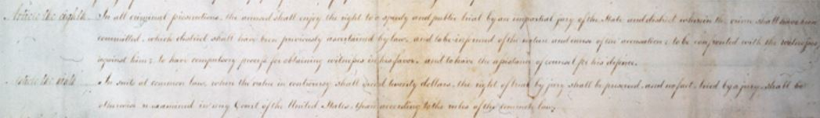
Source: “Creating the Bill of Rights: Trial by Jury,” Library of Congress, https://www.loc.gov/exhibits/creating-the-united-states/interactives/bill-of-rights/trialbyjury/index.html.
Vocabulary
- Define the following terms below and others you are not familiar with in your own words. You may wish to consult a legal dictionary at https://dictionary.law.com/ or https://www.nolo.com/dictionary.
  - ascertain:
  - accusation:
  - compulsory:
  - counsel:
  - defence (defense):
  - impartial:
  - prosecutions:
  - Other words you need to define:
Observe
- What do you notice first about the original copy of the proposed Bill of Rights?
- What do you notice first about the words in this amendment?
Reflect
- What rights does the Sixth Amendment guarantee in your own words?
- Why do you think the Framers of the Bill of Rights included the Sixth Amendment?
Question
- What do you still wonder about this source?

Gideon v. Wainwright / Opinion Analysis
Justice Hugo Black wrote the Majority Opinion of the Court:
writ of habeas corpus is legal term for an order requiring a person under arrest to be brought into court so the government can show that they were arrested lawfully.
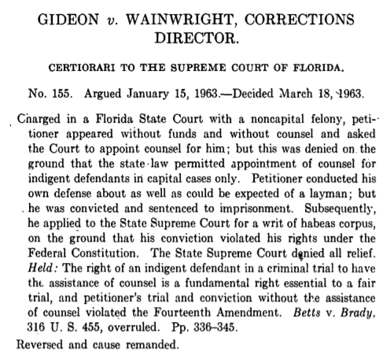
Source: Hugo Lafayette Black and Supreme Court of the United States, “U.S. Reports: Gideon v. Wainwright, 372 U.S. 335. 1962,” Periodical, https://www.loc.gov/item/usrep372335/.
Constitutional Provisions
Sixth Amendment to the U.S. Constitution
“In all criminal prosecutions, the accused shall enjoy the right to a speedy and public trial, by an impartial jury of the State and district wherein the crime shall have been committed, which district shall have been previously ascertained by law, and to be informed of the nature and cause of the accusation; to be confronted with the witnesses against him; to have compulsory process for obtaining witnesses in his favor, and to have the Assistance of Counsel for his defence.”
14th Amendment to the U.S. Constitution, Section 1
“… nor shall any State deprive any person of life, liberty, or property, without due process of law; nor deny to any person within its jurisdiction the equal protection of the laws.”
Vocabulary
- Define the following terms below and others you are not familiar with in your own words. You may wish to consult a legal dictionary at https://dictionary.law.com/ or https://www.nolo.com/dictionary.
- counsel:
- federal:
- felony:
- fundamental right:
- indigent:
- layman:
- non-capital:
- petitioner:
- Other words you need to define:
Observe
- What do you notice first about the words in this text?
Reflect
- Put this part of the opinion in your own words:
- What is the purpose of this piece of the opinion?
- Who is the primary audience for this opinion?
Question
- What do you still wonder about this source?

Gideon v. Wainwright / Newspaper Analysis
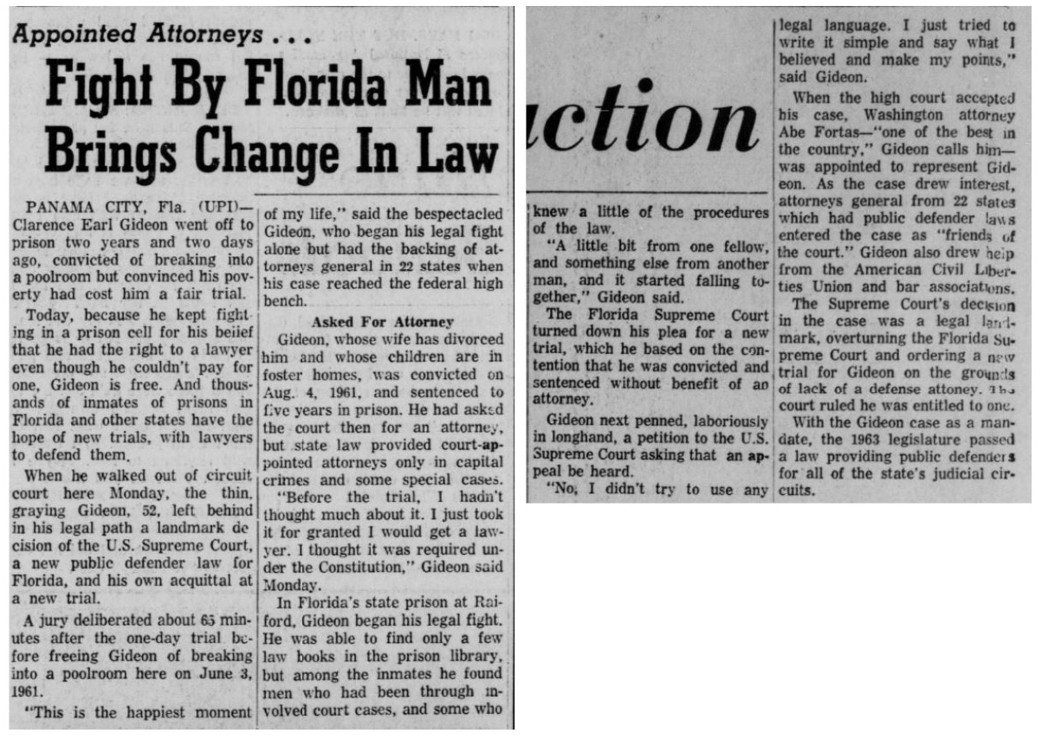
Source: The Chronicle. (Pascagoula, Miss.), 07 Aug. 1963. Chronicling America: Historic American Newspapers. Lib. of Congress. https://chroniclingamerica.loc.gov/lccn/sn87065526/1963-08-07/ed-1/seq-11/.
Observe
- What text do you notice first?
- What do you learn just from the titles and subtitles?
- Where and when was this article published? What is the significance?
Reflect
- What can you tell about what was important at the time and place of publication?
- What can you tell about the point of view of the people who wrote and published this article?
- What do you learn about the importance of the decision in Gideon v. Wainwright (1963) from this article?
Question
- What do you still wonder about this source?

Gideon v. Wainwright / Inquiry-based Task:
Will You Sign the Resolution?
Before you begin:
- Read Gideon v. Wainwright case summary
- Optional: Complete Classifying Arguments Activity
- Complete Sixth Amendment Analysis (Activity 1)
- Complete Opinion Analysis (Activity 2)
- Complete Newspaper Analysis (Activity 3)
Background:
As a result of the decision in Gideon v. Wainwright, states were required to set up a system to provide attorneys to defendants who could not afford them. Many states established public defenders’ offices and hired attorneys full time for this job.
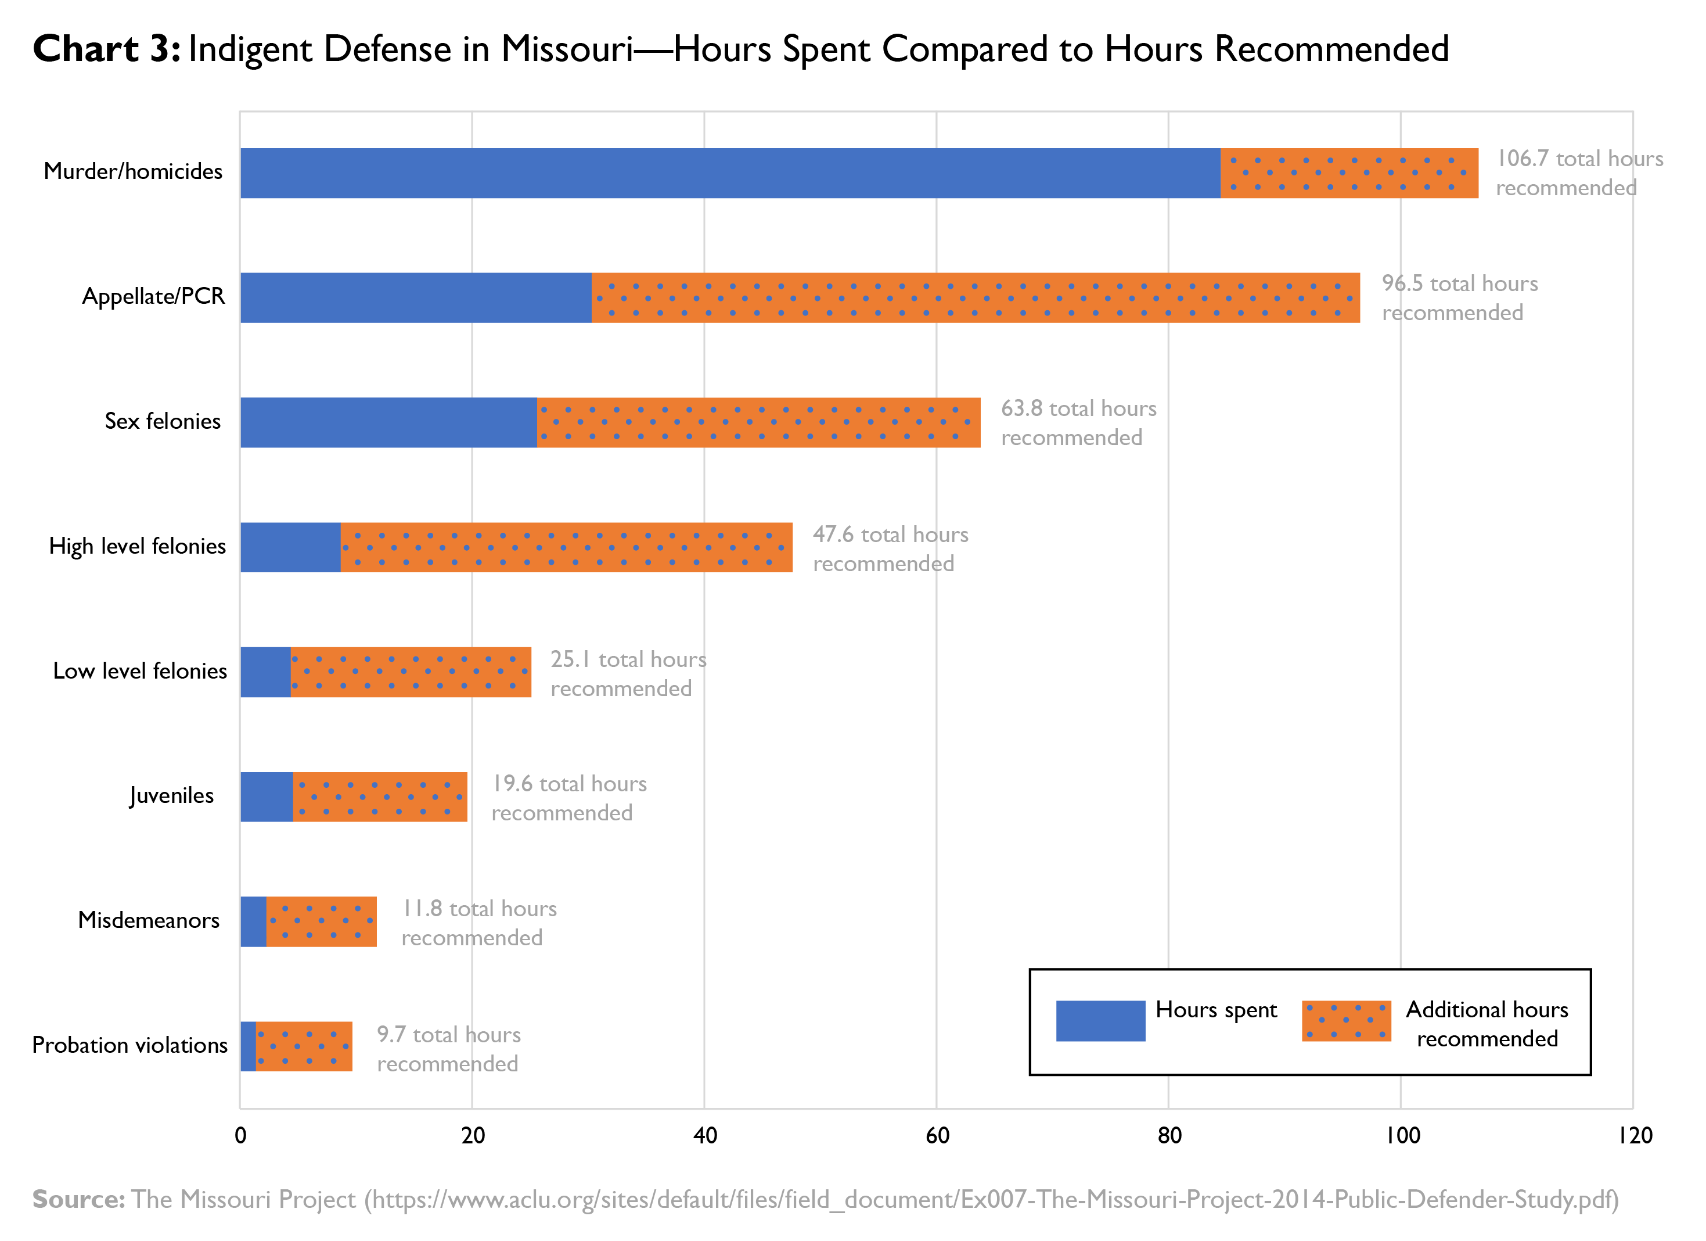

On the 50th anniversary of the decision in Gideon v. Wainwright, the U.S. Department of Justice issued a statement that included the following assessment: “Despite the significant progress that has been made over 50 years after the decision, the promises of Gideon remains unfulfilled. The quality of criminal defense services varies widely across states and localities. Many defenders struggle under excessive caseloads and lack adequate funding and independence, making it impossible for them to meet their legal and ethical obligations to represent their clients effectively.” The chart on page 1 illustrates this problem in the state of Missouri.
Your task:
You were recently elected as your district’s representative to the United States House of Representatives. Tomorrow you must vote on whether to support House Resolution 108. To make an informed decision you should consider the following questions:
- Read House Resolution 108 (pages 4 and 5). Do you agree with the numbered provisions? Why or why not?
(1)
(2)
(3)
- How do you think the House of Representatives might “support strategies to improve the criminal justice system to ensure that indigent defendants in all felony cases are adequately represented by counsel” as encouraged in the resolution?
- If H.Res.108 is successful, what might the impact (if any) be? If it fails?
- Will you vote “yea” or “nay” on H.Res.108? What informed your decision?
- Create an “elevator speech” (a short, persuasive speech that lasts no longer than one minute) encouraging your fellow representatives to vote with you.
- Do you think H.Res.108 passed? Why or why not?
- What questions do you still have about H.Res.108?
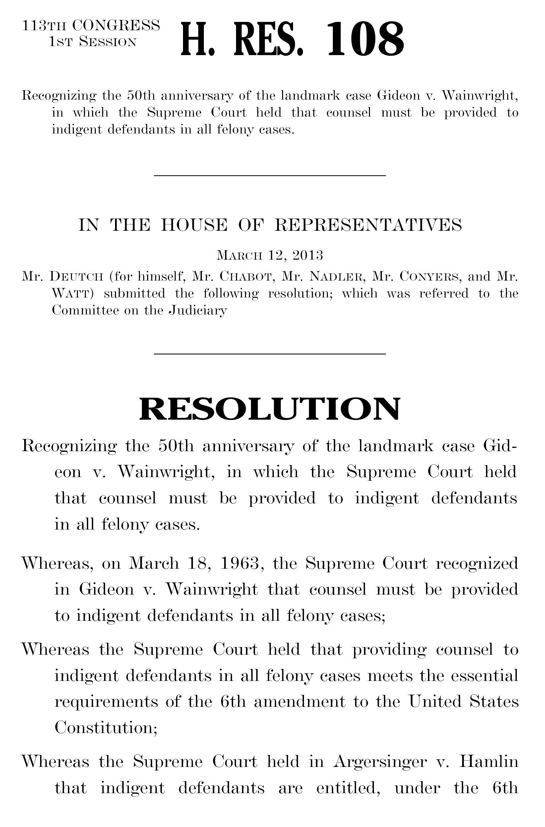
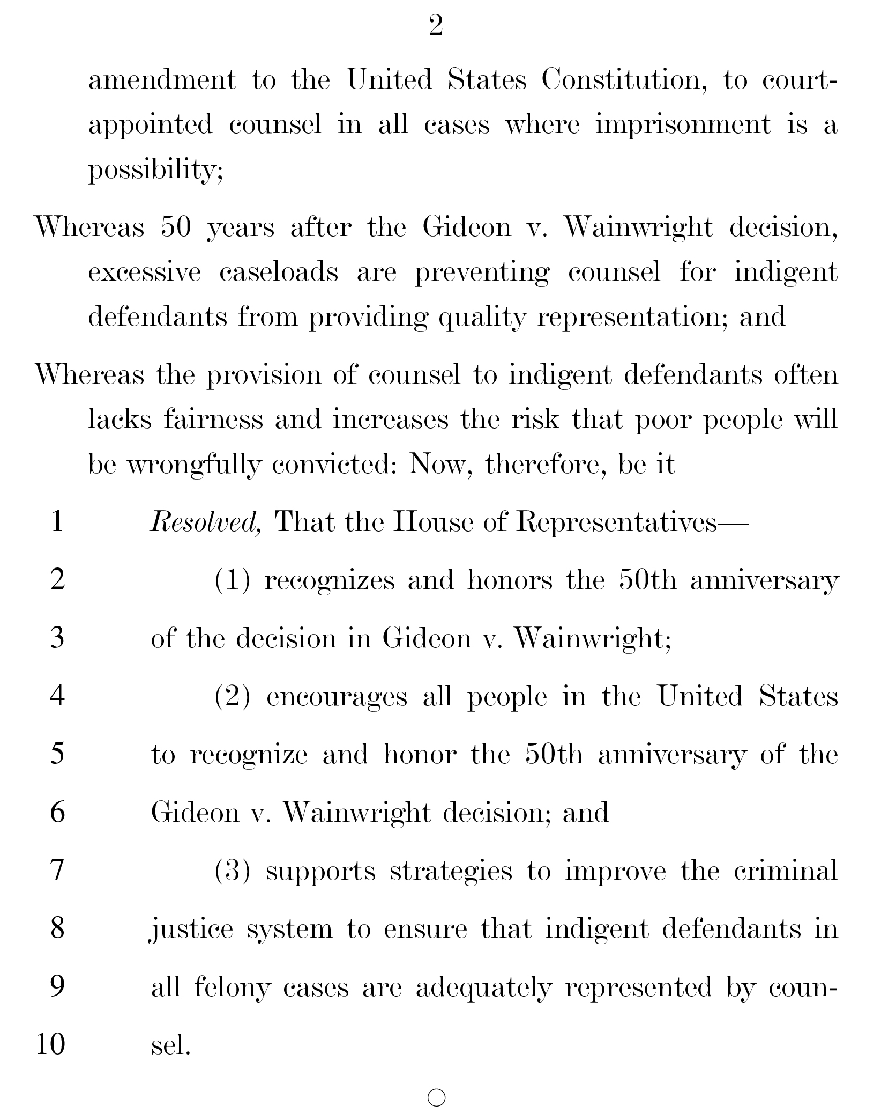

House Resolution 108 was introduced into the Judiciary Committee by Representative Theodore Deutch (D-FL) on March 12, 2013, https://www.congress.gov/bill/113th-congress/house-resolution/108.

