Gideon v. Wainwright / Sixth Amendment Analysis
The Sixth Amendment to the Constitution as proposed and ratified:
“Article in the Eighth… In all criminal prosecutions, the accused shall enjoy the right of a speedy and public trial by an impartial jury of the State and district wherein the crime shall have been committed, which district shall have been previously ascertained by law, and to be informed of the nature and cause of the accusation; to be confronted with the witnesses against him; to have compulsory process for obtaining witnesses in his favor, and to have the assistance of counsel for his defence.”
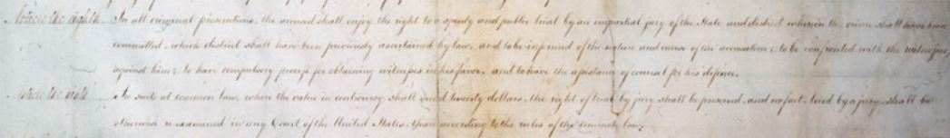
Source: “Creating the Bill of Rights: Trial by Jury,” Library of Congress, https://www.loc.gov/exhibits/creating-the-united-states/interactives/bill-of-rights/trialbyjury/index.html.
Vocabulary
- Define the following terms below and others you are not familiar with in your own words. You may wish to consult a legal dictionary at https://dictionary.law.com/ or https://www.nolo.com/dictionary.
  - ascertain:
  - accusation:
  - compulsory:
  - counsel:
  - defence (defense):
  - impartial:
  - prosecutions:
  - Other words you need to define:
Observe
- What do you notice first about the original copy of the proposed Bill of Rights?
- What do you notice first about the words in this amendment?
Reflect
- What rights does the Sixth Amendment guarantee in your own words?
- Why do you think the Framers of the Bill of Rights included the Sixth Amendment?
Question
- What do you still wonder about this source?

