TEMPLATE LETTER FROM SUPPLIERS to SUBSUPPLIERS/MANUFACTURERS
Request for Emissions Data Collaboration
[Date]
To: [Sub-supplier / Retailer / Manufacturer Name]
Dear Partner,
As part of our commitment to sustainability and transparency, we are aligning with the International Maritime Emissions Framework (IMEF), an initiative to collect emission data that is rapidly becoming a standard in the maritime industry and based on the general initiative across shore-based industries, retail, and consumers sector.
To support this transition, we kindly request your assistance in providing available cradle-to-gate emissions data for the products we procure from you. This includes emissions generated from raw material extraction through to delivery at the destination.
In many cases, original manufacturers or retailers already possess this data, and it is often just a matter of requesting and collecting it. We encourage you to reach out to your own suppliers or data sources to retrieve this information where possible.
Although the information may vary slightly depending on the standard applied, attached is an example of the optimal data set. The minimum is to have Total Carbon Footprint expressed in CO2e (kg CO2 equivalent), Calculation Method and Traceability Data.
Please note that if emissions data is not currently available, this will not hinder our ongoing collaboration. Standardized databases such as Ecoinvent and Exiobase will be used to estimate emissions based on available product attributes.
That said, vendors who provide verified emissions data or offer lower-emission alternatives may be preferred over time. We therefore appreciate your support in helping us build a more transparent and sustainable supply chain.
Thank you for your collaboration and continued partnership.
Warm regards,
[Your Name] /[Your Title]
[Your Company Name]

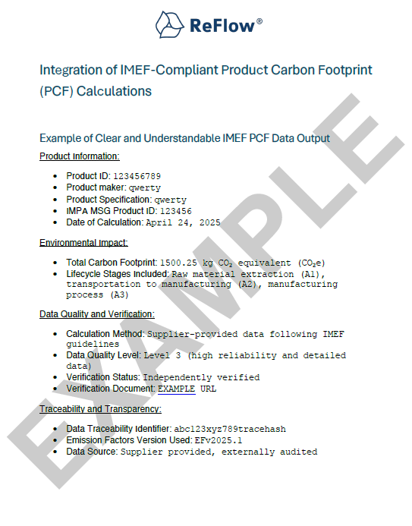
. Country of Origin: Netherlands

