Information Technology. 2025. Theory Prelim. Demarcation.
NOTE: This same demarcation applies to the end of year examination.
Three-hour examination paper. 150 marks.
What to bring to the exam.
2 pens, 2 sharp pencils, 1 eraser, 1 ruler, 1 non-programable calculator, your amazing self.
Sections and section weighting.
Part | Description | Marks
1 | System technologies . Hardware, software and system technologies.  A lot of grade 11 material here. Because the unique grade 12. material is not that extensive it will ALL be examined. | 40 marks
2 | Networking.  Internet and communication technologies.  There are a lot of grade 11 material here. | 45 marks
3 | Social implications. | 15 marks
4 | Data and information management. Solution development. | 50 marks
 | TOTAL | 150 MARKS

Which study resources to use:

Lower order marks | 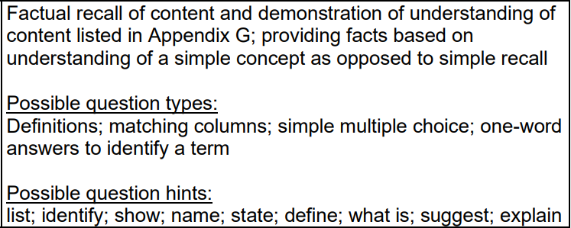 | 30%
Middle order marks | 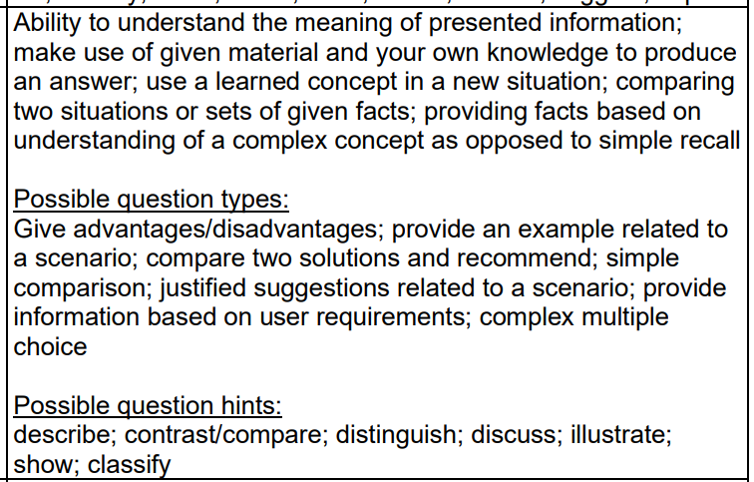 | 40%
Higher order marks | 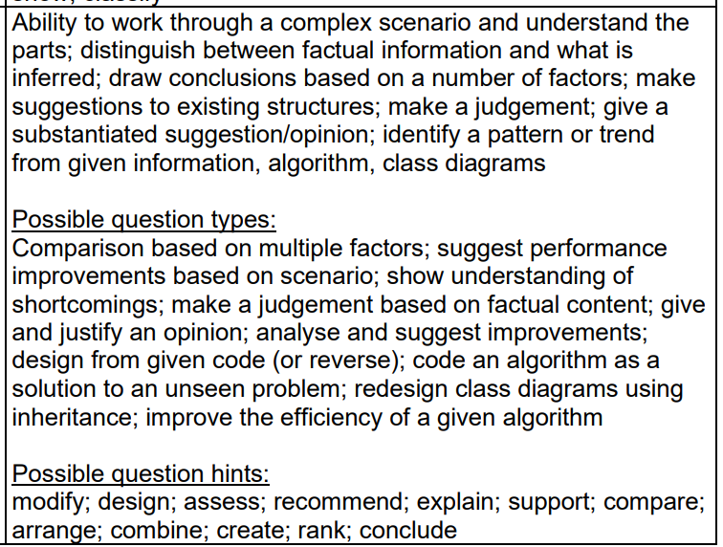  Pseudocode, trace tables, truth tables, class diagrams | 30%

Reading time
Read the scenario. Thoroughly understand it and begin to get your own ideas of the challenges facing the scenario and the solutions provided and possible problems, advantages and disadvantages that will be encountered for the proposed solution. Do this before you read the questions so that you bring to the table some of your own ideas, experiences, opinions and solutions.
OOP
Pivotal to the examination paper part 4 is OOP theory – the characteristics and advantages of using OOP structures and designs. Use this grid to keep track of them as you study each concept. Note that inheritance is not compulsory – it is an option offered by OOP design that can be used or not used.
 | encapsulation |  | inheritance
 | polymorphism |  | abstraction
 | overloading |  | overriding
 | role of arrays |  | arrays of objects and the loops that create them.
 | typed methods |  | void methods
 | class diagrams |  | constructors
 | class properties |  | class methods
 | accessor methods |  | mutator methods
 | parameters and arguements |  | role of the toString method
 | access modifiers |  | Information hiding

Past examination papers
Have your own strategy for 2025 based on the past papers from the past 4 years.

