Missourians and their Contributions
Lesson Summary: Students will choose a leader of activist from the Historic Missourians webpage. They will read the biography, summarize information about their chosen Missourian and describe their historic significance.
Grade Level: 3
Duration: 40 minutes
Common Core Objectives:
CCSS.ELA-Literacy.RI.3.1
Ask and answer questions to demonstrate understanding of a text, referring explicitly to the text as the basis for the answers.
CCSS.ELA-Literacy.RI.3.2
Determine the main idea of a text; recount the key details and explain how they support the main idea.
Missouri Social Studies Standards:
3a.C.3
Identify and describe the historical significance of the individuals from Missouri who have made contributions to our state and nation.
Activities
- Warm-up (5 minutes) Brainstorm. Students will write down all of the historic people they can think of and the contributions they made towards history.
- Think-Pair-Share (5 minutes) Have students share with a partner about who they wrote down. Then have a few students share their examples.
- Missourians and their Contributions (30 minutes) Using the “Missourians and the Contributions” Worksheet, students will navigate to SHSMO’s Historic Missourians webpage and go to the “Leaders and Activists” category, or the “Politicians” category. They will choose one historic Missourian to focus on for their assignment and they will list some of the contributions their chosen Missourian made.
  - Note- Teachers without access to technology for students can select 3-5 Missourians and print their pages to distribute to students.

Name:
Class Period:
Teacher:
Missourians and Their Contributions
Although we are only one state in the United States of America, Missourians have made a large difference in the history of politics and activism in this country. The goal of this lesson is to spend time learning about an individual Missourian and how they’ve contributed to history.

Go to this link to find the historic Missourians webpage: Link
Click the “Category” tab at the top of the page.
Go to the “Leaders and Activists” page OR the “Politicians” page.
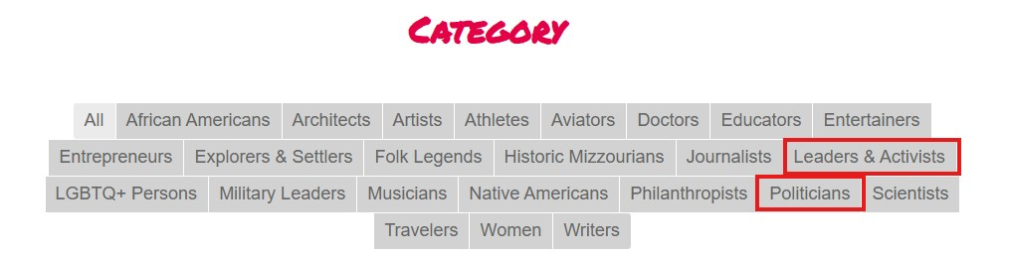
Pick one of the Historic Missourians that most interests you and click on their name.
Read the information on the page and then move on to the questions on page 2.

Missourians and Their Contributions Questions
- Who is the person you chose?

- Why did you pick this person to read about?

- Where were they from, or where did they live in Missouri?

- What years were they alive?

- Write a summary (3-4 sentences) of the biography you just read. Use your own words!

- Write down three things they did that may have changed history.

- In your opinion, why is it important to know about the things people from Missouri have done in history? (1-2 sentences)

