Missouri Mapmakers
Lesson Summary: Students will use clues to create a map of the Boone’s Lick Road, a key trade road for early Missouri settlers and traders. The clues include an abridged entry from SHSMO’s Missouri Encyclopedia, a list of stops along the road, and a map of the road from 1911.
Grade Level: 3
Duration: 60 minutes, could be broken into two parts
Common Core Objectives:
CCSS.ELA-Literacy.RI.3.5
Use text features and search tools (e.g., key words, sidebars, hyperlinks) to locate information relevant to a given topic efficiently.
CCSS.ELA-Literacy.RI.3.7
Use information gained from illustrations (e.g., maps, photographs) and the words in a text to demonstrate understanding of the text (e.g., where, when, why, and how key events occur).
Missouri Social Studies Standards:
5.A.3
Read and construct historical and current maps.
Activities
- Warm-up (5 minutes) Journal- If you had to make a paper map of your route to school for someone who had never been to it, what steps would you take to make that map? Share with your seat partner when you’re done.
- Mapmaker Activity (55 minutes) Hand out the Student Instructions and the blank Missouri survey map. Students will use the three clues to make a basic map of the Boone’s Lick Rd with at least three stops. This could be done individually or with a partner. The activity could also be converted into a “stations” activity, with one clue at each station and a paper for taking notes.
  - Note- for the Blank survey map and Clue #3, the best printing settings are on 8.5 x 14 paper, landscape, shrink to fit. Color if possible

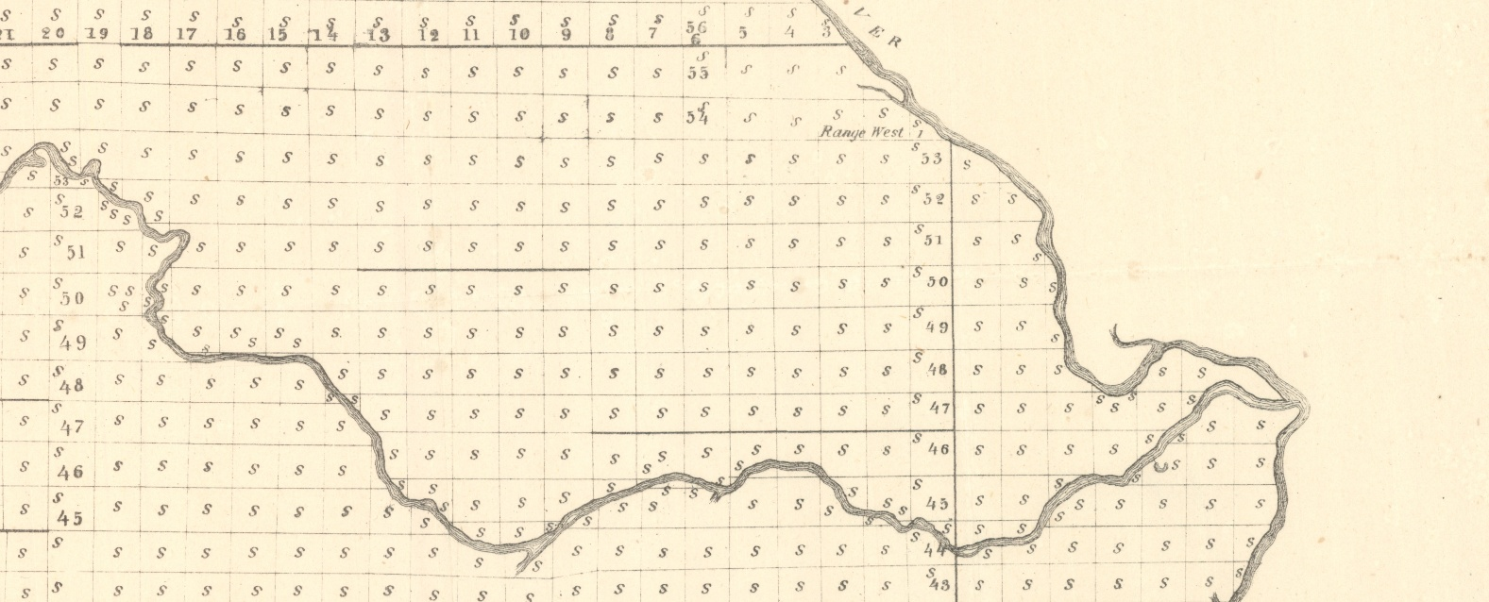
Missouri Mapmaker
A cartographer is someone who makes maps using data and information. Ideally, a mapmaker has the ability to explore the area they’re mapping, but when you need a map of a historical area, sometimes you need to pull information from lots of different places! You’ll be researching and mapping the Boone’s Lick Road, a vital trade road for the old Missouri pioneers.
You’ll have a blank map of Eastern Missouri from 1843. Review the clues, there are three! Using those clues, draw a line mapping the road and add three towns or stops on your map. You’ll be an official cartographer in no time!

Missouri Mapmaker
A cartographer is someone who makes maps using data and information. Ideally, a mapmaker has the ability to explore the area they’re mapping, but when you need a map of a historical area, sometimes you need to pull information from lots of different places! You’ll be researching and mapping the Boone’s Lick Road, a vital trade road for the old Missouri pioneers.
You’ll have a blank map of Eastern Missouri from 1843. Review the clues, there are three! Using those clues, draw a line mapping the road and add three towns or stops on your map. You’ll be an official cartographer in no time!

Missouri Mapmaker
A cartographer is someone who makes maps using data and information. Ideally, a mapmaker has the ability to explore the area they’re mapping, but when you need a map of a historical area, sometimes you need to pull information from lots of different places! You’ll be researching and mapping the Boone’s Lick Road, a vital trade road for the old Missouri pioneers.
You’ll have a blank map of Eastern Missouri from 1843. Review the clues, there are three! Using those clues, draw a line mapping the road and add three towns or stops on your map. You’ll be an official cartographer in no time!
CLUE #1
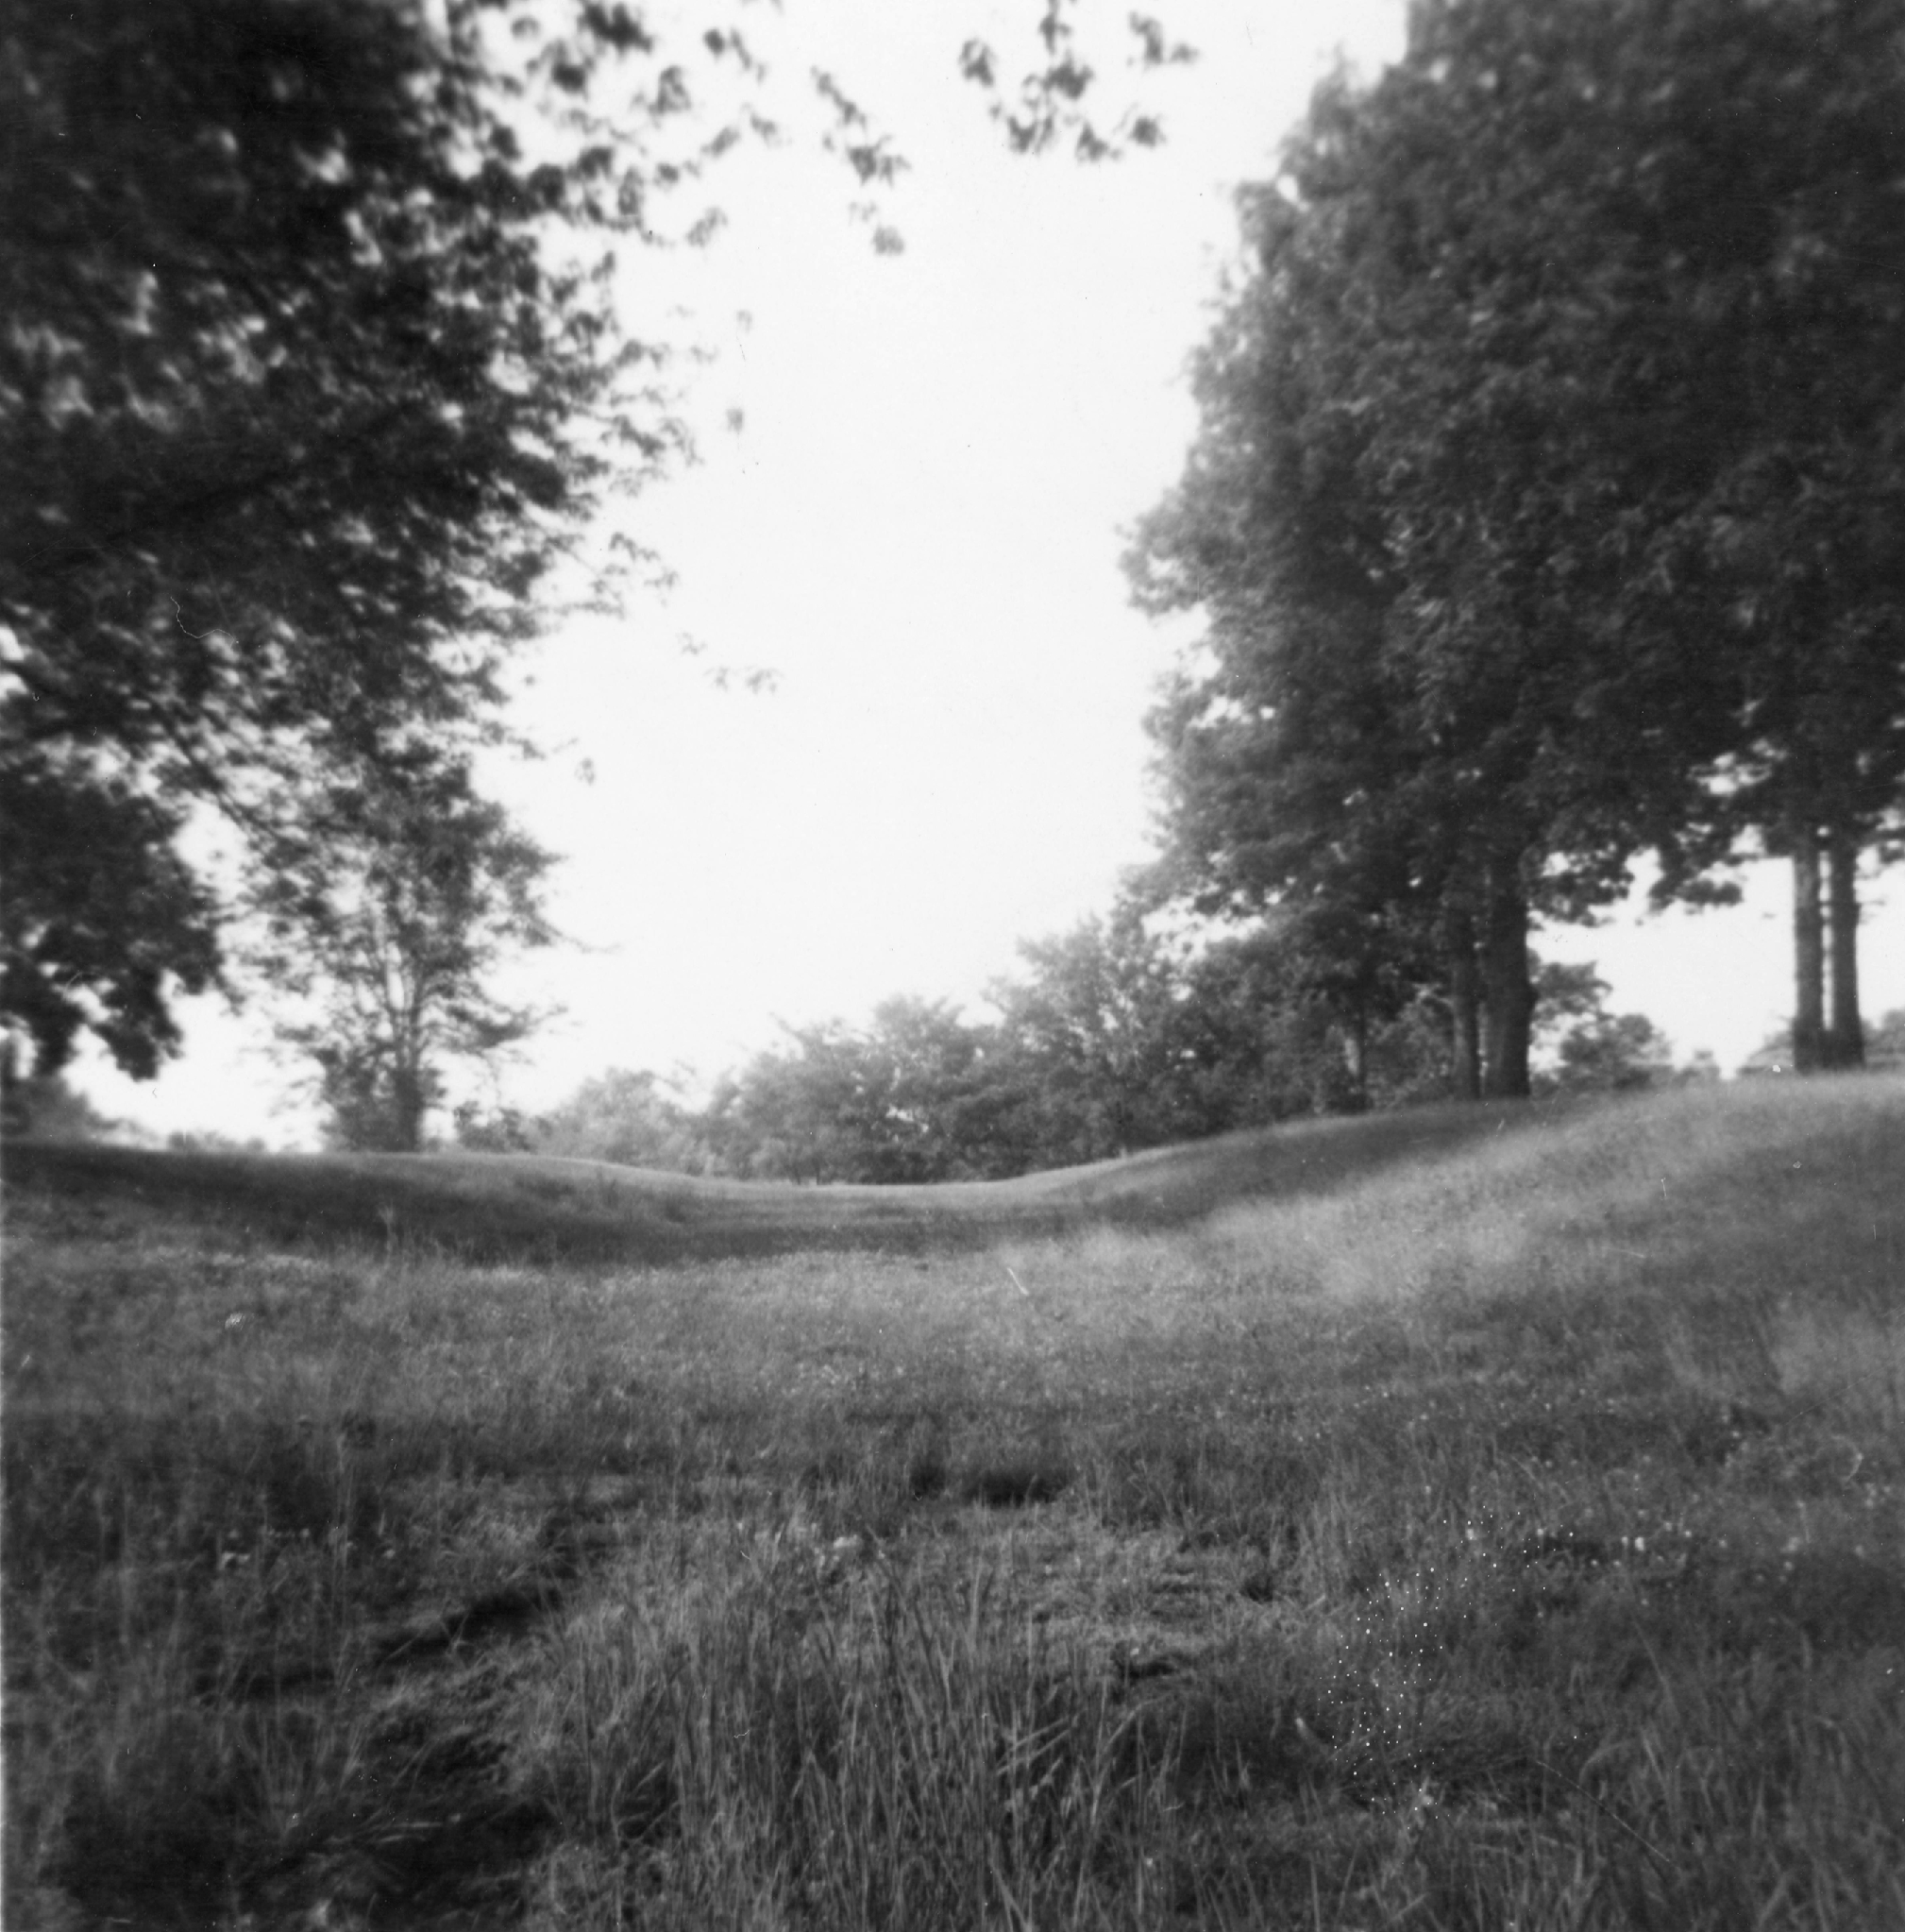
A trace of the Boone’s Lick Road, 1959
The Boone’s Lick Road
Note- The following is a summary of the Missouri Encyclopedia entry written by David Sapp. Full article is available to be read at missouriencyclopedia.org
The Boone’s Lick Road was the first major road to the west after the Louisiana Purchase in 1803. Traveling the Missouri river against the current was too difficult, so a route was needed on land to move families and goods. The Boone’s Lick Road became that route. It started in 1804, when Nathan Boone and his brother-in-law came across saltwater springs, also known as a salt lick, in what is now Howard County. Nathan Boone and his brother, Daniel Morgan Boone, got rights to take salt from the lick to ship for sale. They needed the best route from St. Charles to the Boone’s Lick region. The route was determined by staying far enough north from the Missouri river to avoid the smaller branches and streams of the river. Parts of the route also used Native American trails or buffalo paths.
In 1808, Nathan Boone guided a military expedition to establish Fort Osage along the Boone’s Lick Road. This helped establish the road for other travelers and American settlers began using the road to move westward. The Boone’s Lick Road became one of the most significant routes for migration in the United States around the 1820s and from 1820-1830, Missouri’s population more than doubled.
No early maps of the entire Boone’s Lick Road have survived, but two journalists from the 1820s documented key stops on the road from St. Charles to Franklin. The road changed to go through Columbia and then eventually beyond, which is the variation of the road that is most well-known. The Daughters of the American Revolution placed red granite historical markers along that path in 1913 to commemorate the road. Some short pieces of the road are still visible, and much of it became part of today’s US Highways.
CLUE #2

Below is a chart of stops on the Boone’s Lick Road from an early nineteenth century travel guide.
Note- Not all of these stops are listed on old maps of the road! Many of them are taverns or inns that were along the road where travelers stopped.

