Oral Histories Lesson Plan
Lesson Summary: Students will listen to an oral history recorded and transcribed by an SHSMO historian and connect the recording they chose with the historical context their subject is discussing.
Note- Some of these materials may contain offensive language or references to violence and other harmful content. The State Historical Society of Missouri does not endorse any views expressed in these collections. You can review and select the histories you’d like your students to listen to in advance if you would prefer.
Grade Level: 9-12
Duration: 1 hour
Materials needed: Computer, headphones if possible.
Common Core Objectives, History/Social Studies:
CCSS.ELA-Literacy.RH.9-10.6
Compare the point of view of two or more authors for how they treat the same or similar topics, including which details they include and emphasize in their respective accounts.
CCSS.ELA-Literacy.RH.11-12.6
Evaluate authors' differing points of view on the same historical event or issue by assessing the authors' claims, reasoning, and evidence.
Missouri State Standards, Social Studies, Grades 9-12:
1.1.B. Explain connections between historical context and peoples’ perspectives at the time in United States history.

Activities
- Brainstorm (5 minutes) Students will list 5-10 questions they may ask an older person to learn more about their life and the time period they lived in.
- Listen to an oral history (25 minutes) Students will listen to a segment of an oral history recording on the SHSMO website.
  - Note- Many of the oral histories have transcriptions. The assignment requires them to select a history with a transcription. If headphones are not available, they can read the transcription of the recording.
- Research Analysis writing (30 minutes) Students will research one of the topics discussed in the oral history using online resources. They will use text evidence to compare the perspective shared in the oral history with their chosen article.

Shared Histories
We can connect with our history on a deeper level if we hear the stories and narratives of our elders. “Oral history refers both to a method of recording and preserving oral testimony and to the product of that process. It begins with an audio or video recording of a first-person account made by an interviewer with an interviewee (also referred to as narrator), both of whom have the conscious intention of creating a permanent record to contribute to an understanding of the past. A verbal document, the oral history, results from this process and is preserved and made available in different forms to other users, researchers, and the public.”
Today, you will be listening to a portion of an oral history recording of your choosing.
- Use this link to view the oral histories: LINK
- Select a topic and then pick an interview. Make sure that you pick an interview with a transcript. The transcript is the written version of the audio recording. When you click on the person’s name, the interview files and transcript should come up. If there is no transcript, select a different interview.
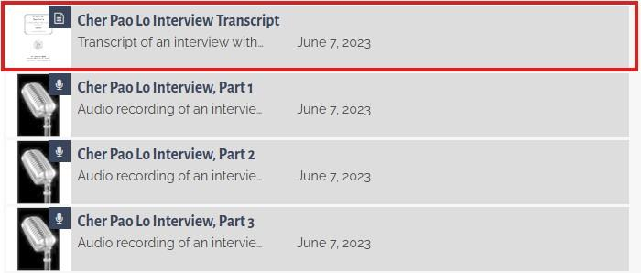
- Each Transcript has a preface around pg. 5 that gives a short history of the interviewee. Read the historical background before you move on to the listening portion.
- Listen to approximately 20 minutes of the tape. If you do not have access to headphones, read an equivalent portion of the transcript.
Compare and Analyze
- After listening to the interview you selected, find an article online on one of the topics discussed and read it.
  - For example, if my interview talked about the Vietnam war and how it affected Laotians, I would find an article about civilian life in Laos during the war.
- Copy and paste the link to the article you found here:

- How did the perspective shared in the interview you listened to compare to the article you read? Write a PIE-IE paragraph comparing them.
Point: 1-2 sentences explaining what your point is. Brief overview of the similarities and differences you found.
Illustrate: Select a quote from your interview. Use a direct quote or paraphrase, but be sure to cite it. (LastName, Year of Interview) Ex. (Smith, 2023)
Explain: 1-2 sentences explaining what the previous quote shows about the perspective of the interviewee
Illustrate: Select a second quote from the article you read. Use a direct quote or paraphrase, but be sure to cite it. (Last name, Year Published)
Explain: 1-2 sentences explaining what this second quote shows about the article’s point of view on the same topic. Compare this second quote to your first.
Concluding Sentence: 1 sentence summarizing your ideas.

Frequently Asked Questions: Veterans History Project.” What Is an Oral History? - Ask a Librarian, Library of Congress, Nov. 2025, ask.loc.gov/veterans-history/faq/368984.

