Transportation and the Missouri Encyclopedia Lesson Plan

Lesson Summary: Students will use the State Historical Society of Missouri’s Missouri Encyclopedia website to research a transportation topic of their choosing. They will summarize the entry they chose, analyze the effect of their chosen transportation topic, and reflect on the sources used for historical articles.

Grade Level: 9-12

Duration: 1 hour

Common Core Objectives, History/Social Studies:

Grade 9-10

CCSS.ELA-Literacy.RH.9-10.2
Determine the central ideas or information of a primary or secondary source; provide an accurate summary of how key events or ideas develop over the course of the text.

Grades 11-12

CCSS.ELA-Literacy.RH.11-12.2
Determine the central ideas or information of a primary or secondary source; provide an accurate summary that makes clear the relationships among the key details and ideas.

Missouri Social Studies Standards:

Grades 9-12 American History

3.3.A.
Describe how the expansion of transportation and technological developments influenced acquisition of new territories.

3.6.A.
Analyze physical geography to understand the availability and movement of resources in this era.

4.2.B.
Explain how the expansion of industrialization, transportation and technological developments influenced different regions and the relationship between those regions

Activities
- Think-Pair-Share (10 minutes) Students will turn to a partner and share the types of transportation they’ve used. Cars, planes, trains, etc. The teacher will ask a handful of students to share types of transportation with the class and will write them on the board. Then the students will turn to their partner again and talk about pros and cons of the types of transportation the class put together. The teacher will ask students to share these pros and cons with the class and will make an informal chart on the whiteboard with some of the advantages and disadvantages of the different types of transportation. Alternatively, you could have one student from each pair come up to add their pros and cons to the whiteboard themselves.
- Transportation Handout- Read (20 minutes) Using the links and information on the first page of the handout, students will read an article on transportation in Missouri using their Chromebook or other school device. If technology is unavailable, the educator can select and print articles in advance. The text boxes on the handout may need to be expanded for on-paper work.
- Transportation Handout- Write (30 minutes) The students will summarize their chosen article and analyze the effects that their transportation topic had. They will also provide information on the sources used to write the encyclopedia article.

Transportation and the Missouri Encyclopedia
Name:
Class period:
Teacher:

Instructions:

- Follow this link to view the Missouri Encyclopedia: LINK

- Go to the “Topics” tab
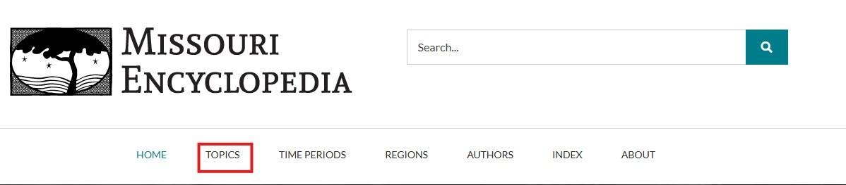

- Scroll down and select the “Transportation” topic

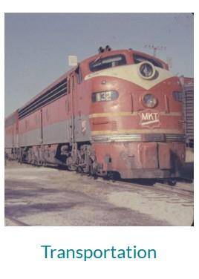
- Select the person or topic most interesting to you in this section and read the article, then come back to complete the work on the following page.
Article Title:
Summary:
(Write 5-7 full sentences summarizing the article you chose.)

How did the transportation topic you read about impact the area it was in? Write 3-4 full sentences.

Did the terrain affect it at all? Explain why or why not. 1-2 sentences.

Scroll to the bottom of your article and click the “Further reading” tab. How many sources were used to write this article?

Select one of the sources and tell me what kind of source it is. Is it a magazine, an academic journal, an archival collection, a website, or another kind of source? You may need to use Google.
Title:
Type of source:

What kinds of sources do you think would be best for a historical article? Why?

