Name:
Class Period:
Teacher:
Missourians and Their Contributions
Although we are only one state in the United States of America, Missourians have made a large difference in the history of politics and activism in this country. The goal of this lesson is to spend time learning about an individual Missourian and how they’ve contributed to history.

Go to this link to find the historic Missourians webpage: Link
Click the “Category” tab at the top of the page.
Go to the “Leaders and Activists” page OR the “Politicians” page.
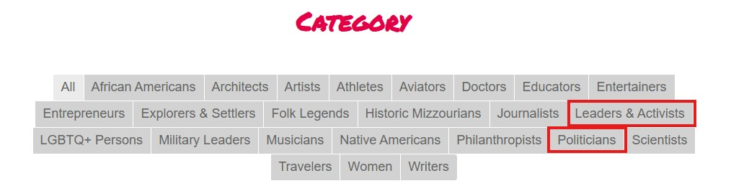
Pick one of the Historic Missourians that most interests you and click on their name.
Read the information on the page and then move on to the questions on page 2.

Missourians and Their Contributions Questions
- Who is the person you chose?

- Why did you pick this person to read about?

- Where were they from, or where did they live in Missouri?

- What years were they alive?

- Write a summary (3-4 sentences) of the biography you just read. Use your own words!

- Write down three things they did that may have changed history.

- In your opinion, why is it important to know about the things people from Missouri have done in history? (1-2 sentences)

