Name: Date:
Energy
Directions: Complete this study guide as you move through the lesson. By taking notes, you are more likely to remember what you are learning. The completed study guide can be used for practice activities and to prepare for quizzes and exams. Be sure to save each study guide so you can access it when you need it.
Essential Vocabulary
As you encounter these scientific terms in the lesson, enter the meaning and an example (or two) for each. You can even draw a picture. If there are other unfamiliar words you find, enter them in the blank spaces provided.
energy | kinetic energy
work-energy theorem | elastic potential energy
law of conservation of energy | gravitational potential energy
mechanical energy | system
Mechanical Energy
- Fill in the blanks about energy.
Energy is .
- Define mechanical energy and give three examples of it.
Definition:
Example 1
Example 2
Example 3
- What is the law of conservation of energy?
An Overview
- Which type of energy will we discuss in this class?
- Define gravitational potential energy, elastic potential energy, and kinetic energy and give its formula.
Name | Definition | Formula
Gravitation potential energy
Elastic potential energy
Kinetic energy
- Describe the total energy inside a closed system.
- Complete the equation for total energy.
Total Energy = |  | + |  | + |  | +

- Fill in the blanks about the work-energy theorem.
To change the energy of a or
, an is required. must be done to change an object’s
energy.
- Write the equation for the work-energy theorem. Then define each term in the equation.
Work-energy theorem equation:
$$W$$ | =
$$∆KE$$ | =
$${KE}_{final}$$ | =
$${KE}_{initial}$$ | =
Gravitational Potential Energy
- Write the formula for gravitational potential energy.
- Fill in the blanks below about gravitational potential energy.
Gravitational potential energy (GPE) is the an object has that depends on of the Earth it is. In other words, it is the energy that it has due to its
.
- Why is the GPE the same for an object lifted 2 meters, pushed up a ramp to a height of 2 meters, and carried of stairs to a height of 2 meters?
GPE in Roller Coasters
(continue on next page)

Draw lines to match the height of these roller coasters to the gravitational potential energy of an 8,350 kg car on the ride.
Height |  | GPE = mgh
$$128.02 m$$ |  | $$1.036 x {10}^{7} J$$
$$126.49 m$$ |  | $$5.742 x {10}^{6} J$$
$$92.96 m$$ |  | $$6.117 x {10}^{6} J$$
$$74.68 m$$ |  | $$1.049 x {10}^{7} J$$
$$70.10 m$$ |  | $$7.615 x {10}^{6} J$$
Kinetic Energy
- Write the formula for kinetic energy.
- Fill in the blanks below about kinetic energy.
An object that has energy due to its has energy. That energy is directly to the
of the object and it is moving. Energy is not a quantity, so kinetic is also not a vector. You can use the of the in the equation regardless of . That kinetic energy provides the object an to do on other . In other words, that kinetic energy can be to another object or
from one to another on this .
KE in Roller Coasters
Draw lines to match the speed of these roller coasters to the kinetic energy of an 8,350-kg car on the ride.
Speed |  | GPE = mgh
$$52.22 m/s$$ |  | $$5.742 x {10}^{6} J$$
$$44.09 m/s$$ |  | $$7.740 x {10}^{6} J$$
$$43.06 m/s$$ |  | $$6.117 x {10}^{6} J$$
$$38.28 m/s$$ |  | $$1.138 x {10}^{7} J$$
$$37.09 m/s$$ |  | $$8.114 x {10}^{6} J$$

The Conservation of Energy
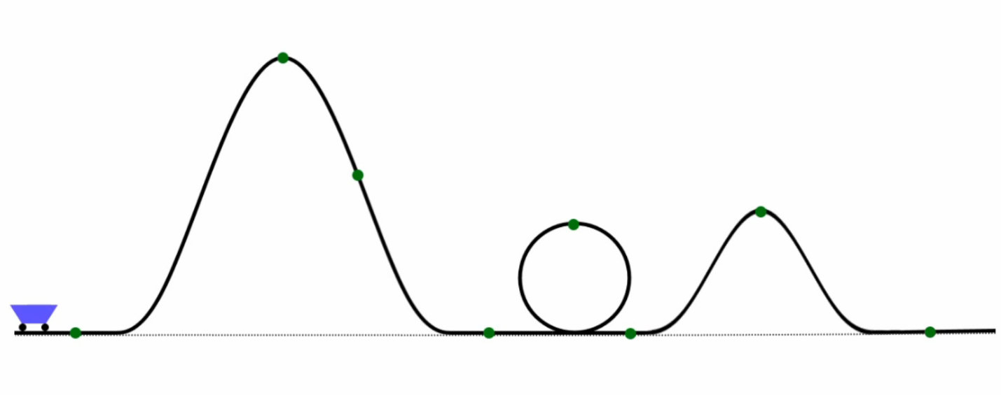
- Complete this drawing with the labels provided in the video.

- Are roller coasters the only objects that obey the law of conservation of momentum?
Conservation of Energy Example
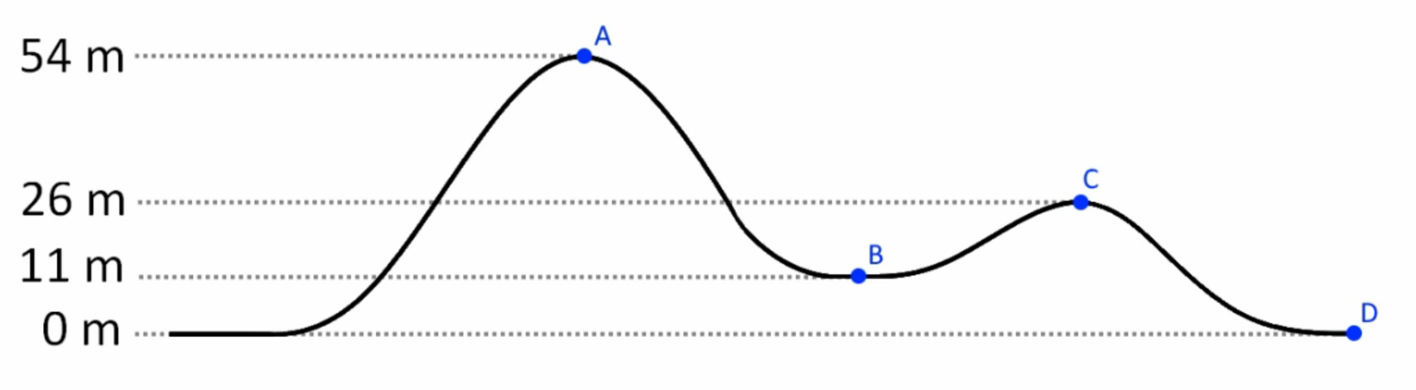
Use the diagram below to answer some questions about a roller coaster.

- What is the gravitational potential energy at Point A (54 m)? Show your work.
Solution:
- How fast is the roller coaster moving at Point C (26 m) when it goes over the top of the second hill? Show your work.
Solution:
- What is the general form of the law of conservation of energy? What does it mean in words?
Putting It All Together
Select one of the problems provided and show each of the steps in solving it. Choose from The Fahrenheit, The Storm Runner, or The Blob Jump.

