Name: Date:
Net Force and Newton’s First Law
Directions: Complete this study guide as you move through the lesson. By taking notes, you are more likely to remember what you are learning. The completed study guide can be used for practice activities and to prepare for quizzes and exams. Be sure to save each study guide so you can access it when you need it.
Essential Vocabulary
As you encounter these scientific terms in the lesson, enter the meaning and an example (or two) for each. You can even draw a picture. If there are other unfamiliar words you find, enter them in the blank spaces provided.
kinematics | dynamics
net force | Newton’s First Law
inertia | equilibrium
unbalanced force

Newton’s First Law
- Fill in the blanks below about Newton’s First Law:
An __________________ at _____________ will stay at ________________ and an object in _______________ will _____________ in __________________ (same ______________ and ________________________) unless ____________ ________________ by an ___________________ _________________.
- According to Newton’s First Law, when forces are balanced, what are the two options for an object to do?
- Stay
- Stay

Inertia
- What is one way to determine which of two similar looking objects has more inertia?
- In the experiment shown, which force is unbalanced after the card moves away that causes the coin to fall into the glass?
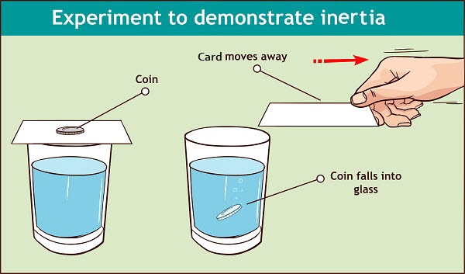
Balanced vs. Unbalanced Forces
- For each of the following images, identify whether the forces acting on the soccer ball are balanced or unbalanced.
 | □ Balanced □ Unbalanced
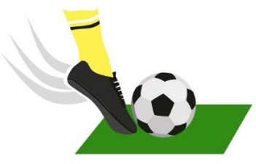 | □ Balanced □ Unbalanced
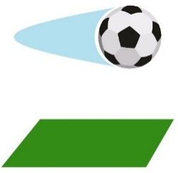 | □ Balanced □ Unbalanced
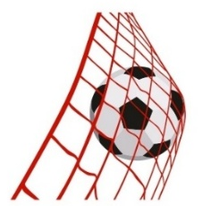 | □ Balanced □ Unbalanced
- What is a tool that can be helpful in determining whether forces are unbalanced or not?
Finding the Net Force
- Define net force in your own words.
- What does the symbol $Σ$ stand for?
- Using the concept of net force, describe the difference between an object at equilibrium and an object that is accelerating.
- What does it mean when a net force is negative?
- Under what condition can you not simply add up the magnitudes of two force vectors to find the net force? What mathematical theorem is used in this situation?

(continue on next page)
Net Force Practice
Choose one of the problems on this page and complete the table showing the free-body diagram and the calculation of the net force. Choose between:
Broken down car, Volkswagen bug, Paddleboard, Stalled car, or Chew toy.
Problem:

Free-Body Diagram

Net Force

