Name: Date:
Speaking Rhetoric
Directions: Complete this study guide as you move through the lesson. By taking notes, you are more likely to remember what you are learning. The completed study guide can be used for practice activities and to prepare for quizzes and exams. Be sure to save each study guide so you can access it when you need it.
Essential Vocabulary
As you encounter these terms in the lesson, enter the meaning and an example (or two) for each. You can even draw a picture. If there are other unfamiliar words you find, enter them in the blank spaces provided.
hook | clincher
persuasion | reasoning
rhetorical devices

Setting Fire
Review the picture. Describe how Patrick Henry used rhetoric to inspire his audience.
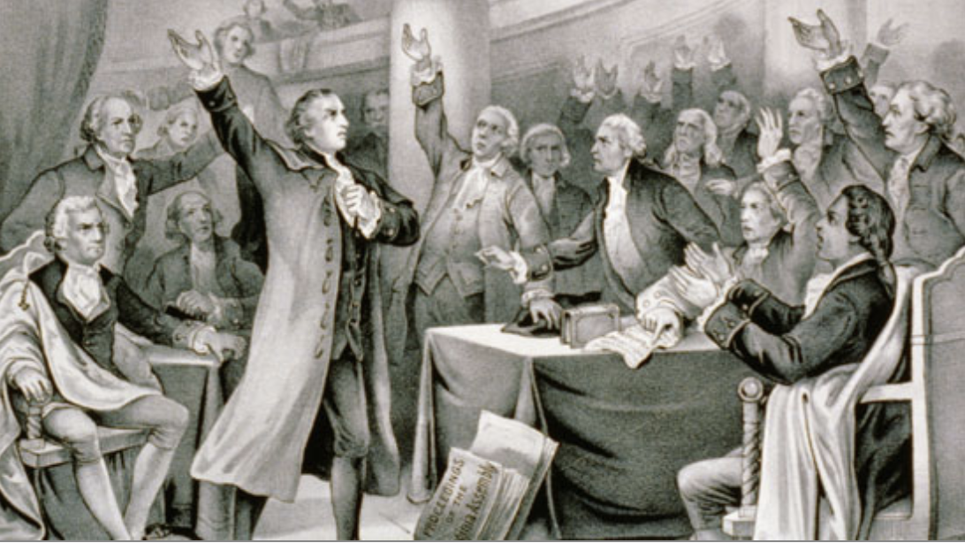

Just Don’t Do It!
Identify the sentences from “Texting and Driving: A Recipe for Tragedy” that will work well in a speech and one that will not work well.
Works Well
Does Not Work Well
Saving the Structure
Identify the hook, body, and clincher used in Trevor’s speech.
Hook
Body
Clincher

Text to Spoken Word
Describe the changes Trevor made from his essay to his speech.
The Hook
The Clincher
Follow Me?
Compare the changes Trevor made throughout the body of his essay and speech.
Essay | Speech
Special Delivery
Describe the strategies to deliver your final speech.
Big and Bold |  | Memorize
Note Cards |  | Be Expressive
 | Speak Up

