Exponential Decay

Directions: Complete this study guide as you move through the lesson. By taking notes, you are more likely to remember what you are learning. The completed study guide can be used to complete practice activities and to prepare for quizzes and exams. Be sure to save each study guide so you can access it when you need it.

Essential Vocabulary

As you encounter these mathematical terms from within the lesson, enter the meaning and an example (or two) for each of the terms. You can even draw a picture. If there are other unfamiliar words you find, enter them in the blank spaces provided.

Exponential Growth Function | exponential decay
decay factor | Exponential Decay Function
domain | range

Exponential Growth Review

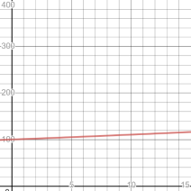 | 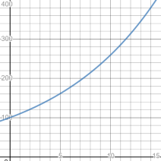 | 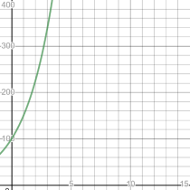

Each of the graphs represents an exponential growth function with an initial value of 100, but with different growth factors. Explain how the growth factor affected the graphs.

Graphing Exponential Decay Functions

- Handan’s parents bought her a car for $16,500 and expect that the car will lose approximately 25% of its value each year. What exponential decay function represents this situation?

- Create a graph to show how the value of Handan's car decreases over time. You can use the exponential decay function you wrote, $f(x)=16,500⋅{0.75}^{x}$.

Finding the Domain and the Range

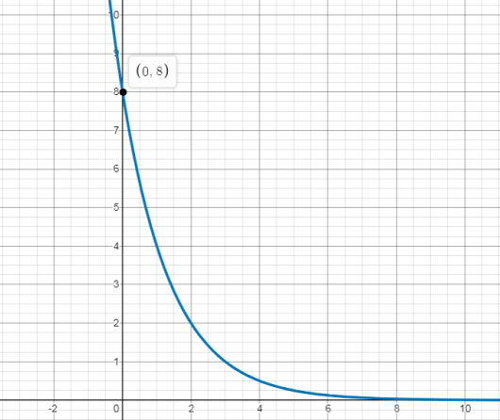

- What are the domain and the range of the exponential decay function shown on this graph?

- The function that describes the curve below is $f(x)=8⋅{12}^{x}$. What do you notice about the function and the $y$-intercept of the graph?

