Inverse Relations and Functions

Directions: Complete this study guide as you move through the lesson. By taking notes, you are more likely to remember what you are learning. The completed study guide can be used to complete practice activities and to prepare for quizzes and exams. Be sure to save each study guide so you can access it when you need it.

Essential Vocabulary

As you encounter these mathematical terms from within the lesson, enter the meaning and an example (or two) for each of the terms. You can even draw a picture. If there are other unfamiliar words you find, enter them in the blank spaces provided.

relation | function
inverse function | implicit form
inverse relation | vertical line test

Relations vs. Functions Review

Use the vertical line test to determine if the following are functions or not.

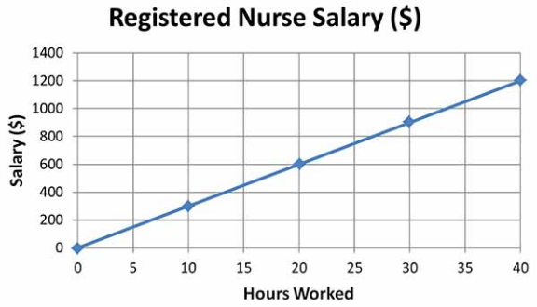

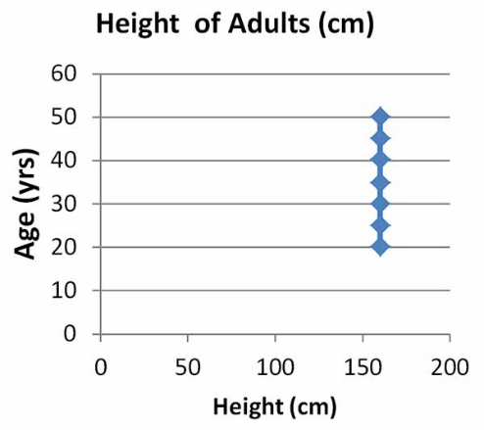

Undoing a Relation or Function

What do you notice about the domain and range of the tables below?

  X | y
  0 | 1
  1 | 3
  2 | 5
  3 | 7
  x | y
  1 | 0
  3 | 1
  5 | 2
  7 | 3

Finding the Inverse Practice

- Find the inverse of the relation $\{(-3, -20); (-1, -12); (0, -8); (1, -4); (3, 4)\}$.

- Find the inverse of the function $f(x)=7x^{2}-16$.

Checking Inverse Functions Practice

- Use a graph to show that the inverse of the relation
$\{(-3, -20); (-1, -12); (0, -8); (1, -4); (3, 4)\}$ is $\{(-20, -3); (-12, -1); (-8, 0); (-4, 1); (4, 3)\}.$

- Use composition of functions to show that $f(x)=4x-8$and $f^{-1}(x)=\frac{x+8}{4}$ are inverses.

