Modeling With Polynomial Functions

Directions: Complete this study guide as you move through the lesson. By taking notes, you are more likely to remember what you are learning. The completed study guide can be used to complete practice activities and to prepare for quizzes and exams. Be sure to save each study guide so you can access it when you need it.

Essential Vocabulary

As you encounter these mathematical terms from within the lesson, enter the meaning and an example (or two) for each of the terms. You can even draw a picture. If there are other unfamiliar words you find, enter them in the blank spaces provided.

mathematical model | extreme
relative extrema | absolute extrema
odd degree polynomial | even degree polynomial
finite differences method | maximum
minimum | intercepts

Let’s Review

What does the graph of $b\left(t\right)=-t^{2}+40t+500$ look like? Complete the table to review key concepts of graphical analysis.

The Graph | Key Features | Model Analysis
Extrema

This is the graph of $y=5x^{3}-6x$. Find the relative extrema.  Describe the end behavior of this graph. | 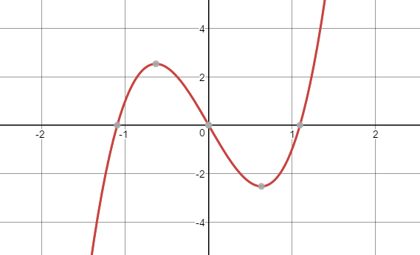
This is the graph of $y=5x^{4}-8x^{2}+16$. Find the relative extrema.  Describe the end behavior of this graph. | 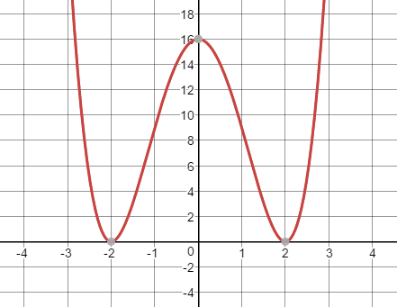

Modeling with Polynomials

A herd of elk are introduced into the ecosystem of a small island. The number of elk on the island was then recorded each year for five years. The data are shown in this table.

Year | 0 | 1 | 2 | 3 | 4 | 5
Population | 100 | 120 | 168 | 208 | 180 | 0

Create a polynomial equation to model this situation.

